**Dry extracts**

Dry extracts are dried extracts of biologically active substances from medicinal plant raw materials, which are free-flowing powders with a moisture content of no more than 5%.

Dry extracts are the most rational type of extracts because they have the following advantages:

- more compact;

- more stable during storage;

- more convenient in the manufacture of other dosage forms.

The main disadvantage of dry extracts is their high dampness.

The dampness of dry extracts can be controlled in the following ways:

- the correct selection of the extractant;

- adding fillers (aerosil, sugar, etc.);

- the correct choice of packaging and storage conditions.

There are several classifications of dry extracts.

*I. Classification of dry extracts based on the requirements for the content of biologically active substances.*

1. Extracts with an unlimited upper limit of biologically active substances (rhubarb, buckthorn, licorice, immortelle, etc.). These extracts are prepared from non-potent medicinal plant raw materials, fillers are not used in their manufacture, since there is no upper limit for the content of biologically active substances.

2. Extracts with a limited upper limit of biologically active substances (belladonna, chilibuhi, etc.). These extracts are prepared from potent medicinal plant materials. Fillers are added to regulate the content of biologically active substances.

*II*... Classification by the group of the main biologically active substances is shown in Table 4.

**Table 4**

**Classification of dry extracts by groups of basic biologically active substances**

|  |  |
| --- | --- |
| The main biologically active substances | Representatives of dry extracts |
| Alkaloids  Anthraglycosides  Flavonoids  Polysaccharides  Cardiac glycosides | Belladonna extract dry  Rhubarb extract dry  Dry buckthorn extract  Helichrysum dry extract  Rosehip extract dry  Marshmallow root extract dry  Adonis extract dry |

**Technological scheme for obtaining dry extracts**

**BP - 1.** Sanitary preparation of production

**BP - 1.1. Preparation of industrial premises**

**BP - 1.2. Processing equipment**

**BP - 1.3. Sanitary preparation of technological clothing**

**BP - 1.4. Sanitary training of personnel**

**BP –2.** Preparation of raw materials and extractant

**VR-2.1. Grinding raw materials**

**VR-2.2. Ethanol dilution**

**TP - 3. Extraction**

**TP - 4. Cleaning Extraction**

**TP - 5. Drying extraction**

**TP - 6. Standardization**

**UMO - 7. Packing, packaging**

**PO - 8. Waste processing (ethanol recovery)**

**Stages VR - 1, VR - 2, TP - 3, TP - 4** - are carried out similarly to thick extracts.

**TP - 5. Drying.** In industrial conditions, two drying methods are used in the production of dry extracts:

1. *Drying in vacuum evaporators through the stage of obtaining a thick extract.* With this method of obtaining, the following technological operations are present.

**TP - 5.1. Thickening.**It is carried out in vacuum evaporators at a temperature of 50-60 0С.

**TP - 5.2. Drying.**The condensed extract is dried in vacuum drying ovens or vacuum roller dryers at a temperature not exceeding 50-60 ° C to a mass having a moisture content of not more than 5%.

**TP - 5.3. Shredding.**Grinding of the resulting mass is usually carried out in ball mills.

**TP - 5.4. Screening.**Screening of the crushed material is carried out using flat screen machines.

1. *Drying in a spray dryer.*

Despite the higher drying temperature (up to 150 ° C) in spray dryers, biologically active substances are less destroyed, since the drying time is several seconds.

1. *Freeze drying possible*but it is too expensive.

**TP - 6. Standardization.** Standardization of dry extracts is carried out by the following indicators:

1. Description (color, smell, uniformity).

2. Authenticity (qualitative reactions, chromatographic analysis, UV spectrum).

3. The content of ethanol (the determination of this indicator is carried out by the boiling point or by the distillation method (GF XI ed., Issue 1, p. 26).

4. The content of biologically active substances (the specified indicator is determined by the chemical, physicochemical, or biological method. The biological method is used if cardiac glycosides are contained, the activity is expressed in frog units of action (ICU), or feline units of action (CED).

5. Moisture content. In this case, the moisture content is not more than 5%.

6. The content of heavy metals - in dry extracts, this indicator should not exceed 0.01%).

7. Microbiological purity. Dry extracts should not contain more than 104 aerobic bacteria, 102 yeasts and molds, enterobacteria not more than 102. In the absence of Salmonella, Escherchia coli, Pseudomonas aeruginosa, Staphylococcus aureus.

*Bringing to the standards of the standard is possible:*

1. Drying to a certain humidity.
2. Mixing with indifferent fillers (sugar, dextrin, etc.).

**UMO - 7. Packing, packaging.** Dry extracts are packed in small jars of usually dark glass, weighing no more than 100 g... To prevent dampness, the flasks are sealed hermetically. Filling machines can work according to the volumetric and weighing principle.

The hardware diagram for the production of dry extracts is shown in Fig. 7.

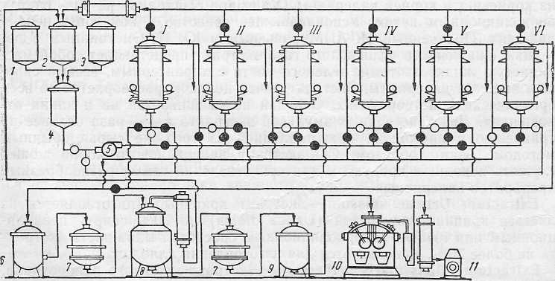

Figure: 7. Apparatus scheme for obtaining dry extracts

I-VI - percolators

1– measuring tank for alcohol; 2 - measuring tank for distillation, 3 - measuring tank for water; 4 - mixer, 5 - vacuum apparatus, 5а - distillation apparatus, 6 - collection, 7 - filter, 8 - settler, 9 - collection of finished product, 10 - pump.

**Extracts-concentrates**

**(standardized extracts)**

This is a special group of liquid and dry extracts designed for the rapid preparation of infusions and decoctions in a pharmacy. This group of extracts is standardized, because:

- liquid extracts-concentrates are prepared in a 1: 2 ratio;

- dry extracts-concentrates are prepared in a 1: 1 ratio.

A feature of the standardized extracts-concentrates is that in their manufacture, ethanol of low concentrations of 20-40% is used, in order to bring the composition of biologically active substances closer to aqueous extracts.

In the GR 2004 year... 9 extracts-concentrates are included, among them: three extracts - standardized liquid and six extracts - standardized dry (Table 5).

**Table 5**

**Nomenclature of extracts**

**standardized (concentrate extracts)**

|  |  |  |
| --- | --- | --- |
| N | Standardized liquid extracts  (12) | Extracts  standardized  dry (1: 1) |
| 1. | Adonis extract | Marshmallow root extract |
| 2. | Valerian extract | Thermopsis extract |
| 3. | Thermopsis extract | Helichrysum extract |
| 4. |  | Lily of the valley extract |
| 5. |  | Montenegrin extract |
| 6. |  | Foxglove extract |

Liquid extracts-concentrates are obtained, as a rule, by the method of repercolation (countercurrent multistage extraction) in a battery of three percolators.

Dry extracts-concentrates are obtained similarly to dry extracts. Extraction of biologically active substances from medicinal plant raw materials is usually carried out by the method of fast-flowing repercolation, and drying in vacuum roller dryers.

The technological scheme for obtaining liquid extracts-concentrates is similar to liquid extracts; dry extracts-concentrates - dry extracts.