## RECOVERY AND RECTIFICATION of ethanol

**Recovery** (from Lat. recuperatio - return, receipt again) - a technological method carried out with the aim of returning to production a part of valuable solvents from waste raw materials, condensates, etc.

When obtaining extraction preparations from plant or animal raw materials, ethanol is widely used as an extractant, a large amount of which remains in the material after extraction.In order to avoid losses of ethanol, to reduce the cost of finished products and ensure the profitability of production, it is partially or completely recovered.

Partial recovery of ethanol. It boils down to distilling ethanol with steam or displacing it with water, the volume of which should be 3-5 times relative to the mass of raw materials. Recuperation is carried out in extractors, percolators or other containers, where the material is infused for 2-3 hours, after which the wash water is slowly drained. The recuperate contains 6-10% ethanol and various dyes that give it a dark color.

Steam stripping is carried out in steam-jacketed extractors or in special installations operating at atmospheric pressure. The installation consists of a distillation still with a false bottom and a steam jacket. Through the "trunk" the cube is connected to a refrigerator (condenser). The meal is loaded and unloaded through hatches located in the lid and bottom of the apparatus. The meal enters the false bottom of the distillation cube, under which a bubbler for the supply of live steam is laid. Heating of the cube begins with the entry of steam into the steam jacket and lasts up to 6 hours until the material is completely warmed up. Then live steam is fed through the bubbler, which evenly passes through the entire thickness of the raw material and entrains ethanol. The distillate is collected in a receiver. Recuperates are colorless, contain from 20 to 25% ethanol, have a certain odor due to volatile components, entrained from raw materials by steam, as a result of which their use is limited. After strengthening, recuperators can be used to extract raw materials of the same type.

For the purification and strengthening of ethanol recuperators in production, rectification (complete recovery) is widely used.

**Rectification** (from Lat. rectificatio - correction, purification) consists in separating a mixture of intermiscible liquids with different boiling points into individual components, in systems containing azeatropes - into an azeatropic mixture and one of the components.

In a broad sense, distillation is a process carried out once or repeatedly, involving the partial vaporization of the mixture to be separated, followed by the condensation of the resulting vapors. The separation of a mixture of volatile liquids with different boiling points into fractions by a single simple distillation is incomplete. Since the boiling point of the individual components of the mixture is different, the composition of the vapor above the boiling liquid differs from its composition. The vapor contains more volatile (low boiling) component than the liquid from which it is formed.

When boiling the recuperator (ethanol-water mixture), the steam is enriched with ethanol as a low-boiling component. Condensed vapor - distillate is a more concentrated ethanol compared to the original ethanol-vodka mixture.

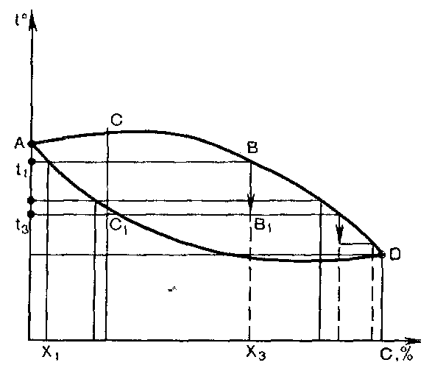

Figure: 14.12. Composition diagram - properties.

Explanation of text

During the distillation process, the composition of the recuperator and the vapor phase gradually changes. As the low-boiling component (ethanol) evaporates from the recuperator, its temperature rises continuously, the steam becomes more and more enriched with the high-boiling component (water vapor), and the content of the low-boiling component decreases. Further distillation makes no sense, since the ethanol concentration in the resulting distillate begins to decrease. For a more complete separation of a mixture of volatile liquids, multiple distillation is used - rectification carried out by countercurrent interaction of vapors formed during the distillation of a liquid and reflux obtained during condensation of vapors. Evaporation and condensation processes are repeated many times and are accompanied by mass and heat exchange,

The rectification process can be traced on the "Composition - properties" diagram, representing the dependence of boiling and condensation temperatures on the composition of liquid and vapor (t -XY) (Fig. 14.12).

The diagram is expressed by two curves connected at two points. Point A - boiling point of water (100 ° C at 101,324.72 N / m2)

Point D is the boiling point of the azeotropic mixture (the liquid phase is in equilibrium with the vapor phase of the same composition). The lower curve is the boiling line, the upper curve is the condensation line. The space under the lower curve represents the area of ​​liquid, above the upper curve, vapor. Between the lines of boiling and condensation there is a two-phase region of liquid and vapor. From the diagram, you can determine the boiling point of an ethamal-water mixture of any composition. To do this, you need a sag g and a vertical to intersect with the boiling line and then project a point on the ordinate axis You can also find the composition of the vapor of any mixture, for which its composition is laid on the abscissa axis and a vertical is drawn from this point until it intersects with the boiling line and further from the point of intersection - horizontal to the condensation line. The abscissa of the found intersection point expresses the desired vapor composition.

The diagram shows that the boiling point of the mixture is below the boiling point of the pure high-boiling component and above that of the pure low-boiling component. As the low-boiling component increases in the mixture, its boiling point decreases. The abscissas of the condensation lines are larger than the abscissas of the boiling line at the same ordinates, i.e., the liquid and vapor phases in equilibrium have different compositions. With partial condensation of the vapor phase, the resulting distillate has a boiling point above the dew point of the vapor.

The C-C1 line, on which the points are located, shows a different degree of vapor condensation from 0 at point C to full - 100% at point C1,

Heating the initial mixture of composition X1 to the boiling point t1, we obtain vapor of composition X3 in equilibrium with the liquid, enriched with a low-boiling component (ethanol). With the partial condensation of this B-B1 vapor, more of the high-boiling component passes into the distillate, and more of the low-boiling component remains in the vapor phase, but the boiling point of the resulting distillate will be lower than the boiling point of the initial mixture. With further partial condensation of steam enriched with a low-boiling component, the resulting distillate will have an even lower boiling point (t3) than the previous one, and the resulting steam will be enriched with a low-boiling component, etc. until an inseparably boiling mixture (azeotrope) is formed.

The rectification process can take place at atmospheric pressure, underpressure to separate high-boiling mixtures and at a pressure higher than atmospheric pressure for mixtures that are in a gaseous state at lower pressures.

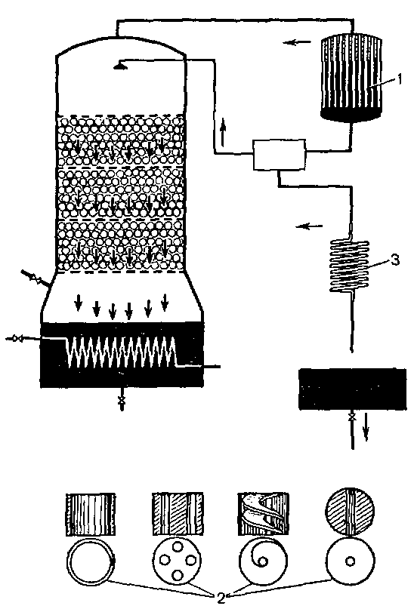

Figure: 14.13. The device of the landing distillation column.

1 - deflector. 2 - iagal. 3 - end cooler

Rectification installations. The rectification process is carried out in installations that consist of a rectification column, a distillation still, a reflux condenser, a condenser-cooler and a distillate collector. The distillation column is a cylindrical apparatus with a height of 15 to 30 m and a diameter of 1 to 6 m.Depending on the internal arrangement, the distillation columns are divided into packed columns (Figure 14.13) and bubble columns, having perforated (Figure 14.14) or cap (Figure 14). 14.15) plates. The purpose of the internal device is to ensure the closest contact of the vapors rising from below with the liquid phase flowing down the column from top to bottom.

The reflux condenser (shell-and-tube heat exchanger) is designed for complete or partial condensation of vapors (when cooled with water at a temperature of 60-80 ° C). The refrigerator is an end condenser in which the distillate is cooled and the vapors that have passed through the reflux condenser and remain in the vapor state are condensed. The recuperate enters the distillation still heated by solid steam and is brought to a boil. The resulting vapors rise upward, enter the distillation column and then into the reflux condenser, from where they return to the upper part of the column in the form of condensate, the so-called reflux.

Packed columns are cylindrical devices. To create a larger surface of phase contact and the intensity of mixing of the liquid and vapor phases, a packing is loaded into them - solids of various shapes: balls, rings, thin-walled cylinders made of ceramics, porcelain, steel. The nozzles are filled in randomly or in regular rows in the form of separate layers, with a height of 1.5 to 3.0 m, between which guide cones are installed. Depending on the mode of movement of liquid and vapor, packed columns can operate with different efficiency. In the first case, when the vapor flow is continuous, and the liquid flows down the packing in a thin film, the contact of the phases is determined by the size of the packing surface. If the movement of vapor is accelerated by bubbling through the liquid, the contact between the phases increases, which leads to the intensification of the mass transfer process. During emulsification, the liquid fills the entire volume of the packing not occupied by the vapor and becomes a dispersion medium, while the vapor becomes a dispersed phase distributed in the liquid, which further increases the degree of separation of the mixture.

|  |  |
| --- | --- |
|  |  |
| Figure: 14.14. Device bzrbotazhkoy, disc column (sieve)  1 - sieve plate;  2 - overflow tube | Figure: 14.15. The device of a bubble, poppet column (cap)  1 - reflux condenser; 2 - cap plate;  3 - end cooler. |

Bubble columns have a number of horizontal partitions - plates. Their mode of operation is somewhat different from packed columns. Steam is distributed in the liquid in the form of bubbles and jets, forming a large contact surface.

The sieve trays have holes with a diameter of 2-5 mm through which steam passes. It bubbles through a layer of liquid on a tray 25-30 mm high, which is supported by the position of the upper ends of the overflow tubes, and from the bottom - by the vapor pressure. The liquid flows to the next tray only through the overflow pipes. The interaction between vapor and liquid occurs at some distance from the bottom of the tray in a layer of foam and spray. For normal operation of the column, it is necessary that the steam has the pressure necessary to overcome the hydrostatic resistance of the liquid on the tray. If the vapor pressure is insufficient, the liquid will drain through the holes and flood the column.

Cap trays are equipped with caps covered on top. Steam passes through a layer of liquid, the level of which on the tray is maintained by overflow tubes. The lower ends of the tubes are lowered under the liquid level of the next tray, thereby creating a water seal that prevents steam from passing through them. The columns differ in the number of caps on the tray. The bubble columns provide a fairly good separation of the mixture.

Rectification plants, regardless of the design of the columns, can be either batch or continuous.

In batch distillation columns, the entire mixture is loaded into a cube, where it is kept at a constant boil. Steam enters the column, refluxed with reflux, it is strengthened. Another part of the distillate from the reflux condenser and the end condenser, cooled to a certain temperature, enters the collection of the finished product. The rectification is continued until the liquid in the still reaches the specified composition. After that, the heating of the cube is stopped, the residue is removed, and the cube is loaded with a new mixture. At the beginning of the process, vapors rich in a low-boiling component enter the column. During this period, a large amount of reflux must be supplied to the column in order to isolate the high-boiling component contained in the vapors from the vapors. During the process, the still liquid is depleted in the low-boiling component, and the vapors are increasingly enriched in the high-boiling one. In this regard, to obtain a distillate of constant composition, it is necessary to increase the amount of reflux. If it is left constant, then the concentration of the low-boiling component (ethanol) in the distillate will decrease.

The disadvantages of batch columns are: deterioration in the quality of the finished product and heat loss during loading and unloading of the cube.They are eliminated in continuous distillation columns, consisting of two lower parts, in which the low boiling point component is separated from the reflux flowing down, and the upper reinforcing, purpose which to enrich the rising vapor columns of the low-boiling component

The initial mixture is heated to boiling and continuously at a certain rate enters the exhaustive part of the column, then into the reflux condenser, from which the same amount of reflux of constant composition is supplied to the upper part of the column.

The interaction of vapor and liquid on the trays of the distillation column can be traced on the "Composition-properties" diagram (Figure 14.16). Steam A from the still, having a temperature low temperature - 1V, steam is partially condensed. Due to the released heat of condensation, the liquid on the plate boils. The resulting steam contains more low-boiling component than the steam rising from the bottom. Its composition corresponds to the position of point D, and the temperature - tВ. The reflux enriched with the high-boiling component at the moment of equilibrium of the system A has a temperature equal to the temperature of the vapor, its composition corresponds to the point E, the composition of the vapor will be YD, and the reflux will be XE. On the next plate, the process is repeated. Steam comes out from the last plate at the top of the column,

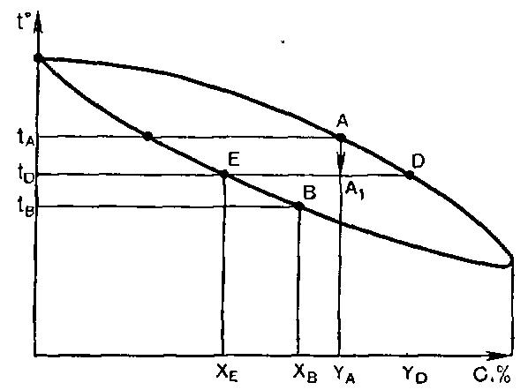

Figure: 14.16. Composition diagram - properties

Explanation in the text.

In addition to the column apparatus, for rectification, rotary apparatus with different designs of contact devices can be used: film, drop-jet, combined, etc. They operate in the regime of turbulent flows of vapor and liquid phases, at atmospheric pressure and under vacuum. In rotary film rectifiers, mass transfer occurs between rotating and non-rotating cylinders, the wall of the apparatus and the rotor, on the surface of the film and drops. In drop-jet devices, steam interacts with a liquid in a finely dispersed state. The maximum contact surface of the phases in such devices is carried out by repeated deformation of liquid droplets. The contact device of these devices can be smooth conical discs, from which the liquid flows into the center of the rotating baskets with a perforated surface. Under the action of centrifugal force, the liquid rises along the surface of the basket and is sprayed through the holes in the form of drops and jets. Striking against the body of the device, it flows down to the center of the lower basket. The vapor rises through the curtain of liquid droplets. Apparatus are proposed in which the cones are installed on the inner side of stationary and on the outer side of rotating cylinders, which ensures multiple deformation of liquid droplets and improves the turbulent motion of vapor passing through the liquid in different directions. The vapor rises through the curtain of liquid droplets. Apparatus are proposed in which the cones are installed on the inner side of stationary and on the outer side of rotating cylinders, which ensures multiple deformation of liquid droplets and improves the turbulent motion of vapor passing through the liquid in different directions. The vapor rises through the curtain of liquid droplets. Apparatus are proposed in which the cones are installed on the inner side of stationary and on the outer side of rotating cylinders, which ensures multiple deformation of liquid droplets and improves the turbulent motion of vapor passing through the liquid in different directions.

Rotary rectifiers are characterized by compactness, high productivity, low hydraulic resistance and the ability to use in non-stationary conditions.

Characterization of fortified and absolute ethanol. When rectifying recuperators, purified and fortified ethanol of any strength is obtained - up to 97.18% (95.57% by weight), the density of which is 0.8025, the boiling point is 78.12 ° C. Sometimes ethanol contains volatile impurities, to remove which it is treated with activated carbon. When diluted with water to a concentration of 96.2-96.4%, ethanol recuperator is obtained, which is unlimitedly used in pharmaceutical production.

For analytical work, chemical synthesis of medicinal substances at the purification stage, absolute ethanol is used, its boiling point is 78.5 ° C (78.37 ° C), density is 0.78927 Absolute ethanol is obtained by distillation of a water-ethanol solution under reduced pressure or in presence of the third component (benzene) A mixture of benzene with water boils at a temperature lower than that of ethanol-water, which makes it possible to separate the components. Strong rectifications are subjected to dehydration using water-dehydrating agents, distillation over sodium or metal potassium, boiling for several hours with anhydrous copper sulfate.