**Extracts (Extracta)**

According to the general article of the GF XI ed. "Extracts", extracts are concentrated extracts from medicinal plant materials.

According to Professor I.A. Muravyov, extracts are called concentrated or condensed liquid by partial or complete removal of the extractant, aqueous, hydroalcoholic, alcoholic or ethereal extracts of biologically active substances of plant origin.

*Depending on the amount of the remaining extractant (by consistency), there are:*

1. Liquid extracts (Extracta fluida) - liquid concentrated extracts containing the extractant in the original concentration.
2. Thick extracts (Extracta spissa) - viscous masses that do not pour out of the vessel and stretch into threads (contain up to 25% moisture).
3. Dry extracts (Extracta sicca) - bulk masses, contain up to 5% moisture.

*By the nature of the extractant used, they are distinguished:*

1. Water extracts (can only be thick or dry, since water is microbiologically unstable).
2. Alcohol extracts:

* ethanol-based can be liquid, thick, dry;
* based on other alcohols (amyl, propyl, methyl) can only be dry and thick, since these alcohols are toxic and must be removed.

1. Essential extracts (can only be thick, since lipophilic substances are not removed to a dry residue).
2. Oil extracts.

Most of the extracts belong to the group of alcoholic ones based on ethyl alcohol.

The State Register 2004 includes 67 extracts, including:

* 26 - liquid;
* 10 - thick;
* 22 - dry;
* 9 - standardized extracts-concentrates.

**Liquid extracts**

For a long time, a distinctive feature of liquid extracts was that they were prepared 1: 1. Currently, there are no such strict restrictions, the evaluation criterion is not the raw material: drug ratio, but the BAS content in the liquid extract and the high depletion of raw materials. The ratio of raw materials: finished product in the production of liquid extracts is usually 1: 1 or 1: 2.

Advantages of liquid extracts as a dosage form:

1. Easier to make than thick and dry ones.
2. When obtaining liquid extracts, biologically active substances do not undergo any changes, that is, they are in a natural state.
3. Convenient dosing (classic extracts!).

Disadvantages of liquid extracts as a dosage form:

1. High saturation with ballast substances.
2. Inconvenience in transportation.

Liquid extracts are classified according to the main biologically active substances that provide the effect of this extract, i.e. liquid extracts containing:

* alkaloids (liquid jaundice extract);
* flavonoids (liquid hawthorn extract);
* saponins (liquid leuzea extract);
* vitamins (nettle extract liquid);
* anthracene derivatives (buckthorn extract liquid), etc.

Ethanol is used as an extractant in the production of liquid extracts in a concentration of 20 to 70%, which depends on the properties of the biologically active substances to be extracted.

**Technological scheme for obtaining liquid extracts**

**Additional Stage (AS) - 1.** Sanitary preparation of production

**(AS) - 1.1. Preparation of industrial premises**

**(AS) - 1.2. Processing equipment**

**(AS) - 1.3. Sanitary preparation of technological clothing**

**(AS) - 1.4. Sanitary training of personnel**

**TS - 2.** Preparation of raw materials and extractant

**TS - 2.1. Grinding raw materials**

**TS - 2.2. Ethanol dilution**

**TS - 3. Extraction (extraction of biologically active substances) or dissolution of dry or thick extracts**

**TS - 4. Cleaning Extraction**

**TS - 5. Standardization**

**TS - 6. Packing, packaging, marking**

**TS - 7. Ethanol recovery**

**AS stages - 1** (Preparation of premises, equipment, personnel) and BP - 2 (Preparation of raw materials and extractant) are carried out similarly to tinctures.

**TS - 3. Extraction.**

For the extraction of biologically active substances in the production of liquid extracts, methods are used that make it possible to obtain concentrated extracts.

**Percolation** (filtering through the medicinal plant layer at a certain speed).

Unlike tinctures, percolation is carried out not until the depletion of raw materials, but up to 85 parts by volume of the extraction. Then the percolation is continued in another receiver until the depletion of the raw material. The second extract is evaporated under vacuum (temperature not higher than 50-60 ° C) to a thick mass, which is added to the first extract and brought to 100 parts by volume, as a result, an extract is obtained in a 1: 1 ratio.

**2.**Repercolation. This method is preferable for obtaining liquid extracts, since it allows one to obtain concentrated extracts without evaporation. The required concentration of biologically active substances in the extraction is achieved by using a battery of 3-6 percolators in which the raw material is placed. Moreover, fresh extractant is poured only into the first percolator, and the extraction of biologically active substances in all subsequent percolators is carried out using extracts obtained in the previous percolators. The finished product is considered to be a mixture of overflows from the last percolator or one continuous overflow from the last percolator. The schematic diagram of the repercolation is shown in Fig. 1.

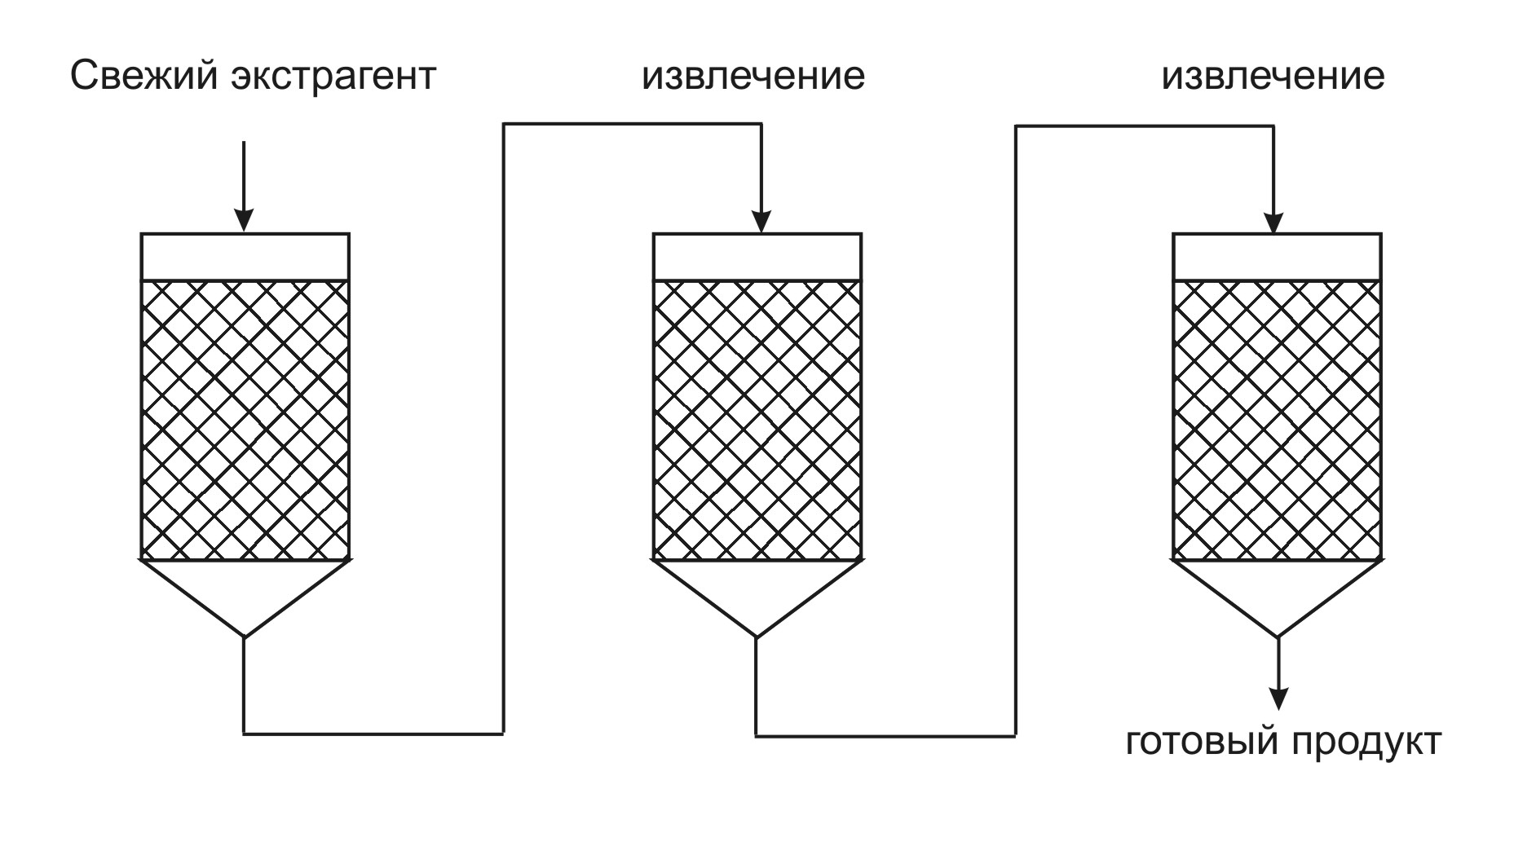

Figure: 4. General scheme of the repercolation process

Varieties of repercolation with periodic supply of the extractant and periodic collection of portions of the extraction are called stepwise or counter-current multistage extraction.

The most common in the production of liquid extracts are:

*Repercolation according to Belova*

It is carried out in a battery of 3 percolators. It is used for the extraction of light raw materials, that is, raw materials with a low bulk density (leaves, grass, flowers, etc.). To provide a "mirror" over the surface of the raw material, the extractant is used not in III, but in II reception.

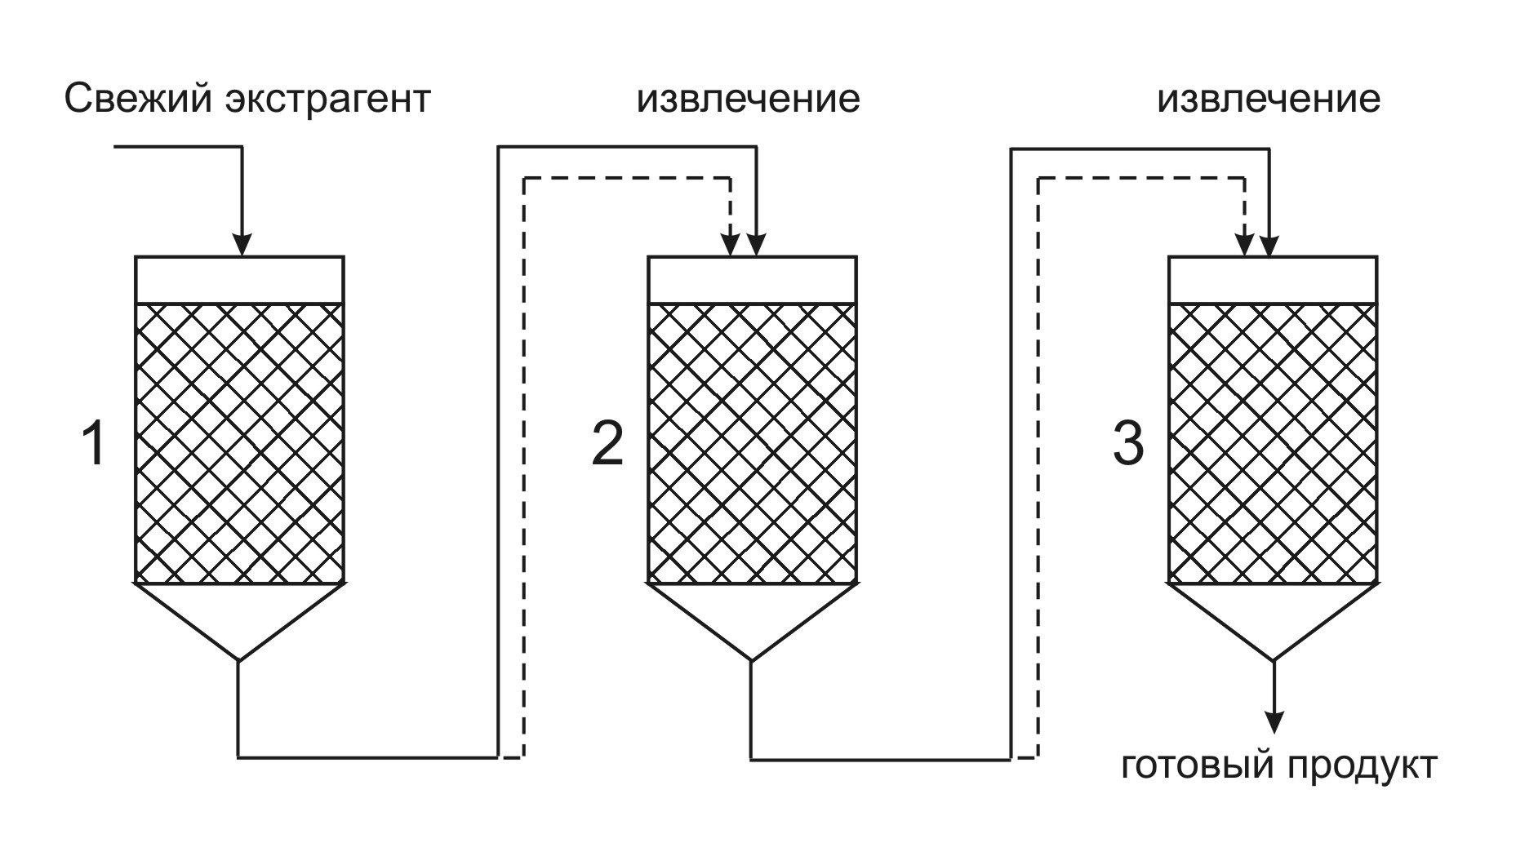

Figure: 5. Repercolation according to Belova

*Repercolation according to N.A. Chulkov*

This method is used to extract raw materials with a large bulk density (bark, roots, some types of herbs). The number of inhalations of "fresh" extractant is equal to the number of percolators in the battery (for a description of these extraction methods, see section VII "Extraction Methods".

Liquid extracts can be prepared by dissolving thick or dry extracts. It is currently used to obtain liquid buckthorn extract.

**Stage - 4. Cleaning the extraction.** The main method of purification of extracts when obtaining liquid extracts is settling at a low temperature (not higher than 10 0 С). The extracts are settled in cylindrical stainless steel tanks. The settling process is carried out until the precipitation ceases, usually 3-4 days, but not less than 2 days according to the GF XI ed., OFS "Extracts".

During settling, mechanical inclusions and IUDs precipitate, the solubility of which decreases with decreasing temperature. The extraction after settling is drained from the sediment and filtered through Druk filters, press filters, i.e. filters operating under pressure. Vacuum filters cannot be used in this case, as the loss of valuable extractant may occur.

There is evidence that sedimentation is best carried out in the presence of adsorbents.

**TS - 5. Standardization.** Standardization is the establishment of compliance with the requirements of a standard (FS, FSP) or the establishment of uniformity of products. Standardization of liquid extracts is regulated by OST 91500.05.001-00 “Quality standards for drugs. Basic Provisions ", according to which the following quality indicators are mandatory for liquid extracts:

1. Description (color, smell, transparency).

2. Authenticity (qualitative reactions, chromatographic analysis, UV spectrum).

3. The content of ethanol (the determination of this indicator is carried out by the boiling point or by the distillation method according to the RPh).

4. The content of biologically active substances (carried out by a chemical, physical-chemical, or biological method). The biological method is used if cardiac glycosides are contained, the activity is expressed in feline action units (ICU), or feline action units (CUU).

5. Dry residue (method RPh).

6. The content of heavy metals (method RPh). In liquid extracts, this indicator should not exceed 0.01%.

7. Microbiological purity. Liquid extracts should not contain more than 104 aerobic bacteria, 102 yeasts and molds, enterobacteria not more than 102. In the absence of Salmonella, Escherchia coli, Pseudomonas aeruginosa, Staphylococcus aureus.

*If the liquid extract does not answer for any of the indicators, then it is brought to the standards of the standard, while:*

1. If the liquid extract is not transparent, then it is filtered and checked for compliance with other indicators.

2. In case of inconsistency in ethanol content, strengthening or dilution is possible. It is better to use a similar extract with a deviation of the indicator in the other direction, so that there is no deviation in the content of biologically active substances

3. If the content of biologically active substances or dry residue does not match, it is possible:

- strengthening or dilution with a similar extract that has a deviation in the other direction;

- re-extraction using additional portions of raw materials.

4. If the content of heavy metals and microbiological purity is exceeded, liquid extracts are discarded with the identification of the reasons for exceeding this indicator, since these impurities can pass into the preparation from raw materials, equipment, extractants.

**TS - 6. Ethanol recovery**

Extraction of ethanol from waste raw materials is carried out:

- receiving wash water;

- by distillation.

These methods are described in detail in the methodological development of the department on the topic "Alcoholometry".

**TS - 7. Packing, packaging, marking.**Packing of liquid extracts is carried out using filling filling machines, piston filling machines in bottles and flasks made of glass OS (medical light-protective). Packaging and labeling of tinctures are carried out in accordance with the law of the Russian Federation No. 86-FZ "On Medicines" and GMP rules.

**Storage of liquid extracts**

The storage of liquid extracts is carried out in compliance with all principles of storage of medicines:

* by pharmacological groups;
* by toxicological groups;
* by state of aggregation;
* by type of LF;
* by physical and chemical properties.

A feature of the storage of liquid extracts, based on the physical and chemical properties, is storage in a cool, but not below 8 ° C, protected from light place. During storage of liquid extracts, precipitation is possible. The precipitate is allowed to be filtered, and if the extract meets the requirements of the standard, it can be used.

**Thick (soft) extracts**

A specific group of extracts produced mainly from plants containing bitter, bitter aromatic or sweet substances (moisture content no more than 25%).

Thick extracts have a high viscosity, therefore, they are used as auxiliary substances in the manufacture of pills, as well as in the manufacture of other preparations (thick licorice root extract for making a breast elixir; thick nettle extract for making Allochol tablets; thick valerian extract for making valerian tablets, etc.).

In the GR 2004 year 10 thick extracts included.

Thick extracts are classified according to the content of a certain group of biologically active substances (Table 3).

**Table 3**

**Classification of thick extracts by BAS**

|  |  |
| --- | --- |
| The main biologically active substances | Representatives of thick extracts |
| Alkaloids  Saponins  Bitter glycosides  Bitter glycosides and essential oils  Phenolic compounds  Vitamins  Organic acids and essential oils  Phytoncides  Capsaicins  Iridoids, flavonoids | Belladonna extract thick (Betiol candles)  Licorice extract thick  Dandelion extract thick  Wormwood extract thick  Male fern extract thick  Nettle extract thick (Allohol tablets)  Valerian extract thick  Garlic extract thick  Capsicum extract thick  Thick water shamrock extract |

**Technological scheme for obtaining thick extracts**

**AS - 1.** Sanitary preparation of production

**AS - 1.1. Preparation of industrial premises**

**AS - 1.2. Processing equipment**

**AS - 1.3. Sanitary preparation of technological clothing**

**AS - 1.4. Sanitary training of personnel**

**AS - 2.** Preparation of raw materials and extractant

**AS - 2.1. Grinding raw materials**

**AS - 2.2. Ethanol dilution**

**TS - 3. Extraction**

**TS - 4. Cleaning Extraction**

**TS - 5. Thickening of the extraction**

**TS - 6. Standardization**

**TS - 7. Packing and packaging**

**TS - 8. Waste processing**

Stages **AS** - 1 (Sanitary preparation of production) and **AS** - 2 (Preparation of raw materials and extractant) is carried out similarly to tinctures and liquid extracts.

**TS - 3. Extraction.** *The following are used as extractants in the preparation of thick extracts:*

1. Purified water.

To inactivate enzymes and increase microbiological resistance, water usually has an elevated temperature. Preservatives are often added to water, which also increases microbiological resistance (0.5% chloroform, chloroetone, etc.). Acids and alkalis are often added to water to convert sparingly soluble compounds into readily soluble salts.

1. Water-ethanol mixtures of various concentrations (usually 70% ethanol).
2. Volatile organic liquids (ethyl ether, dichloroethane, carbon tetrachloride).
3. Liquefied carbon dioxide.

*The following extraction methods are used to extract biologically active substances:*

1. Remaceration.
2. Percolation (in contrast to liquid extracts, this method is carried out in the same way as for tinctures without separation into primary and secondary extracts).
3. Repercolation (the most commonly used method is fast repercolation).

4. Circulation.

The circulation is carried out using a volatile organic extractant. Currently, this method is used to obtain a thick male fern extract.

1. Continuous countercurrent extraction.

All of these extraction methods are described below in section VII "Extraction Methods".

**TS - 4. Purification of extracts.** The choice of the method for purifying the extracts depends on the extractant used.

*Purification of water extracts*

The purification of water extracts is the most difficult because the water removes a large amount of ballast substances. The following methods are used to purify water extracts:

* denaturation (carried out by boiling at atmospheric pressure by evaporation of the extraction to 1 / 2-1 / 4 of the volume, while proteins and mucus coagulate and precipitate, which is filtered);
* adsorption (carried out by infusion or boiling with adsorbents: talc, bentonite, kaolin, aluminum oxide, activated carbon, crushed filter paper, followed by settling and filtering).
* alcohol purification (when cleaning by this method, the extraction is evaporated to 1/2 part of the feedstock, strong ethanol is added (96%, but not less than 60%), as a result of the dehydrating properties of ethanol, the IUDs lose their protective hydration shell and precipitate, after which they are defended (not higher than 10 0С) and filtered).

*Purification of water-ethanol extracts*

If water-ethanol mixtures of low concentration are used as an extractant, then it is possible to use all the above cleaning methods. In addition, the solvent exchange method can be used. For example: water is added to the water-ethanol extraction, while lipophilic substances (chlorophyll, resinous substances) precipitate.

*Purification of ether extracts*

Purification of ether extracts is not carried out, since ether and similar solvents extract only lipophilic substances.

**TS - 5. Extraction thickening.**

It is carried out in vacuum evaporators at a temperature of 50-60 ° C, which allows you to preserve thermolabile components.

**TS - 6. Standardization.**

Standardization of thick extracts is carried out according to the same parameters as liquid extracts, plus moisture content (no more than 25%).

With an increased content of biologically active substances, thick extracts can be diluted with dextrin, sugars, molasses. With a reduced content of biologically active substances, thick extracts should be mixed with an extract with a high content of biologically active substances.

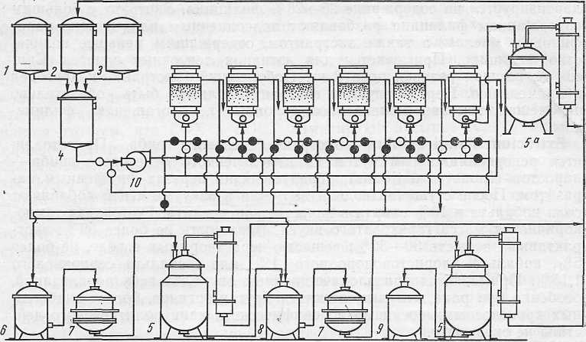The instrumental scheme for obtaining thick extracts is shown in Fig. 6.

Figure: 6 Apparatus scheme for obtaining thick extracts

(I.A.Muraviev, 1980)

I-VI - percolators

1 - measuring tank for alcohol; 2 - measuring tank for distillation, 3 - measuring tank for water; 4 - mixer, 5 - vacuum apparatus, 6 - collection, 5 a - distillation apparatus, 6 - collection, 7 - filter, 8 - settler, 9 - collection of finished product, 10 - pump.

**TS - 7. Packing and packaging.** Packing of thick extracts is carried out in wide-necked hermetically sealed dark glass flasks.

The storage of thick extracts is carried out in compliance with the general rules for storing. A special feature of storing thick extracts is hermetically sealed cork, since at high air humidity they can become moldy, and at low air humidity they can turn into a solid mass.