1.Density of a water-alcohol solution depending on temperature and relative alcohol content (by weight)

2. Density of a water-alcohol solution depending on temperature and relative alcohol content (by volume) at a temperature of plus 20 ⁰С

3.Relative alcohol content (by volume) depending on the reading of the glass alcohol meter and the temperature of the solution

***Explanations for the use of table. 3***

Tab. 3 expresses the relationship between the readings of the glass alcohol meter, temperature and volumetric alcohol content. In the first and last columns of table. 3 the temperature values ​​are indicated at an interval of 1 degree from +40 to -25 ° C. In the remaining columns of table. 3 shows the volumetric alcohol content for the corresponding readings of the glass alcohol meter.

***Example 1.***Determine the volumetric alcohol content in the solution, if at a temperature of +5 ° C the glass alcohol meter reading is 83.5%.

According to the table. 3 at the intersection of the column 83.5% and line +5 find that the desired alcohol content in the solution is 87.64%.

***Example 2.*** Determine the volumetric alcohol content in the solution, if at a temperature of +18 ° C the reading of a glass alcohol meter is 94.4%.

According to the table. 3 find that an alcohol meter reading of 94.5% at a temperature of +18 ° C corresponds to a volumetric alcohol content of 94.93%, and an alcohol meter reading of 94.0% at the same temperature corresponds to a volumetric alcohol content of 94.44%. The desired alcohol content X is found from the proportion

https://img.wikireading.ru/226654_20_i_118.png

***Example 3.***Determine the volumetric alcohol content in the solution, if at a temperature of +17.64 ° C the reading of a glass alcohol meter is 93.75%.

Write out from the table. 3 four values ​​of alcohol content for the nearest whole degrees of temperature and readings of a glass alcohol meter.

An auxiliary table is compiled according to the form below, where A is the volumetric alcohol content in the solution, corresponding to an alcohol meter reading of 94% and a temperature of +17.64 ° C; B - the same, but corresponding to the indication of the alcohol meter 93.5% at the same temperature; x is the desired alcohol content,%.

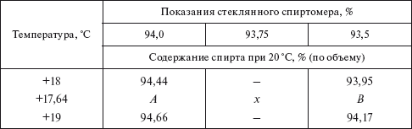

To find A, B and x, using the auxiliary table, the following proportions are made:

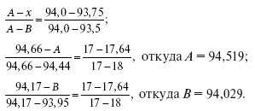

Substituting the found values ​​of A and B into the first proportion, x = 94.27%.