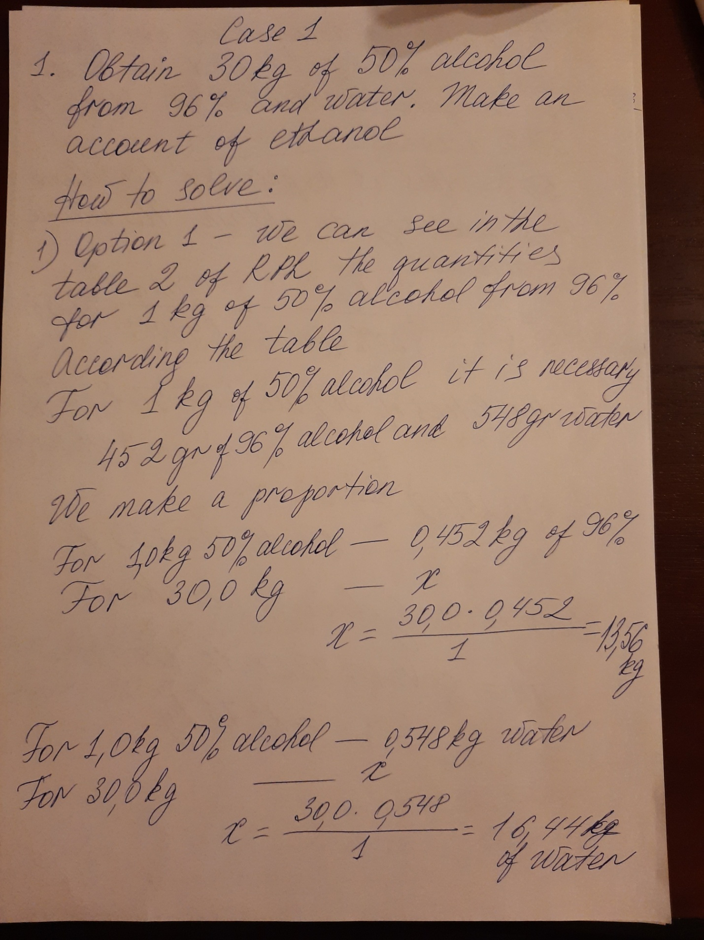

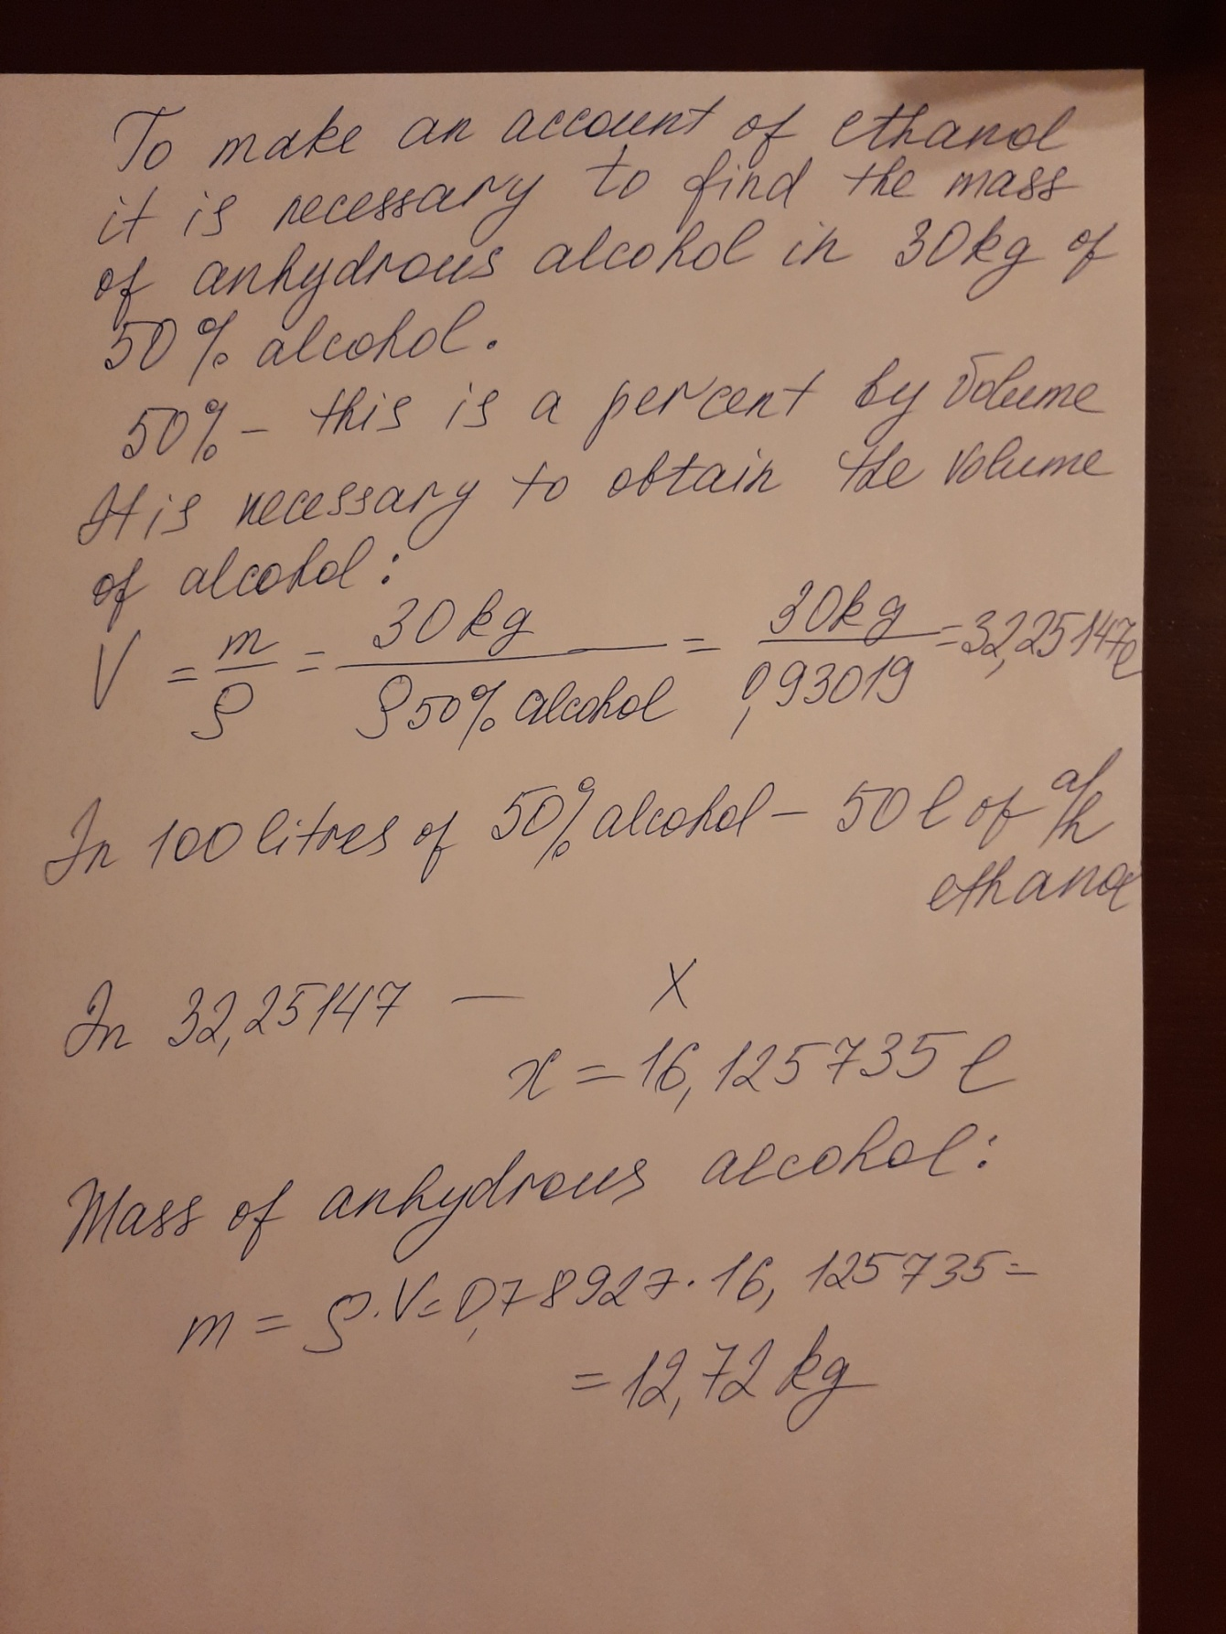

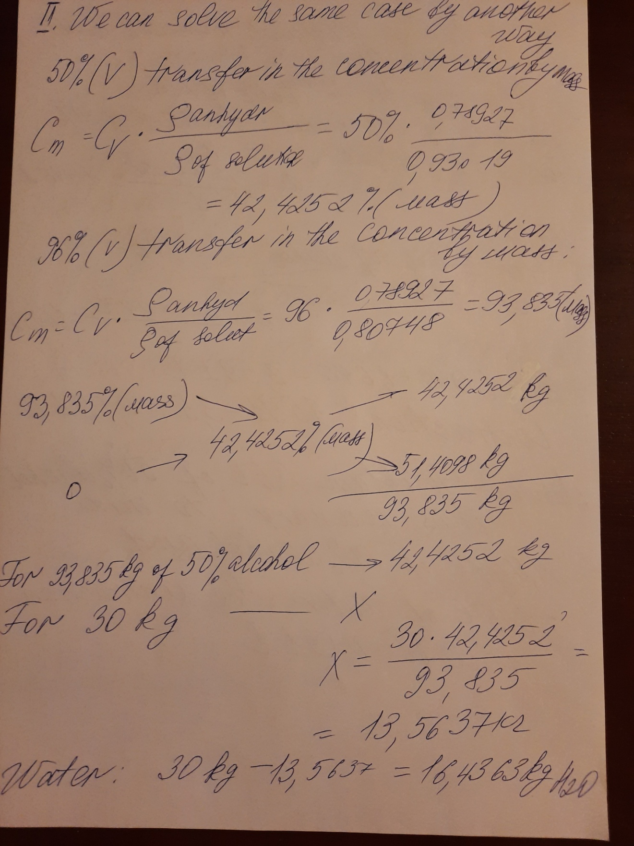

Answer : To obtain 30 kg of 50% alcohol it is necessary to mix 13,56 kg of 96% alcohol and 16,44 kg of water, mass of anhydrous ethanol will be 12,72 kg

