**Practical work**

**Obtaining tinctures from medicinal plant materials by maceration**

The work is carried out in subgroups in the form of research work "Influence of the absorption coefficient (K consumption) On the volume of the obtained extraction". Students receive tinctures from various types of medicinal plants by maceration.

**Stages of practical work**

1. Draw up a technological scheme for the production of tinctures.

2. Make up a working formula for obtaining 50.0 tinctures, taking into account K absorption (the first subgroup K = 1.5, the second subgroup K = 1.2).

3. Prepare medicinal plant materials for extraction (grinding, sieving).

4. To obtain a given volume of extractant of the required concentration from 95%.

5. Get tincture (work in subgroups) by maceration method.

After receiving the tincture by the maceration method, students drain the resulting tincture, purify and standardize it.



Figure: 1. Hardware scheme for obtaining tincture:

1 - mill for grinding belladonna leaves; 2 - sieve shaker; 3, 4, 5, 10 - measuring tanks for water, alcohol and filtered ready-made tincture; 6 - maceration tank; 7 - percolator; 8 - sump; 9 - filter press; 11 - containers for collecting and pouring the finished tincture; 12 - distillation apparatus for the rectification of alcohol from the recuperator; 13 - refrigerator; 14 - collection-receiver of alcohol.

**Description of the technological process of obtaining tincture by maceration**

A gauze napkin is placed on the bottom of the glass percolator, which prevents the clogging of the drain hole of the percolator with vegetable raw materials. Crushed medicinal plant materials are loaded into a percolator, lightly tamped with a wooden stick. The extractant is diluted to a predetermined concentration and most of it is poured into a percolator. Insist at room temperature with periodic stirring of raw materials for 7 days. After the end of the extraction period, the tincture is drained, the residue is wrung out and washed with the remaining amount of the extractant, it is squeezed out again, and the wrung out tincture is added to the original drain. The volume of the obtained tincture is measured and a conclusion is made about the correspondence of the consumption coefficient.

If necessary, the extract is brought up to the specified volume with the extractant.

***Educational laboratory regulations for obtaining motherwort tincture (Tincturae Leonuri) 1: 5 by the method of classical maceration***

**Section I**

***Characteristics of the finished product***

Transparent liquid of greenish-brown color, weak aromatic odor, bitter taste. Density not less than 0.900. Dry residue not less than 1.4%. The ethyl alcohol content is not less than 64%.

Motherwort tincture ***(Tincturae Leonuri)*** must meet the requirements of RPh.

Available in dropper bottles or dark glass bottles of 25, 40 and 50 ml. Store in a cool, dark place.

Motherwort tincture ***(Tincturae Leonuri)***  is used as a sedative and lowering blood pressure in hypertension.

**Section II**

***Characteristics of raw materials***

|  |  |  |
| --- | --- | --- |
| name of raw materials | Properties | NTD |
| Grass  motherwort  Alcohol  ethyl  Water  cleared | Pieces of stems, leaves and inflorescences ranging in size from 1 to 8 mm... The smell is weak, the taste is bitter. Extractive substances not less than 10%; moisture not more than 13%, total ash not less than 12%, organic impurities not more than 2%, mineral impurities not more than 1%  Transparent, colorless, mobile, volatile liquid with a characteristic alcoholic odor and a burning taste. Boils at a temperature of 78 oС. Highly flammable, burns with a bluish flame. Density 0.812-0.808, which corresponds to the content of С2Н5ОН 95 - 96%  Colorless transparent liquid, odorless and tasteless. pH = 5.0 - 6.8. The dry residue should not exceed 0.001%. Water should not react to chlorides, sulfates, calcium and heavy metals | RPh  RPh  RPh |

**Section III**

***Production hardware diagram***

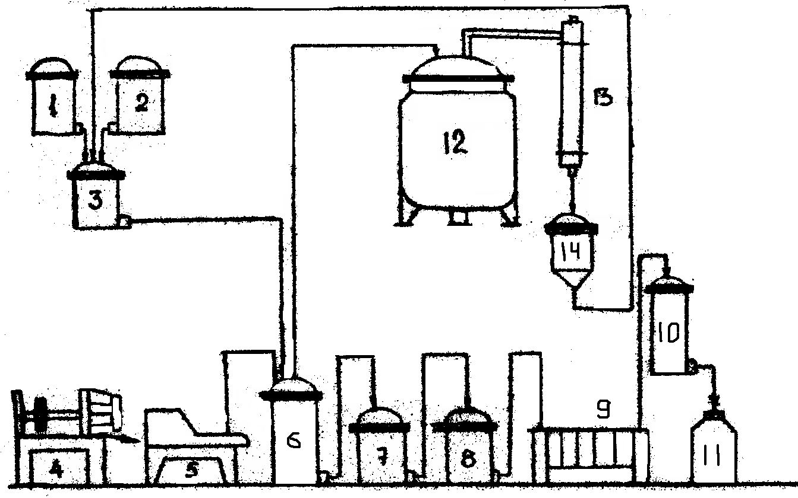

1. - measurer for water; 2 - measuring tank for alcohol; 3 - mixer; 4 - mill; 5 - sieve; 6 - tank for soaking and extraction; 7 - collection; 8 - sump; 9 - filter; 10 - collection; 11 - bottle; 12 - apparatus for distilling alcohol; 13 - refrigerator; 14 - receiver.

**Section IV**

***Description of the technological process***

For production 1 l motherwort tincture 1: 5 on 70% ethyl alcohol according to the State Pharmacopoeia you need to take:

motherwort herbs (Herba Leonuri) 200.0 g

ethyl alcohol 70% to 1 l...

The production process of motherwort tincture ***(Tincturae Leonuri)*** consists of 7 technological stages:

BP - 1. Sanitary preparation of production.

BP - 1.1. Preparation of premises.

BP - 1.2. Equipment preparation.

BP - 1.3. Air preparation.

BP - 1.4. Preparation of technological clothing.

BP - 1.5. Staff training.

ВР - 2. Preparation of raw materials and extractant.

TP - 3. Obtaining extraction (extraction).

TP - 4. Cleaning the extraction.

TP - 5. Standardization of the tincture.

ULV - 6. Packing, packaging and labeling.

PO - 7. Recovery of ethyl alcohol.

ВР - 1. The stage "Sanitary preparation of production" in laboratory conditions consists in the sanitary preparation of students (putting on a dressing gown, hats, washing hands); organization of the workplace; selection of the necessary utensils, weighing equipment, auxiliary and sealing materials.

ВР - 2. The stage "Preparation of raw materials and extractant" consists of the following technological operations.

BP - 2.1. Preparation of raw materials.

The raw material is thoroughly crushed with scissors to the appropriate particle size.

BP - 2.2. Extractant preparation.

The required volume of the extractant is obtained by mixing the calculated amounts of high concentration ethyl alcohol and purified water. When calculating, the phenomenon of contraction must be taken into account.

TP - 3. Obtaining extraction (extraction).

The crushed raw material is placed in a sealed vessel and poured with the calculated amount of the extractant (in this case, a "mirror" of the extractant must be provided over the raw material) and infused at a temperature of 18-20 oС, periodically shaking and stirring for 7 days. After insisting, the extract is drained. The rest of the raw material is squeezed out, the remaining meal is washed with a small amount of extractant and squeezed out again. The pressed extract is added to the original merged extract.

TP - 4. The "Extraction cleaning" stage consists of the following technological operations:

TP - 4.1. Defending.

The resulting motherwort tincture is mixed and left to settle for 3 days at a temperature not exceeding 8 oС (until the precipitation stops).

TP - 4.2. Filtration.

The tincture is filtered into a tempering bottle through a funnel with a triple layer of gauze and long-fiber cotton wool.

# TP - 5. Standardization of tinctures

The standardization of motherwort tincture is set out in section VII of this laboratory regulation "Analysis of the finished product" and in laboratory conditions is carried out according to the following indicators: description, authenticity, alcohol concentration, dry residue, content of heavy metals. It should be remembered that currently, according to the OST “Quality Standards for Medicines. Basic Provisions "No. 91500.05.001-00 obligatory indicators of the quality of tinctures, in addition to those listed, are such indicators as authenticity, quantitative content and microbiological purity.

ULV - 6. The “Packing, packaging and labeling” stage consists of the following technological operations:

UMO - 6.1. Preparation of glass containers.

In laboratory conditions, this operation is performed by laboratory assistants of the department.

UMO - 6.2. Spill of tincture.

In laboratory conditions, this operation is combined with the filtration stage.

UMO - 6.3. Registration.

On a bottle filled with filtered products, a label is attached indicating the surname, name, patronymic of the student, the name of the drug, its quantity and date of manufacture. The bottle is sealed and handed over to the teacher with a completed report.

PO - 7. Recovery of ethyl alcohol.

It will be discussed in detail in Section V "Production Wastes".

**Section V**

***Waste production***

Waste raw materials (meal) are washed several times with purified water. The wash water comes as a by-product. Measure the volume of rinsing water (to compile the material balance). The meal is disposed of.

**Section VI**

***Safety engineering***

Motherwort tincture is prepared in a training laboratory in compliance with safety instructions, labor protection and fire-fighting measures.

**Section VII**

***Analysis of the finished product***

Motherwort tincture is analyzed according to the following indicators: authenticity, alcohol concentration, dry residue and heavy metals.

1. Authenticity:

2 ml of the drug is evaporated in a porcelain cup to almost dryness; the residue is dissolved in 2 ml of water with stirring with a glass rod and filtered through 1-1.5 g aluminum oxide "for chromatography" of the second degree of activity, which is then washed with 0.5 ml of water.

To 1 ml of the filter add 1 ml of 95% alcohol, 5 drops of a solution of n-dimethylaminobenzaldehyde in concentrated sulfuric acid and heat in a boiling water bath for 1 min; a blue-green color appears. To the resulting mixture, add 1.5 ml of chloroform, 3-4 drops of water and shake; the chloroform layer turns red-violet.

To 0.5 ml of the same filter add 0.5 ml of a 2% alcohol solution of vanillin, 5-7 drops of concentrated sulfuric acid and heat in a boiling water bath for half a minute, a red color appears.

2. Concentration of alcohol, dry residue and heavy metals.

**Determination of alcohol concentration**

**by boiling point**

Under laboratory conditions, a device is used consisting of an external test tube a, an internal test tube b, a capillary c, an alcohol-containing mixture e, glycerin e, an electric stove g and a thermometer g with a graduation value of 0.1 ºС.

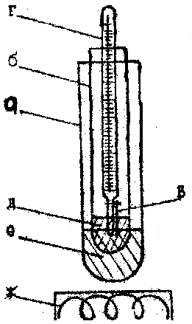

Figure: 1. Device for determining the concentration of alcohol

by boiling point:

a - external test tube; b - inner tube; c - capillary; g - thermometer; e - alcohol-containing mixture; e - glycerin; w - electric stove.

3 ml of an alcohol-containing mixture is poured into the inner test tube, into which a thermometer with an attached capillary is placed so that the open end of the capillary is immersed in the liquid. Glycerin is poured into an external test tube. The entire system is heated on an electric stove until the liquid in the inner tube boils. The boiling point at which the liquid will be sucked into the capillary is noted. Since the boiling point depends on atmospheric pressure (pressure change by1 mmrt. Art. entails a change in the boiling point by 0.04 ºС), when carrying out the calculations, the correction for the boiling point is added to the thermometer reading if the pressure is below atmospheric, and subtracted if the pressure is higher.

Tkip = Tkip. expert. + (760 - Ratm.) × 0.04.

Correspondence of alcohol concentration to boiling point, see table GF XI, p. 28.

**Determination of dry residue**

5 ml of the tincture is placed in a weighed bottle, evaporated in a water bath and dried in an oven for 2 hours at a temperature of 100-105 ºС, then the bottle is cooled in a desiccator   
(30 min) and weighed on an analytical balance to the fourth decimal place. The calculation of the dry residue in percent is carried out up to the second decimal place.

**Determination of heavy metals**

5 ml of tincture is evaporated to dryness in a water bath, 1 ml of concentrated sulfuric acid is added, carefully burned and ignited.

The resulting residue is treated with heating with 5 ml of a saturated solution of ammonium acetate, filtered through an ashless filter, washed with 5 ml of water and the filtrate is brought to a volume of 100 ml with water, 10 ml of the resulting solution must withstand the test for heavy metals (no more than 0.001%).

Note. After completing the work, an analysis table (table 1) and material balance (table 2) are drawn up. The main technological characteristics are calculated. A conclusion is made on the work.

Table 1

Quality indicators of the manufactured dosage form (specification)

|  |  |  |  |
| --- | --- | --- | --- |
| P / p No. | Quality indicator name | NTD | Experimental |
| 1.  2.  3.  4. | Description  Authenticity  Ethyl alcohol concentration  Dry residue  Heavy  metals |  |  |

table 2

Material balance

|  |  |  |  |
| --- | --- | --- | --- |
| Coming | m, g | Consumption | m, g |
|  |  |  |  |
| Total: |  | Total: |  |

ȵ (output) = × 100%.

Ƹ (waste) = × 100%.

Kconsumption =.

**Conclusion** (students must conclude in the protocols about the quality of the product received).

**Output control**

The teacher is receiving protocols on the results of laboratory work.