Lesson content:

Orthopedic patients with jaws:

Injuries to the face and jaws can be of gunshot and non-gunshot origin. There are the following main types of neognestrel injuries of the maxillofacial region:

1) isolated soft tissue injuries with violation of the integrity of the skin of the face and the oral mucosa (penetrating into the oral cavity);

2) damage to the soft tissues and bones of the face with a violation of the integrity of the skin or mucous membrane of the oral cavity or closed damage to the bones of the facial skeleton;

H) damage to the soft tissues and bones of the face (open and closed), combined with damage to other areas of the body.

Injuries to the bones of the face are very diverse. In order to ensure the possibility of statistical processing of materials of clinical observations, diagnosis and treatment of fractures, B. D. Kabakov, V. I. Lukyanenko and P. 3. Arzhantsev propose a working classification of facial bone injuries:

1. Damage to teeth (upper and lower jaw).

P. Fractures of the lower jaw.

A. By nature:

• single;

• double.

B. On localization:

• alveolar part; chin part of the jaw body;

• lateral part of the jaw body;

• angle of the jaw;

• branches of the jaw (actually branches, bases or necks of the condylar process, coronal process)

Which are interconnected by loops. The head cap is connected to the chin sling with the help of hooks and an elastic band. By adjusting the force of elastic traction between the cap and the sling, you can use the device in the form of a supporting or fixing bandage, depending on the nature of the damage to the bones of the facial skeleton and the general condition of the patient. For the same purpose, individual (plaster, plastic) chin sling bandages are used. For the rapid manufacture of an individual sling-shaped bandage in the laying of an emergency doctor, we have a device made of elastic rubber in the shape of the chin.

The bed of the device in the form of a cast spoon is lined with two layers of bandage, gypsum (fast-hardening plastic) is prepared. alabaster, etc.), apply it in the form of a plate with a thickness slightly higher than the triangular edges of the device, two more layers of bandage are applied on top of it. Then the device with plaster and bandages is tightly pressed to the chin area of the victim and held in this position until the material hardens, after which the device is removed from the finished prashevidny bandage. An individual sling-shaped bandage is strengthened with the help of the ends of the bandage to the patient's head or to any head cap. The victim is taken to a multidisciplinary hospital on duty for emergency trauma care.

The hospital stage of treatment of patients with multiple and combined facial trauma begins with examination by various specialists, depending on the nature and localization of injuries: surgeons, traumatologists, neurosurgeons. resuscitators, ophthalmologists and dentists. The examination is carried out as soon as possible with the continuation of anti-shock measures, starting from the emergency department and up to the operating room or intensive care unit (thorough clinical examination, X-ray and laboratory examination). At the same time, the severity of the shock and its further prognosis are determined, on which the nature, volume and sequence of therapeutic measures largely depend.

To improve the quality of X-ray examination of the facial and cerebral skull in patients with traumatic brain injury and shock, especially in cases of psychomotor agitation, it is advisable to inject intravenously droperidol and seduxen 10 mg each 5 minutes before the study, This allows to improve the image quality on X-rays and, consequently, the diagnosis of damage to the facial and cerebral skull.

Long-term observations on the treatment of patients with multiple and combined fractures of the facial skeleton have revealed the feasibility of early specialized treatment. The doctor conducts therapeutic measures to immobilize the fragments after removing the victim from the state of shock on the operating table under general anesthesia together with other specialists or in the intensive care unit using atraumatic, simple and reliable methods that do not interfere with the function of the lower jaw,

2.1. Stage-by-stage rehabilitation of patients with multiple trauma

bronchial tree toilet, feeding and effective cavity care

In the presence of a traumatic brain injury, therapeutic tactics depend on its type and severity. In the case of diagnosis of intracranial hematoma, the skull is trepanated with its evacuation, and temporary (transport) bandages are applied to immobilize the fragments of the jaws, which are replaced with therapeutic ones after the patient's consciousness is restored. They also come in the presence of a brain injury. With increasing phenomena of hemopneumothorax, respiratory failure, internal and external bleeding, their surgical treatment is carried out, and then therapeutic immobilization of facial bones.

Treatment of injuries to the facial skeleton is carried out taking into account the nature and severity of the dominant injury, the general condition. the age of the patient, the location and the nature of the displacement of the fragments of the jaws. For fractures of the lower jaw without mixing and with slight mixing of fragments, dental wire or plastic splints with fixation on one or both jaws are used. In cases where the patient's condition is moderate or severe, preference should be given to simple and atraumatic orthopedic methods with fixation on one jaw. In case of fractures of the jaws within the dentition without displacement of fragments, it is advisable to use a dental plastic splint in an elastic conductor reinforced with tantalum wire. To do this, take an elastic conductor (from a single-use blood transfusion system) along the mine of the dental arch of the jaw, fill it from a syringe with a fast-hardening hyastmass, 1-2 wire ligatures are inserted into its thickness and pressed against the cervical areas of all teeth under the control of the position of the central occlusion until the plastic hardens. Then the individually fitted plastic tire is fixed to the teeth with wire ligatures. Such a splint securely binds the fragments of the jaw, is hygienic, does not cause inflammatory processes of the oral mucosa.

In case of fractures of the lower jaw within the dentition without displacement of fragments, you can also use the device proposed by V. M. Zotov et al. (1990). The device contains fixing mouthguards made for 2-3 teeth located on both sides of the fracture line. To them, one metal sleeve is soldered horizontally from the vestibular side (they are obtained by pulling standard dental sleeves through the SAMSON apparatus to the desired size).

In the sleeves on the side surface from the vestibular side, 2 holes are drilled for U-shaped brackets. After polishing the mouthguards with soldered sleeves, they are fixed in the oral cavity on the teeth with visphate cement, Then take a PVC tube, the outer diameter of which is equal to the inner diameter of the soldered sleeves, fill it with a quick-hardening plastic from a syringe. To strengthen the plastic for bending and tearing, a ligature wire with a diameter of 0.3—0.4 mm is introduced into its thickness. After that, the tube with plastic is inserted into the sleeves between the mouthguards, fixed in them with U-shaped metallics-

using brackets, the fragments of the lower jaw are placed in the correct position under the control of the teeth closing in the position of central occlusion.

Before the plastic solidifies in the elastic tube and sleeves , the fragments are finally corrected according to the shape of the closure of the dentition in the position of the central occlusion and in this position the lower jaw is fixed to the upper with wire ligatures for h . In the future, a sling-shaped bandage is used for 5-7 days, the use of the device allows you to accurately repose the fragments of the lower jaw, firmly fix them for the entire period of fusion under the influence of functional load.

In case of fractures of the lower jaw within the dentition without mixing or with a slight displacement of fragments, the method of choice is the use of a device for fixing fragments with a given compression force between them (Zotov V. M. et al., 1990). The device contains metal mouthguards to which the sleeves are soldered, and one sleeve has a bottom on the distal side with a hole for the rod, and the other is made with a through cavity. A fixing element is placed in the sleeves, made in the form of an elastic tube filled with self-hardening plastic. The device also contains a metal threaded rod made of wire or cable, which passes through the plastic from one to the other sleeve, while the rod rests on the bottom of one sleeve with the head, and a spring with a given compression force (from 3.5 to 8 kg) is installed on the free threaded end of the rod. The spring is made of an elastic metal plate in the form of the letter "U" and has holes on the diverging plates for mounting it on the rod. Compression is carried out by a nut through a spring.

To prevent axial rotation of the elastic conductor with plastic in the sleeves, holes are made in them for the introduction of U-shaped metal brackets even before the plastic hardens. Before the plastic hardens in the elastic tube and sleeves, the final correction of the fragments is carried out along the bite, turning the nut on the rod until the divergent spring plates converge.

In case of fractures of the lower jaw with a small number of supporting teeth on the fragments, the authors suggest using a single-piece plastic splint, which serves to immobilize fragments of the jaw. A splint fixed on one jaw makes it possible to carry out early functional treatment.

For the manufacture of such a tire, an impression is taken from the lower jaw with alginate impression material, a plaster model is cast, on which all the undercuts are filled with base wax — both on the teeth below the equator and on the jaw. A quick-hardening plastic is kneaded and a tire is modeled, the boundaries of which pass in the same way as the boundaries of the plate prosthesis. overlapping the existing teeth from all sides or leaving the vestibular surface below the equator free. Good fixation of the jaw fragments is achieved not so much-due to the teeth, but due to toothless alveolar processes.

The remaining teeth, covered with a base plate together with toothless alveolar processes, are securely fixed, combining into a single system.

The most difficult problem is the treatment of patients with fractures of the lower jaw and complete absence of teeth. In addition to traditional methods of conservative orthopedic treatment (Limberg splints, Port splints, available complete removable splint prostheses), it is advisable to use a splint-gtrothesis with a telescopic connection (Zotov V. M. et al., 1990). To make such a tire, casts are taken from the upper and lower jaws, plaster models are cast, wax bases with bite rollers are made, the central ratio of the jaws is determined, the models are plastered into an articulator. New wax bases are made on the models, four pairs of standard metal sleeves are installed on them (5.5 mm in diameter on the upper jaw, 6 mm on the lower jaw), which are located on the crest of the alveolar process in the area of the canines and second molars. A steel wire with a diameter of 1-2 mm is soldered to the metal sleeves from the vestibular and oral sides, which ensures the strength of the splint prosthesis and the fixation of the sleeves in plastic bases.

The polished frame of the tire is mounted on wax bases taking into account the height of the lower part of the face and the tire is modeled in the articulator so that it is in the thickness of the wax, and in the area of the front and side teeth (right and left) there are holes 2.0—2.5 cm long and 5 cm high for receiving writing and oral care. The replacement of wax with plastic and the finishing of the tire prosthesis is carried out according to the general rules. Both parts of the prosthesis are inserted into the oral cavity alternately, connected in the position of the central occlusion according to the type of telescopic system, after which an immobilizing elastic sling-shaped bandage is applied for up to 3 weeks.Complex restorative treatment should be carried out under the supervision of electromyography, radiography and special laboratory methods.

FIRST AID FOR JAW FRACTURES

The first medical aid for a jaw fracture consists in temporarily fixing the fragments in a stationary state. This is necessary first of all to stop the bleeding or prevent it, as well as to stop the pain. Temporary splinting of fragments is one of the means of dealing with shock. Medical care for fractures of the jaws in wartime is provided at the stages of evacuation of the wounded. In peacetime, transport immobilization of fragments is carried out before the provision of specialized care to the patient by doctors of district hospitals and ambulance stations.

It is used for a short period (2-3 days) for fractures of the upper and lower jaws, when there is a sufficient number of teeth holding the interalveolar height. The rigid chin prasha consists of a headband and a plastic chin prasha. A cotton wool lining is placed in the sling and attached with rubber cords to the headband with sufficient traction.

For immobilization of fragments of the lower jaw and fractures of the alveolar process of the upper jaw, ligature binding of the jaws with bronze-aluminum wire 0.5 mm thick is also used. Several ways of applying wire ligatures are proposed: according to Ivy, Wilga, Geikin, Limberg, etc.

In case of fractures of toothless jaws, removable dentures of patients can be used as a transport tire if the atrophy of the iveolar processes is moderate, and the occlusion of artificial teeth is good. However, in this case, the imposition of a chin sling is mandatory.

V. M. Zotov and M. I. Sadykov proposed an apparatus for fixing fragments of the lower jaw, which allows you to accurately compare and fix fragments in the position of the central occlusion until the plastic solidifies in an elastic tube. Wire reinforcement of plastic and fixing the tube with plastic with U-shaped brackets increases the structural strength of the device and reduces the time for the reposition of fragments of the lower jaw. The plastic contained in the elastic tube does not have a harmful effect on the tissues of the oral cavity. At the same time, favorable conditions are created for hygienic oral care, early functional load.

Indications for the treatment of patients with uncomplicated fractures of the lower jaw are: a fracture of the body without displacement and with displacement of fragments, the presence of two or more teeth on fragments with mobility of no more than 1-2 degrees, bilateral fractures, if there are at least two stable teeth on each of the fragments, fractures with a bone defect within cm, fractures in patients with an unfixed height of the lower part of the face, including with the complete absence of teeth on the upper jaw.

The method is as follows. Dental spoon is used to remove casts. Heat-resistant "Cielast" is used as the impression material. Stamps of a group of teeth made of fusible metal are cast directly from the mold. According to the stamps, metal mouthguards are made from a steel plate with a thickness of 0.15 mm.

Metal mouthguards are made for two teeth or more on both sides of the fracture line. Sleeves (standard blanks) with pre-drilled holes for U-shaped metal brackets are soldered to the mouthguards in the horizontal plane. After packing and polishing the mouthguards with sleeves, they are fixed with visphate cement on the teeth. A thin-walled elastic PVC tube is selected according to the inner diameter of the sleeves, the size corresponding to the length between them. They are prepared quickly-

the elastic tube is filled with plastic with the help of a medical syringe. It is reinforced with one or two wire ligatures with a diameter of 0.8 mm. A tube with reinforced plastic is inserted into both sleeves. U-shaped brackets are passed through the holes on the side surface of the sleeves. The sharp ends of the bracket pierce the shell of the elastic tube and insert it into the uncured plastic. Before polymerization of the plastic, the final leveling of the bite is carried out. Fragments of the jaw by bite are held for 10-12 minutes (the time of hardening of the plastic). If necessary (in individuals), additional immobilization is applied for 5-7 days using a chin sling bandage.

The average stay of patients in the hospital with uncomplicated fractures of the lower jaw body is 9 days. The device for fixing fragments is removed on the 28-29 th day after X-ray and functional examination. Temporary disability of patients with the use of this device is on average 21 days.

SPECIALIZED ASSISTANCE FOR JAW FRACTURES

Orthopedic treatment of fractures of the upper jaw

Fractures of the alveolar process

Fractures of the alveolar process of the upper jaw in the area of the front teeth are most often observed. They can be offset and non-offset. The direction of displacement of the fragment is determined by the direction of the applied force. Basically, the fragments are shifted back or to the median line. The reposition of fragments in case of fresh fractures can be carried out manually, in case of old ones — by surgery or with the help of orthopedic devices,

For fractures of the alveolar process without displacement, a single-jaw aluminum splint (smooth wire brace) is used (Fig. 2). It bends along the dentition from the vestibular side and is fixed to the teeth with a ligature wire. In case of fresh fractures with displacement, the fragments are inserted simultaneously with anesthesia and fixed with a single-jaw wire splint. In case of untimely treatment of the patient to the doctor, the fragments become stiff and it becomes impossible to set them at the same time.

Possible treatment options for fractures of the alveolar process are shown in Fig.

In case of fractures in the lateral parts of the alveolar process, a springy Engl arch can be used, which is adjusted in such a way as to move the teeth together with the alveolar process in the direction desired by the patient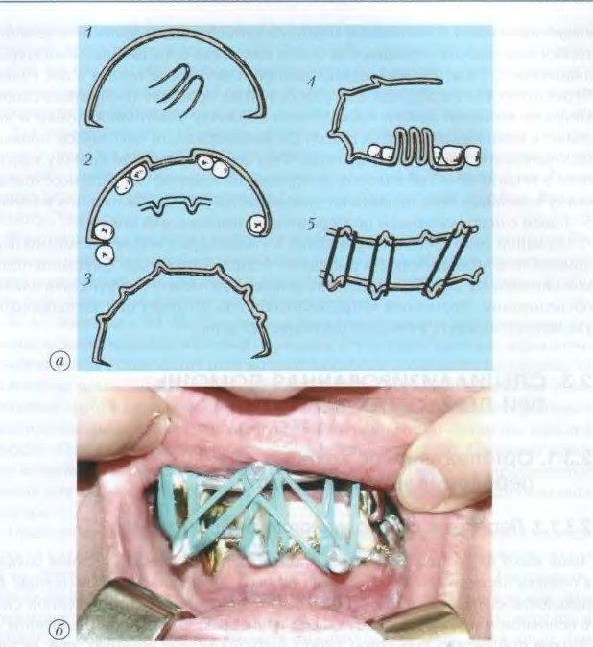

Fig. 2. Wire tires according to Tigerstedt (a): 1 — a smooth tire-bracket; 2 — a smooth tire with a spacer; 3 — a tire with hooks; 4 — a mine with hooks and an inclined plane; 5 — a tire with hooks and a mandibular traction. Splint in the oral cavity (b)

restoration of normal occlusion. So, for example, when a fragment is mixed in the palatine direction, the arch fits snugly to the teeth of the healthy side, but is separated from the teeth of the displaced alveolar process. After the ligatures are removed, the elastic arc will move the teeth and the alveolar process of the damaged side outward, i.e. to the correct position.

In case of punctured fractures of the alveolar process and its fractures in the anterior part of the dental arch, a stationary wire steel arc with a thickness of 1.2—1.5 mm is used. The arc is attached to the teeth of the healthy side, and the fragment is pulled up to the arc with rubber rings or a ligature.

Orthopedic treatment of fractures of the upper jaw body

Fractures of the upper jaw are among the most severe injuries to the facial skeleton. This is due to the fact that the upper jaw is located in the center of the lineal skeleton, connected to the other bones surrounding it and connected to the base of the skull. That is why her injury is often combined with rupture of blood vessels and nerves, damage to the brain and organs of vision.

Taking into account the peculiarities of the anatomical structure of the upper jaw, experimental data and clinical observations, Le Faure (1900) identified the weakest areas of the skull skeleton in which fractures of the upper jaw occur most often (Fig. 4):

1. Fracture of the upper jaw body in the horizontal plane, in which the bottom of the maxillary sinus and the bottom of the nose break off. With a bilateral fracture, a horizontal fracture of the nasal septum occurs. The fracture line runs from the edge of the pelvic orifice horizontally posteriorly, above the stveolar process to the mound of the upper jaw and to the pterygoid process of the sphenoid bone (Le Fore 1).

2. The fracture line passes horizontally through the nasal bones, passes to the inner surface of the eye socket and reaches along it to the lower orbital slit. Then it goes forward along the lower wall of the eye socket, crosses the lower orbital margin near the zygomatic suture, stitches along it and along the suture passes from the anterior wall of the upper jaw to the lower part of the pterygoid process. With a bilateral fracture of the upper jaw according to type 2, as a rule, the nasal septum breaks in the vertical direction and somewhat from the front to the back (Le Fore 2). A. A. Limberg defines type 2 as a maxillofacial separation.

3. The fracture line in this type passes transversely through the nasal bones, passes to the inner wall of the eye socket and reaches the bottom-

Fig. 4. Fractures of the upper jaw according to Le For (see explanations in the text)

non-ocular slit. From it, the fracture line passes along the outer wall of the eye socket forward, crosses the outer edge of the eye socket along the frontal-zygomatic suture or near it and goes posteriorly to the upper part of the pterygoid process of the sphenoid bone, which separates together with the upper jaw. In addition, in this type, a fracture of the temporal process of the zygomatic bone occurs near the zygomatic suture. With bilateral fractures of this type, a vertical fracture of the nasal septum is determined, as with type 2 (Le Fore 3). A. A. Limberg calls this type of fracture a craniofacial separation.

Fractures of the upper jaw can be one- and two-sided. In addition, there are punctured fractures of the upper jaw, and sometimes a complete separation of it. Mixed fractures are often observed, when a fracture may occur on the one hand, for example, according to type Le Fore 2, and on the other — according to type Z or a combination of a fracture according to types and 2, etc. The main symptom of a fracture of the upper jaw with displacement is a violation of the closure of the teeth in the form of an open bite.

The mixing of fragments of the upper jaw occurs under the influence of external force, as a rule, posteriorly and under the influence of its own gravity downward. The posterior part of the upper jaw shifts downwards slightly more than the anterior one, due to the traction of the contracting pterygoid muscles, and in case of a type 3 fracture, due to the contraction of the masticatory muscle.

Clinic. Patients complain of pain when closing the jaws and the inability to bite off the writing with the front teeth due to the formation of an open bite. Often, the sensitivity of the middle zone of the face is lost, especially with a type 2 fracture. Most patients report loss of consciousness at the time of injury due to concussion or brain injury. All patients have nosebleeds caused by damage to the nasal mucosa, the maxillary sinus and the trellis labyrinth. Fractures of the base of the skull cause bleeding not only from the nose, but also from the ears.

With a significant mixing of fragments in a type fracture, it is possible to determine the elongation of the lower part of the face (upper lip), and in fractures of types 2 and Z — the middle part of the face (nose).

When examining the oral cavity in the case of displacement of fragments, there is no closure of the front teeth, i.e. a symptom of an open bite is formed.

Treatment of fractures of the upper jaw with pronounced mobility of fragments consists in manual reduction of fragments and fixing them in the correct position. For the treatment of bilateral fractures of the upper jaw, wire splints are used, which have an intraoral part fixed to the teeth, and an extraoral part connected to a head cast. A similar splint for the treatment of fractures of the anterior maxilla was proposed by Ya. M. Zbarzh. It is made as follows.

An aluminum wire with a mine of 75-80 cm is taken . On each side, its ends 15 cm long are bent towards each other and twisted into a spiral. The angle between the long axes of the wire should not exceed 450. The turns of one process go clockwise, and the other — counterclockwise. The formation of twisted processes is considered complete when the middle part of the wire between the last turns is equal to the distance between the premolars. This part is further developed by the front part of the dental splint. The side parts are bent from the free ends of the wire. The intraoral part of the splint is fixed with a ligature wire to the teeth after the fragments are set. The extraoral processes are bent upwards to the head so that they do not touch the skin of the face. After that, a plaster cast is applied, into which the ends of the wire appendages are placed.

For the treatment of fractures of the upper jaw types 1 and 2, Ya. M. Zbarzh has developed a standard kit consisting of an arc splint, a supporting headband and connecting rods (Fig. 5 and 6). The device allows you to set and fix fragments at the same time. The splint-arc is a double steel arc covering the dentition of the upper jaw on both sides. The dimensions of the wire arc are regulated by extension and shortening of its palatine part. Extra—oral rods extend from the arc, directed back to the auricles. The extra-screw rods are connected to the headband using connecting metal rods. M. 3. Mirgazizov proposed a similar device for a standard tire to fix the fragments of the upper jaw, but only with the use of a palatal plate made of plastic.

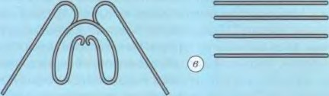

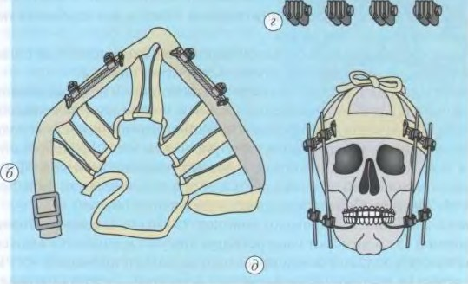

Fig. 5. The standard set of Zbarzh for the treatment of fractures of the upper jaw:

a — splint-arch; b — headband; c — connecting rods; — connecting rods; D — general view

Treatment of fractures of the upper jaw with a mixture of fragments downwards with an intact lower jaw can be carried out using a Weber-type dental splint (Fig. 7). It consists of a wire frame and a plastic base that covers and covers the hard palate and couplings for extraoral rods. The cutting edges and chewing surfaces of the teeth remain open to control the closure of the teeth.

The frame is bent from orthodontic wire with a diameter of 0.8 mm. It covers the dentition in the form of arches from the vestibular and palatine surfaces. In order for the tire to rest on the teeth and not damage the gingival edge, crossbars are soldered to the frame, which should be located at the contact points of the teeth, as well as tetrahedral tubes that will hold the extra-oral rods. The soldered frame will interfere with the jaw model and a tire is modeled from wax. A model with a wax reproduction is plastered into a cuvette and the wax is replaced with plastic.

A dental splint can be prepared using a different technology. First, a wire frame with tubes is made, placed on a plaster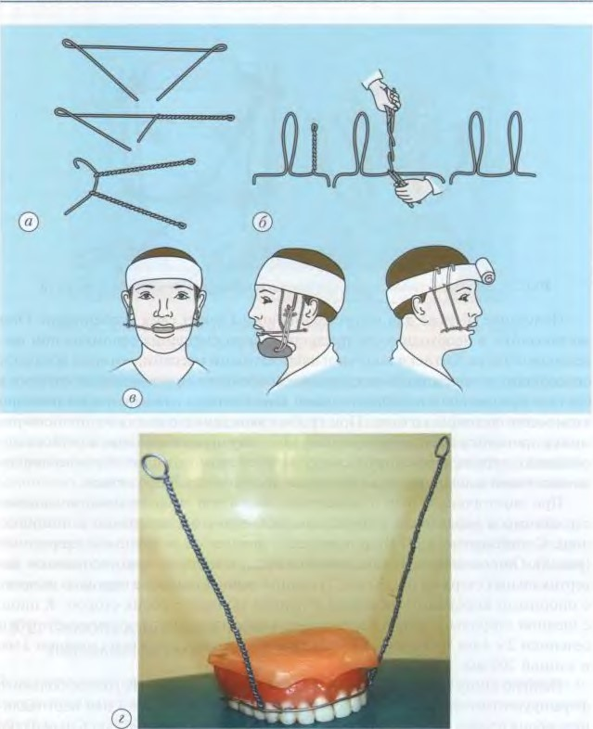

Fig. 6. The sequence of manufacturing of aluminum wire tires according to Zbarzh:

a — the first option, b — the second option; a — fixing of one—piece aluminum wire tires with the help of connecting rods; - general view

of the model, and then a tire is modeled from a fast-hardening plastic. Polymerization is carried out in a vulcanizer. The basis of the tire turns out to be translucent. This allows you to see the places of compression of the mucous membrane under the tire.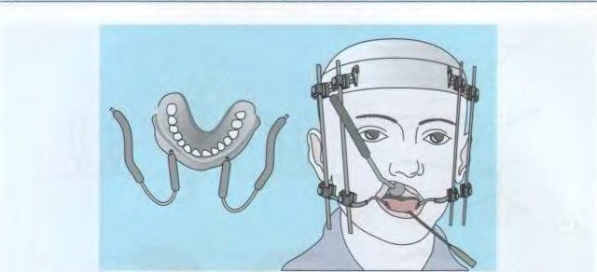

Fig. 7. Dental splint for fixing fragments of the upper jaw

Obtaining an impression for tire manufacturing has its own characteristics. They consist in the need to prevent the mixing of fragments when removing a typo. Impressions are obtained by alginate masses, which have the ability to stick to the mucous membrane when removing the impression due to the formation of a peripheral closing valve and adhesion phenomena occurring at the same time. With a rough removal of a typo from the oral cavity, a mixture of fragments may occur. Therefore, before removing the impression, it is necessary to open the transitional fold and break the formed closing valve with a jet of water, thereby opening air access under the impression.

With a bilateral fracture of the upper jaw and limited mobility of the fragments, the reduction and fixation of the latter is carried out with the help of splints. To this end, 3. I, Shur proposed a device with counter rods (Fig. 8). It consists of: 1) a plaster cap, to which two vertical rods of mm are attached; 2) a single soldered splint on the upper jaw with supporting crowns on the canines and the first molars on both sides. Flat tubes with a cross section of 2 x 4 mm and a length of 15 mm are attached to the tire from the buccal side in the area of the first molar; 3) two extra-lateral rods with a cross section of 3 mm and a length of 200 mm.

The soldered tire is cemented on the teeth of the upper jaw. A plaster cap is formed on the patient's head and at the same time short rods are fixed vertically in it on both sides so. so that they are located somewhat behind the lateral edge of the orbit and descend down to the level of the wings of the nose. Extra-oral rods are inserted into tubes and bent along the buccal surface of the tooth. In the area of the canine, they point backwards, at the level of the short upper rod and bend towards it. The movement of the jaw fragments is achieved by changing the direction of the extraoral rods. After setting the jaw in the correct position, the ends of the levers are connected with a ligature.

Treatment of unilateral fractures of the upper jaw with stiff fragments is carried out with the help of wire splints with interdigital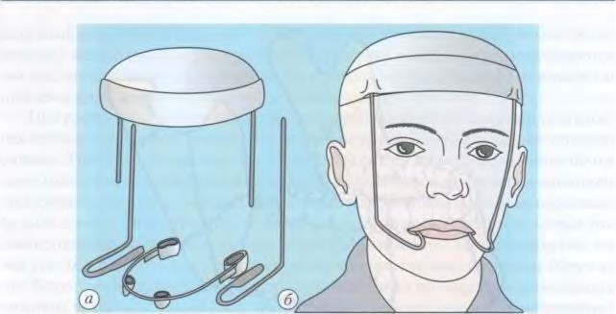

Fig. 8. Apparatus for the reduction of fragments of the upper jaw no Shuru:

p — the components of the apparatus; b — the patient with

the traction apparatus. A Tigerstedt tire with hook loops is bent on the lower jaw, a wire tire with hook loops only on the healthy side is bent on the upper jaw, and the tire remains smooth on the fragment and is not fixed by ligatures. After strengthening the tire, an interdigital rubber traction is applied on the healthy side, and a rubber gasket is installed under the pubescent fragment of the upper jaw. After the fragment is set, the free end of the smooth splint on the upper jaw is tied to the teeth.

With a complete separation of the upper jaw with its displacement backwards and with a hammered fracture, the extension of the fragment is carried out with the help of a steel wire rod, one end attached to a plaster headband, and the other to an intraoral splint.

2.3.2. Orthopedic treatment of fractures of the lower jaw

Fractures of the lower jaw, as a rule, occur by .lgtnii are weak and have a typical localization — in the neck of the articular process, angle or body of the lower jaw (Fig. 9). Gunshot fractures, on the contrary, have a different location. Fractures of the mandible most often occur with the displacement of fragments, which is explained by the influence of the action of the applied force, the gravity of the fragments and the traction of the masticatory muscles attached to them (Fig. 10). The last factor is crucial. Displacement of fragments does not occur with incomplete fractures and sometimes with fractures in the area of the angle of the lower jaw.

With a fracture of the lower jaw along the median line, when the same number of lifting and lowering are attached to each of the fragments-

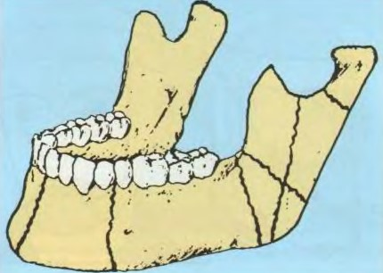

Fig. 9. Typical localization of mandibular fractures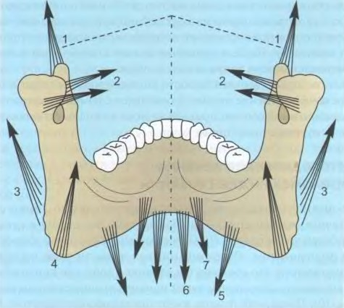

Fig. 10. Direction of force of the masticatory muscles attached to the lower jaw:

— temporal; 2 — lateral pterygoid: 3 — masticatory: 4 — medial pterygoid;

5 — maxillofacial; 6 - chin—lingual; 7 - double—abdominal

of course, the displacement of fragments is insignificant. However, due to the more powerful masticatory and temporal muscles, the fragments turn somewhat inward, which leads to a juinically determined divergence of the fragments along the lower edge of the chin of the lower jaw body.

When the fracture line is located away from the median line of the lower jaw body, the displacement of fragments under the influence of mouse TRACTION is much more pronounced.In this case, a small fragment, on which the attachment of almost all the muscles that lift the lower jaw remains, will mix upwards, and under the influence of the pterygoid muscles — inward. At the same time , the powerful masticatory muscle shifts the lower k somewhat more

the edge of the jaw is outward. As a result, the small fragment is not only shifted upwards and inwards, but also rotated along the axis so. what comes into contact with the antagonist teeth only with the buccal tubercles. The large fragment retains a connection with the entire group of muscles that raise the lower jaw, and almost the entire group of muscles that lower it, with the exception of the maxillofacial muscle of the opposite side. Due to the muscles lowering the lower jaw, a large fragment will mix downwards, mixing in the direction of damage is carried out due to the pull of the wing-shaped mouse.

With linear fractures in the area of the angle and branch of the mandible, significant mixing of fragments, as a rule, does not occur, since in these areas the masticatory muscle is attached for a long time and its tendon bundles do not allow the fragments to move.

With double fractures in the lateral parts of the lower jaw body, there is a displacement of the middle fragment posteriorly and downwards, sometimes forward under the influence of inflection, and the muscles of the posterior group will mix the posterior fragments forward and backward. The middle fragment turns out to be mixed anteriorly (Fig. 11).

With double fractures of the lower jaw in the area of its corners, there is a sagging of the anterior part of the middle fragment. Its posterior displacement is usually not observed.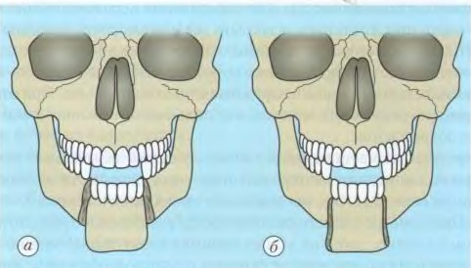

Fig. 11. Displacement of the middle fragment of the lower jaw body in a double fracture:

a — posteriorly and downward as a result of muscle traction; b — atypical displacement of the fragment anteriorly

With double fractures of the necks of the articular processes of the lower jaw, the branches are shifted upward due to the traction of the muscle group that raises the lower jaw. Only large molars-antagonists remain in contact (a symptom of an open bite). Fragments of condylar (articular) processes under the wedge of the lateral pterygoid muscle usually shift anteriorly and inwardly, but very often they turn out to be mixed outwardly as a result of inflection.

With a double unilateral fracture, the middle fragment under the influence of lowering the lower jaw of the mouse shifts inwards and downwards. Fragments that have retained a connection with the condyle processes will mix, as a rule, upwards and inwards.

With multiple fractures of the mandible, there is a disorderly mixing of fragments, depending on the direction of the applied force, the weight of the fragments, the fracture mechanism and the traction of individual muscles attached to the fragments. In these cases, the fragments are often displaced at an angle to each other

Clinic. Patients complain of pain during movements of the lower jaw, bleeding from the oral cavity, violation of the closure of antagonist teeth on one side and the inability to chew food on the other (with fractures of the lateral part of the body of the lower jaw), the inability to bite off food with front teeth with fractures in the corners, necks of the mousetrap (condillary) processes, etc. Some patients note a violation of sensitivity in the chin area with injury to the inferior alveolar nerve.

According to the location of the fracture, you can see the swelling of soft tissues due to bleeding in them with a change in the color of the skin with hematomas.

Palpation should begin from the posterior edge of the lower jaw branch and gradually move along the edge of the lower jaw body to the chin. With a fracture, especially with displacement, irregularities are detected. Usually in this place the patient notes soreness. To determine the fracture of the condylar process, the patient is asked to open and close his mouth or shift the lower jaw to the sides. At the same time, there is a limitation of mobility on the side of the fracture. The nature of the mobility of the condylar process can be defined as followsже при введении указательного пальца в наружные слуховые проходы. При открывании и закрывании рта отмечается ограничение подвижности мыщелкового отростка на стороне повреждения.

To determine the location of the fracture, the so-called load symptom is used. When pressing on certain areas of the jaw, pain occurs in the area of the fracture line. This study is carried out in the first 3-4 days after the fracture. When examining the oral cavity, the separation of antagonist teeth on a large fragment is noted. Teeth on a small fragment are higher than on a large one. In the fracture area, ruptures of the mucous membrane are determined, sometimes with bone exposure. Palpation of these areas allows you to determine the sharp edges of the bone under the mucous membrane.

X-ray examination allows you to clarify the fracture site, root fractures, the presence of fragments, etc. In the course of treatment, X-ray examination allows you to control the accuracy of the comparison of fragments, as well as to determine the formation of a callus (30-40 days) or the development of complications (traumatic osteomyelitis).

The choice of the method of orthopedic treatment of fractures of the lower jaw depends on the localization of the fracture line, the degree and direction of displacement of the fragments. the presence of teeth on the jaw and their periodontal condition, the nature of occlusion disorders.

The following methods are used to immobilize jaw fragments: 1) dental: 2) dental and supra-gingival; H) surgical (intraosseous and bone fixation).

Dental fixation methods. The dental immobilization method is indicated in cases where there are a sufficient number of teeth on the fragments of the lower jaw and on the upper jaw. There are several known methods of dental immobilization of fragments: interdigital (ligature) fastening of the jaws, the use of aluminum wire tires, tape tires, tires made of fast-hardening plastic and mouth guard tires.

Interdigital ligature retention of the jaws is performed for temporary immobilization for 3-4 days. Strengthening of fragments for a longer period is not recommended because of the danger of loosening teeth connected by wire ligatures. The basic principle of this method is the fixation with a metal ligature on each fragment of the lower jaw of two teeth, which are tied to ligatures fixed on the teeth antagonists of the upper jaw.

For the ligature connection of the jaws, bronze-aluminum wire or stainless steel wire with a thickness of 0.4—0.5 mm and a length of 5-6 cm is used. Several methods of inter-jaw ligature connection have become the most widespread: a simple method and methods proposed by Ivy, Geikin and Vilga (Fig. 12).

In the first method, a ligature is applied to each of the two teeth of the upper and lower jaws. This method has certain disadvantages: the bound ligatures form too thick a bundle consisting of eight ligatures. If necessary, examine the oral cavity, you have to remove all ligatures and re-apply them.

Ivy's way is more convenient. The binding of the teeth turns out to be more elegant, and the fixation of the jaws can be easily removed without changing the applied ligatures.

For immobilization of fragments in fractures of the lower jaw, a smooth tire, a tire with a spacer (strut bend) and tires with hook loops for interjaw traction are used.

In the presence of teeth on the jaw, slight displacement of fragments and fractures within the dentition, single-jaw wire splints are used. Fractures outside the dentition or significant displacement of fragments.

For the first time, aluminum wire splints were used by a doctor of the Russian army from the Kiev hospital, S. S. Tigerstedt, in 1915. A deep bite with a vertical or retraction position of the front teeth is a serious obstacle to the use of wire splints.

Tire technology

The technique of applying a wire splint

The wire tire is bent from annealed aluminum wire with a diameter of 1.8—2.0 mm.

To fix the splint to the teeth, bronze-aluminum is used

zirconium wire with a thickness of mm or stainless steel wire. The splint is bent outside the oral cavity, constantly trying it on the dentition. The application of the splint is drained after conduction anesthesia. It should fit snugly to each tooth. In the absence of a part of the teeth in the area of the defect of the dentition, a special spacer or retention loop is bent. The strut bend is made in such a way that it rests against the edges of adjacent teeth in order to avoid mixing fragments. The hook loops are bent with crampons. A splint with meshing loops of the intermaxillary extension is indicated in the treatment of patients with fractures of the lower jaw located behind the dentition, with multiple fractures, linear fractures with a large displacement of fragments when their insertion is difficult, fractures along the median line, fractures of the upper jaw. The ends of the splint should cover the most distally located teeth. To fix it on the teeth, a bronze-aluminum wire with a length of 6-7 cm and a thickness of 0.4—0.6 mm (ligature) is used. The splint should be located between the equator of the tooth and the gum, without causing damage to the latter. The ligature is bent in the form of a hairpin with the ends of the same length. The ends are inserted with tweezers from the lingual side into two adjacent interdental spaces and removed from the vestibule (one under the tire, the other above it).

Congas of ligatures are twisted and bent into interdental spaces. The ligature should not cause damage to the gums. After 2-3 days, it is twisted to make the tire more rigid.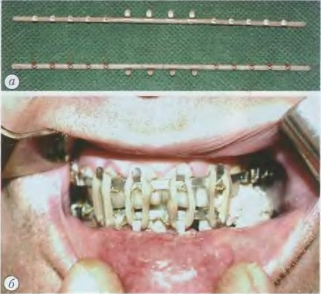

Fig. 13. Standard band splint for interdigital fixation according to Vasiliev: a — general view of the splint; b — splint in the oral cavity

Bent wire tires require a lot of time to bend them. Given the complexity of manufacturing tires with hooking loops, some authors suggest using removable hooking loops worn on a smooth tire-bracket (P. I. Popudrenko). In 1967, V. S. Vasiliev developed a standard toothed belt tire, stamped from stainless steel with ready-made hook loops (Fig. 13). It can be used as a single-jaw smooth tire-a shea brace for inter-jaw traction. The tire bends along the dentition and is fixed to the teeth with a ligature wire.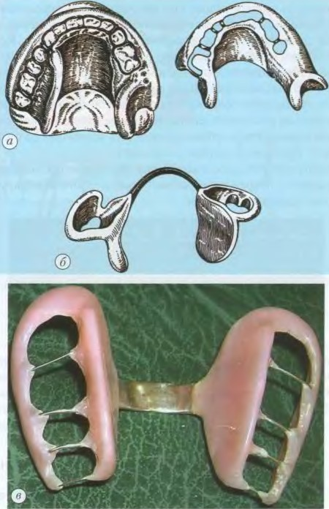

Fig. 14. Removable splints for fixing toothless fragments of the lower jaw:

a — Vankevich splint•, b — Stepanov splint; c — general view of the finished Stepanov splint

Treatment of fractures of the lower jaw with toothless alveolar parts or with the absence of a large number of teeth is drained by M. M. Vankevich splint (Fig. 14, a). It appears to be a dental splint with two planes that extend from the palatine surface of the splint to the lingual surface of the lower molars or the toothless alveolar ridge.

The impressions from the upper and lower jaws are removed with a clay mass, the central ratio of the jaws is determined and the plaster working models are fixed in the articulator. The frame is bent and a wax tire is modeled. The height of the planes is determined by the degree of mouth opening. When opening the mouth, the planes should maintain contact with toothless mveolar processes or teeth. Wax is replaced with plastic. This splint can also be used for bone grafting of the lower jaw to hold bone grafts. The Vankevich tire was modified by A. I. Stepanov (fig. 14, b), who replaced the palatal plate with a meadow.

In case of fractures of the mandible outside the dentition, a Weber dental splint with an inclined plane on the lower jaw, a Schroeder splint and wire splints with sliding hinges of Pomerantseva-Urbanskaya are used (Fig. 15).

Plastic tires. Plastic has also found wide application in the treatment of fractures of the lower jaw. Various modifications of tires made of fast-hardening plastic were proposed by A. I. Markin, M. B. Shvyrkov, G. A. Vasiliev, I. E. Koreiko, M. R. Marei, Ya. M. Zbarzh, etc. A tire made of fast-hardening plastic has the same indications as wire tires, and is formed according to a wax (M. Shvyrkov) or metal template of an arc-shaped shape. Previously, a polyamide thread with plastic beads is strengthened on the teeth. Using this method, it is possible to obtain a smooth tire and a tire with hooking loops (Fig. 16 and 17).

F. M. Gardashnikov proposed a universal plastic toothed tire with mushroom-shaped rods for inter-jaw traction. The tire is reinforced with a bronze-aluminum ligature.

A tire made of fast-hardening plastic can be prepared in the form of a mouth guard directly in the patient's oral cavity. At the same time, it is important to protect the gingival edge with wax from plastic burns. E. Ya. Vares suggested making mouthguards by stamping from matte polymethylmethacrylate in a special mold.

Plastic tires have the following disadvantages:

1) the reinforcement of plastic tires with polyamide thread is not stable enough due to the stretching of the latter;

2) plastic splints in the form of mouthguards change occlusion, are bulky, damage the gingival papillae and violate oral hygiene.

Dental and supra-gingival methods of immobilization. These methods are indicated in patients with a fracture of the lower jaw with an insufficient number of teeth or their absence. Tires are made in the laboratory.

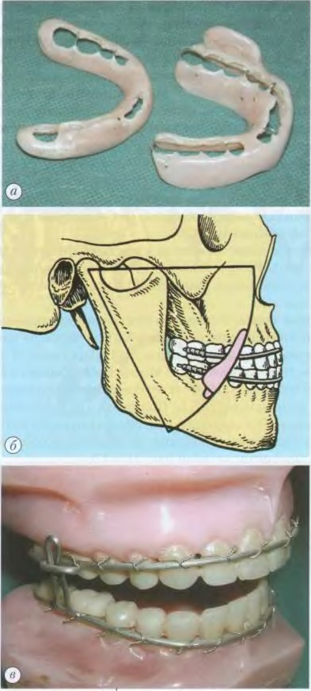

Fig. 15. Splints for the treatment of fractures of the mandible outside the dentition:

##### a — Weber dental splint; b — orthopedic device with sliding hinge [Preler; — wire splint with sliding hinge Pomerantseva-Urbanskaya(Э

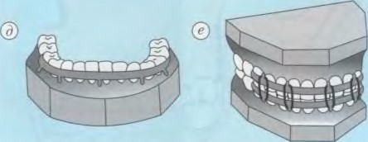

Fig. 16. The scheme of manufacturing a plastic splint for the treatment of fractures of the lower

a — the fixation of beads; b — the formation of a groove; c — the hole; ? — a splint is placed on the jaw; D — a splint with hook loops; e — fixation of the jaws

The Weber tire has become the most widespread. It is used in patients with a fracture passing through the alveolar process, when individual teeth are preserved on the fragments.

Supravarsal splints are used for fractures of the lower jaw in patients with toothless both jaws.

In case of fractures of the lower jaw with a defect of bone tissue (gunshot fractures) or in the absence of teeth on it, fixing bone devices are used A. F. Rudko, V. M. Uvarova, Ya. M. Zbarzha, V. P. Panchokhi and their modifications. The bone fixation of the fragments of the lower jaw can be carried out with the help of an ambient or enclosing seam fixed over a removable prosthesis, or a removable base plate specially made of fast-hardening plastic.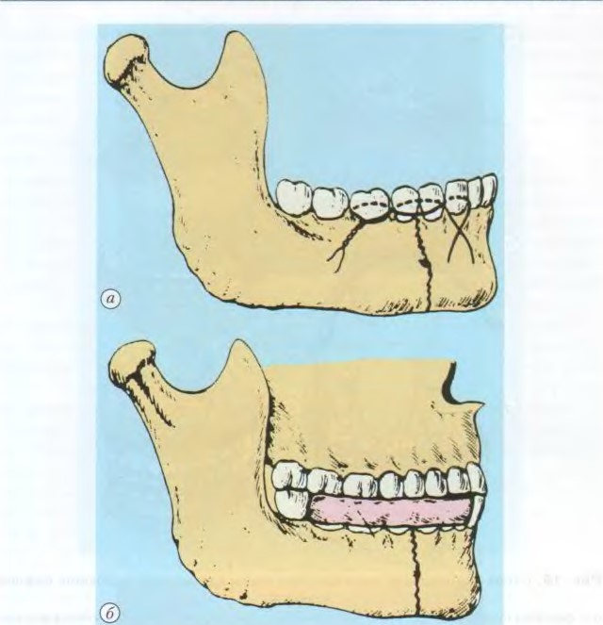

Fig. 17. Superposition of a tire made of fast-hardening plastic according to Frigof:

a — superposition of ligatures; b — general appearance of the tire

In case of fractures of the body of the toothless lower jaw, the simplest methods are the use of prostheses of the patient and fixation of the lower jaw by means of a rigid chin sling until the fragments are fused. To facilitate eating with closed jaws, an opening in the incisor area is formed in the lower jaw prosthesis.

In the absence of prostheses, a Port bus is used, which consists of two base plates with occlusal rollers tightly connected together (Fig. 18).

In cases where there are one or more natural teeth that do not allow the upper and lower splints to be inserted into the oral cavity at the same time, tightly

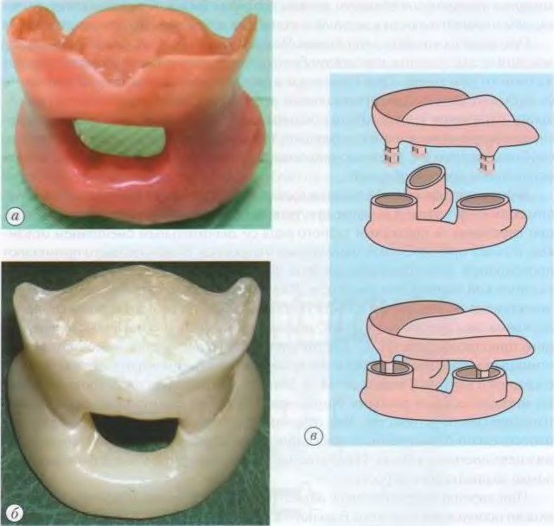

Fig. 18. Types of tires:

a — the Port tire; b — the Gunning—Port tire; c — the Limberg tire

connected to each other, use a collapsible tire, fixed on the teeth with clasps (Gunning—Port tire).

In case of fractures of the toothless lower jaw and the absence of prostheses in the patient, it is best to use a standard Limberg apparatus, which can also be made individually from impressions. A thin layer of heated thermoplastic mass is applied to the bases and impressions are taken from the upper and lower jaws. Thus, the plates fit snugly to the mucous membrane of the oral cavity. Freshly prepared fast-hardening plastic is applied to the recesses of the lower plate. When the jaws are closed, the columns of the upper jaw plate are inserted into the plastic of the lower part of the device. thanks to this, the plates are connected to each other. However, the use of this device or prostheses of the patient should be accompanied by mandatory tightening of the lower jaw to the upper one with the help of a rigid chin sling.

Orthopedic devices (Port, Guninga—Port, Limberg splints), proposed for the treatment of fractures of the toothless lower jaw, sometimes do not give the desired result. They are bulky and do not provide reliable fixation of toothless fragments with significant atrophy of the alveolar part. In the treatment of fractures in this group of patients, preference should be given to surgical methods of treatment: intraosseous immobilization of fragments with sutures, staples, rods, screws; bone immobilization using various devices and devices.

Intraosseous immobilization (osteosynthesis) is indicated for linear fractures of the mandible in the absence of teeth or with a small number of them, for fractures outside the dentition with a significant displacement of fragments, as well as for fractures of the mouse process. The most commonly used wire or polyamide seam. It can be additionally reinforced with a metal spoke or rod. Immobilization with metal staples consists in the insertion of fragments into the bone tissue on both sides of the fracture line of pointed rods extending from the brace, using a special devices (I. S. Karapetyan et al.). Immobilization is used using metal rods of square or rectangular cross-section and rods with screw thread. M. A. Makienko suggests fixing the fragments with metal Kirshner spokes. They are introduced using a special guiding device. As many authors note, these methods have relatively limited indications due to the risk of damage to the teeth and the mandibular canal. Most often they are used to fix a fragment of the condylar process.

With well-preserved alveolar ridges, as a forced measure, the patient's prostheses can be used in combination with a chin sling.

Laboratory-made tires. Wire tires have some disadvantages. Ligatures damage the gums, it is necessary to constantly twist them, and oral hygiene is violated. These disadvantages are devoid of laboratory tires. They consist of supporting crowns and an arc of orthodontic wire soldered to them with a thickness of 1.5—2.0 mm. To make the tire, the typos are removed. Crowns are prepared in the laboratory, They are checked in the oral cavity. An impression is removed from the dentition together with the crowns, into which, after its removal, the crowns are inserted and the model is cast. According to the model, the arc is bent and soldered with crowns. The tire is checked in the oral cavity and reinforced with cement .

Modified Tigerstedt tire

A. M. Eshiev and V. Y. Sheinman (2005) proposed a modified Tigerstedt tire (Fig. 19). The ego tire is made in the form of an arc with hooking loops of aluminum wire with a cross section of 1.5—1.8 mm. Initially, the first hook loop was formed by bending, after which a polyethylene coupling with a tire up to 1 cm and a diameter of 1 mm was put on the wire, which was cut out of a disposable system for intravenous infusion. Then, at a distance of 1 cm, a second hooking loop was formed, etc., as a result, a total of six hooking loops and five couplings were formed.

Fig. 19 shows a fragment of a double-jawed tire, which consists of a curved muminium wire with hooking loops ( P, spacers with support pads on the end parts (2), a nylon coupling (3), hooking loops (f, rubber rods (5). The types of struts are shown below: U—shaped - in the absence of a sufficient number of teeth with support pads — with an abnormal bite (L, straight — with a normal bite ( Y. The spacer is fixed by puncturing the coupling on the upper and lower jaws (9).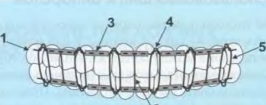

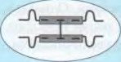

Fig. 19. Modified Tigerstedt tire (description in the text)

The tire made in this way with couplings was fixed to the teeth of the upper and lower jaws, and in some cases the ligature wire can be fixed not to each tooth, but through one. Thanks to the couplings, a gap is formed between the tire and the gum mucosa, so they do not touch.

To prevent the splint from sliding off the necks of the teeth and to make up for missing teeth, an interdigital spacer was made of orthopedic wire with a diameter of 1 mm.

With a normal bite, straight spacers were created as follows: the distance between the splints was measured with closed teeth and, accordingly, the orthopedic wire was bitten off. In the area of the central incisors and premolars, three spacers were fixed by puncturing polyethylene couplings.

With an abnormal bite, the spacers were made with two support plates. With an insufficient number of teeth, two U-shaped spacers were used, which were always inserted into the lumen of the coupling on both sides, the bite was fixed with rubber rings.

Complex treatment and the proposed modified Tigerstedt splint, made on the basis of couplings and interdigital struts, improve the hygienic condition of the oral cavity, increase the effectiveness of immobilization of bone fragments and thereby contribute to the optimization of regeneration processes and reduce the number of purulent-inflammatory complications.

Terms of use of tires and devices

With timely immobilization, jaw fragments in neognestrel fractures fuse after 4-5 weeks. By the end of the 2nd or beginning of the 3rd week after the fracture, a dense formation can be found along the fracture line - a primary corn. The mobility of the fragments is noticeably reduced. During this period, you can remove the traction for several hours. The reception of writing without stretching is forbidden. By the end of the 4th-5th week, and sometimes even earlier, the mobility of the fragments disappears, the compaction in the fracture area decreases, i.e. a secondary callus forms.

Fixing devices are removed after the disappearance of the mobility of the fragments, determined clinically. It should be noted that during X-ray examination, the gap between the fragments can be determined up to 2 months after clinical healing of the fracture. However, in the fracture gap, you can see compacted areas that later disappear. With gunshot fractures, the healing time increases significantly.