Prosthetics during resection

The alveolar process of the upper jaw.

Direct prosthetics is carried out by a removable plate prosthesis with a clamp fixation according to the method of I. M. Oxman. For this purpose, prints are taken from the upper and lower jaws. According to the model of the upper jaw, a fixing plate is made with clasps and ee is checked in the oral cavity. The impression is taken from the upper jaw with a fixing plate and the model is cast. Models of jaws are fixed in the articulator in the position of central occlusion. On the model of the upper jaw, teeth and the alveolar process are removed according to the plan outlined by the surgeon (phantom resection). The phantom resection line should pass I—2 mm inside of the osteotomy line planned by the surgeon. This is necessary in order for a space to be created between the prosthesis and the bone wound, providing wound epithelization.

Prosthetics for unilateral resection of the upper jaw.

Direct prosthetics after the equilateral resection of the upper jaw is carried out according to the method of I. M. Oxman in three steps. First, the fixing part of the prosthesis is prepared with clammers on the supporting teeth. To do this, they take an impression from the upper jaw, cast a model, model a fixing plate made of wax and replace it with plastic. The fixing plate is checked in the oral cavity and an impression is taken from it. Additionally, an auxiliary impression is taken from the lower jaw. Models are cast and fixed in the articulator.

Prosthetics for resection of the half of the lower jaw.

After manufacturing and checking the fixing plate, an impression of the lower jaw is removed along with it, as well as an orientation impression of the upper jaw. Cast plaster models and fix them in the articulator. The model marks the boundary of the future osteotomy. Departing from the line of osteotomy, passing through the middle line, for example, between the central incisors, it is necessary for the patient to cut the crowns of two plaster incisors, central and lateral, on the level of their necks, so that the prosthesis after surgery does not interfere with the epithelization of the mucous membrane covering the remaining healthy bone fragment. The remaining teeth above the tumor are cut off by 2-3 mm of the lower base of the alveolar part of the lower jaw. The resection part of the prosthesis is modeled from wax and artificial teeth are placed on it. The resection part of the base behind the dentition and facing the prosthetic bed should have a rounded shape, on the contrary, the sublingual side is concave with sublingual rollers for free placement of the lateral surface of the tongue, which contributes to the retention of the entire prosthesis. The manufacture of the prosthesis is being completed in an ordinary way.

PROSTHETICS during RESECTION

ALVEOLAR PROCESS OF THE UPPER JAW

Direct prosthetics is carried out with a removable plate prosthesis with a clamp fixation according to the method of I. M. Oxman. To do this, remove the typos from the upper and lower jaws. According to the model of the upper jaw, a fixing plate with clasps is made and checked in the oral cavity. The impression is taken from the upper jaw together with the fixing plate and the model is cast. Jaw models are fixed in the articulator in the position of central occlusion. On the model of the upper jaw, teeth and the alveolar process are removed according to the plan outlined by the surgeon (phantom resection). The phantom resection line should be -2 mm away from the osteotomy line planned by the surgeon. This is necessary in order for a space to be created between the prosthesis and the superficial wound, ensuring the wound epithelization.

The replacement part of the prosthesis is modeled from wax and artificial teeth are installed. Wax is replaced by plastic according to the usual method. On the operating table, the prosthesis is applied to the jaw. Correction of occlusion and other corrections of the prosthesis are carried out only 2-3 days after surgery. This circumstance is essentially a requirement for high accuracy of the prosthesis before surgery. First of all, this applies to the exact packing of the fixing plate before the operation and the most correct installation of artificial teeth. Of no less importance are the accuracy of manufacturing the fixing elements, the boundaries of the basis, the quality of finishing the grinding and polishing of the entire prosthesis.

Remote prosthetics after resection of the alveolar process of the upper jaw is carried out with small saddle-shaped, arc-shaped and lamellar prostheses with retaining or support-retaining clasps. The number of the latter also increases as the volume of the prosthesis increases. Good fixation is provided by telescopic fastening systems. During the examination of the wax reproduction of the prosthesis, attention should be paid to the modeling of the replacement part of the prosthesis, which should support the soft tissues of the cheek or upper lip.

PROSTHETICS for UNILATERAL RESECTION OF THE UPPER JAW

Direct prosthetics after unilateral resection of the upper jaw is carried out according to the method of I. M. Oxman in three steps (Fig. 36). First, the fixing part of the prosthesis is prepared with clasps on the supporting teeth. To do this, an impression is taken from the upper jaw, the model is cast. a fixing hyastine is modeled from wax and replaced with plastic. The fixing plate is checked in the oral cavity and an impression is taken together with it. Additionally, an auxiliary impression is removed from the lower jaw. Models are cast and fixed in the articulator.

After that, they begin to manufacture the resection part of the prosthesis. On the model of the upper jaw, the resection boundary is marked in accordance with the operation plan. Then, on the side of the tumor, the crown of the central incisor of the upper jaw is cut off at the level of the neck, so that in the future the prosthesis does not interfere with the epithelization of the bone wound. The remaining teeth of the diseased side of the jaw are cut together with the alveolar process to the apical base. The resulting defect is filled with wax and artificial teeth are installed in occlusion with the teeth of the lower jaw. An artificial gum on the vestibular side in the area of molars and premolars is modeled with an LICE. running along the transitional fold. In the postoperative period, this roller forms a bed in the mucous membrane of the cheek, which will serve as an additional point of anatomical retention. The wax reproduction of the prosthesis is replaced with plastic. After the operation, the prosthesis is applied to the postoperative wound.

After epithelization of the wound surface, the obturated part of the prosthesis is formed (the third technique). The palatine part of the prosthesis is ground with a cutter to a thickness of about 0.5— 1 mm, it is covered with a layer of fast-hardening plastic so that a roller of plastic dough forms along the edges of the prosthesis to obtain an imprint of the edges of the postoperative cavity. After 1-2 minutes, the prosthesis is removed from the oral cavity and after the final hardening of the plastic is processed and polished. The patient uses the prosthesis for 3-6 months. The postoperative defect of the jaw is periodically examined and the prosthesis is corrected.

When prosthetics of the upper jaw after resection in the long term, the support and fixation of the resection prosthesis plays an important role. Most often, the remaining part of the jaw is located on one side of the prosthetic bed. About-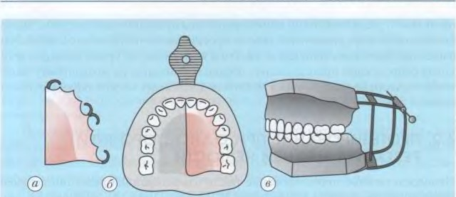

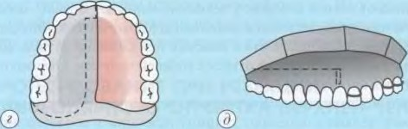

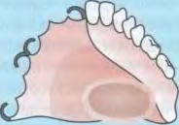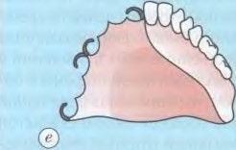 Э 

Fig. 36. The stages of manufacturing a direct prosthesis [10 Ok'cm] during resection / 2 of the upper jaw:

p — fixing plate: b — slip together with the fixing plate: c — models are fixed in the articulator, D — the border of teeth and palate removal on the molar (phantom resection); e — temporary prosthesis; w — a prosthesis with an obturated part

under these conditions, the prosthesis has a one-sided bone support, which leads to an increase in the scope of vertical movements of the sweeping part of the prosthesis under the influence of its gravity and the appearance of functional overload of the supporting teeth and tissues of the prosthetic lock on the healthy half of the jaw.

On the remaining part of the upper jaw, the teeth, the alveolar process, and the hard palate are the most important elements for creating a support. If the periodontal support teeth have signs of the disease, they should be pre-splinted with fixed structures.

To increase the efficiency of fixation

the prosthesis should increase the number of clasps and occlusal pads. The bed for occlusal pads should be expanded to minimize the displacement of the prosthesis and the functional overload of the supporting teeth. The retaining tammers should be placed so that one of them is as close as possible to the defect, the other is possibly longer and at least one (preferably several) is located in the gap between them. To reduce the overturning effect of the prosthesis, it is advisable to use a semi-weak connection of clamps with the basis of the prosthesis. E. Ya. Vares suggests using a dentoalveolar clamp for this purpose, the basis of which is a pelot located from the buccal surface of the preserved teeth. The width of the pelot corresponds to the distance from the transitional fold to the equator of the teeth, the length — from the canine to the last lateral tooth, the thickness does not exceed 2.5 mm. In the distal part, the pelot is fixed to the base using a double orthodontic wire with a diameter of mm. In the front part, the pelot connects to the base semi-weakly. To do this, an orthodontic wire with a diameter of 0.8 mm is made of a swing clamp with a N-shaped bend on the palatine surface (Fig. 37).

To create a prosthesis support, the alveolar ridge is of great importance. Its value increases as the number of remaining teeth decreases. The remains of the hard palate are also the support of the prosthesis. A wide and flat solid sky is more advantageous than having a narrow and high vault. The large palatal roller (palatal torus) must be removed before prosthetics, otherwise it will have to be isolated, which will significantly worsen the conditions for creating a support for the resection prosthesis.

To prevent the prosthesis from tipping over, a support inside the defect is often used. This support can be provided by the contact of the prosthesis with any anatomical structure — a sufficiently solid base. When prosthetics of the defect of the upper jaw, the lower wall of the orbit, the anterior surface of the temporal bone of the wall of the temporal fossa, the nasal septum and the pterygoid plate can serve as a support.

To prevent mixing of the resection prosthesis in the vertical direction, it is necessary to strive to reduce its weight, making the prosthesis, for example, hollow.

When planning an upper jaw obturator, many factors matter. If the defect is large, the problem may be the rotation and stabilization of the prosthesis, resulting from occlusive contacts of the teeth of the prosthesis on the side of the defect. Retention on the side with preserved teeth can be provided by palatal and buccal clamps. The first retention problem is to counteract the sagging of a part of the obturator with artificial teeth, the best solution to this problem (William [E. Oau, Gordon E. king) — kipmayders from the palatine side of the remaining teeth. In patients with partial loss of teeth on the preserved side, a combination of palatine and buccal keepers is necessary. A hard palate prosthesis can be inserted onto a prosthetic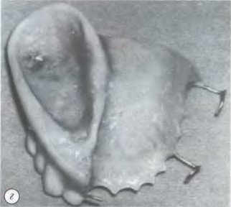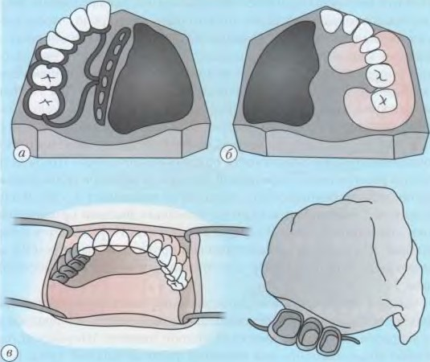 Fig. 37. Methods of fixation of the prosthesis after resection of the upper jaw: a — dentoalveolar clamp (according to Varese); b — semi—lax connection of clamps with the basis of the prosthesis; — prosthesis with a telescopic fixation system; — prosthesis with retaining clamps of the bed by initially applying the elements of fixation of the front teeth, then by rotating around them - fixation elements (the choice of the route of administration is necessary).

Retention can also be carried out on the lateral side of the defect. This is possible if the base of the palatine process is sufficiently preserved and a part of the prosthesis of the hard palate is inserted into the subcutaneous part. If the medial part of the hard palate is preserved and covered with a mucous membrane, the insertion of the prosthesis into this undercut can contribute to increased retention. Technology of resection prosthesis of the upper jaw. Prosthetics of the patient begin with the receipt of an impression. The unusual relief of the prosthetic bed requires the use of a certain technique. So, E. Ya. Vares offers the following technique for obtaining a functional typo from the upper jaw after its resection. An approximate impression is obtained with a standard spoon, which is previously refined using a thermoplastic mass. To do this, a thermoplastic mass is placed on a standard spoon, a two-layer gauze cloth soaked in isotonic sodium chloride solution is applied on top of it. The spoon is inserted into the mouth and pressed against the jaw until it stops. Using active and passive movements, the edge of the slip is formed along the border of the inflection fold and in the area of the defect. The spoon is quickly removed until the final solidification of the mass (Fig. 38).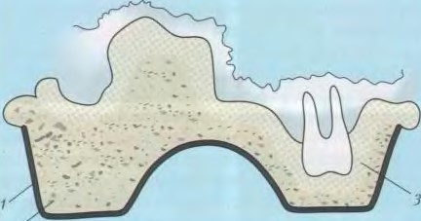

2

38. The technique of obtaining a Vares impression after resection of the upper jaw: 1 — a standard spoon; 2 — a thermoplastic mask; Z — a layer of gauze

After removing the impression, the excess mass is removed and the outer gauze napkin is removed. An elastic silicone impression mass is applied to the surface of the preliminary slip, covered with an inner layer of gauze. A spoon is inserted into the mouth and pressed against the jaw. After polymerization of the elastic mass, the impression is removed. According to such a double slip, the model is cast. On the model, the places to be isolated, as well as the preserved teeth, are covered with adhesive plaster or lead foil. If there is a complex defect relief on the model, then with the help of a parallelometer, the places of undercuts are filled.

An individual spoon is prepared according to the usual method. It is checked in the oral cavity, occlusal rollers from thermomass are glued to the spoon and the central ratio of the jaws is determined. The functional impression is removed under the pressure of occlusal rollers when the masticatory muscles contract.

After receiving a functional impression, a model of the upper jaw is cast. The fixing part of the prosthesis is made, which can be in the form of a cast or plastic base with clasps. The cast basis is checked in the oral cavity and will again interfere with the model. After that, they begin to manufacture the hollow obturating part of the prosthesis. If the fixing part of the prosthesis is plastic, then it is modeled simultaneously with the obturating part. In particular, Y. M. Zbarzh offers the following method of manufacturing a hollow obturating part.

On the model of the upper jaw, the basis of the prosthesis is prepared from a single layer of base wax. The defect of the upper jaw is lined with wax and the latter is replaced with plastic after plastering the model in a cuvette, a depression is formed on the prosthesis according to the defect of the jaw. This recess is covered in the form of a lid with a wax plate, which is also separately replaced with plastic, the latter is connected to the prosthesis with a quick-hardening plastic.

As a permanent prosthesis, you can use a direct prosthesis, in which the replacement part is corrected, for example, according to the method proposed by I. M. Oxman.

The palatine surface of the immediate prosthesis is cut down to a thickness of about 0.5—1.0 mm, and then a layer of silicone impression mass is applied to the surface of the prosthesis and an imprint of the surface of the palate and the edges of the operating cavity is obtained. The jaw defect is pre-filled with gauze swabs, leaving only its edges exposed. A plaster model is cast according to the received impression. In order to avoid bedsores, an insulating aluminum foil is applied to the plaster model in the area of the palatine seam. Then almost the entire base is cut out of the prosthesis, leaving its clamp part and saddle-shaped with artificial teeth, which are again superimposed on the model and the entire base of the prosthesis is again modeled from wax. This is followed by plastering, molding, polymerization according to the rules of repairing the prosthesis. Thus, a fairly light jaw prosthesis is obtained with a small obturating part and a base of uniform thickness.

Another way was suggested by E. I. Varesom. A well-heated thermoplastic mass is applied to the part of the mediate prosthesis adjacent to the defect, two gauze napkins are placed on it and an impression is taken from the edges and bottom of the defect. After removing the typo from the oral cavity, one layer of gauze and excess mass squeezed out of the defect are removed from its surface. Then a silicone impression paste is applied to the mass with a thin layer and the impression is re-applied to the jaw. The model of the jaw is cast from plaster according to the usual method.

The model is plastered into the cuvette in the reverse way. In the cuvette, the defect area is compressed with a wax plate, both parts of the cuvette are connected and disconnected. Wax along the edge of the defect is compressed with a prosthesis. Excess wax is removed. Then the wax surface in the area of the defect is lubricated with vaseline and a plate of bugle wax is applied on top of it. The parts of the cuvette are reconnected together for

refinement of wax edges. Having opened the cuvette, the cap of the bugle wax obtained in this way is changed. It is replaced with plastic, a thin locking cap made of plastic is obtained, which is smaller in size than the defect by the amount of the base wax. The cap is placed in the cuvette in the area of the defect, self-hardening plastic is applied to the edges and both parts of the cuvette are connected. After connecting the cap to the base, wax is melted from the cuvette and molding with base plastic and polymerization is carried out. Thus. a hollow obturated part is obtained on a direct prosthesis.

For the manufacture of obturator prostheses after resection of the upper jaw, light-curing plastic is used, which can be worked directly in the patient's oral cavity (khan 7., 1989

Prosthetics of patients with an acquired defect of the upper jaw is a difficult task due to the large volume of defects, penetration into the maxillary sinus and nasal cavity, the presence of cicatricial changes surrounding the defect of soft tissues. and also because of the predisposition of the tissues of the prosthetic bed to the action of mechanical, thermal, chemical stimuli. In this regard, a post-resection prosthesis should not disrupt wound healing, complicating the course of the wound process, provoke an inflammatory process (allergic or mechanical in nature) in the mucous membrane of the prosthetic bed.

The leading role of some representatives of the resident microflora of the oral cavity in the development and exacerbation of the course of periodontal diseases, stomatitis, odontogenic inflammatory diseases of the maxillofacial region is well known. Recent studies indicate that the state of the microecology of the patient's oral cavity, the composition and amount of microflora are essential in the selection of structural material.

In order to increase the effectiveness of orthopedic treatment of patients with postoperative jaw defects, based on an experimental microbiological assessment of the adhesive ability of oral cavity microorganisms to some basic structural materials, S. D. Arutyunov and A. E. Kharazyan (2006) studied the adhesive ability of microorganisms to the two most commonly used basic plastics "Stomacril" and "Fluorax", structured in an in vitro experiment. The manufacturing process is carried out in two ways — by hot and microwave polymerization.

Evaluation of the results of adhesion of microbes in the in vitro experiment by the method of V. N. Tsarev allowed the authors to make presumptive conclusions of a prognostic nature from the point of view of the probable destabilization of the microbiocenosis of the oral cavity (dysbiosis, dysbiosis) of patients with jaw defects, the possibility of exacerbation of periodontitis or increased risk of stomatitis, depending on the degree of severity of adhesion.

Orthopedic treatment of patients with upper jaw defects penetrating into the maxillary sinuses and nasal cavity has a number of difficulties. Despite the constant improvement of structural materials and methods of manufacturing medical devices. often, after their introduction into the oral cavity, complications develop due to the accumulation of resident oral microflora of varying degrees of virulence. Violation of microbiocenosis, developing in the process of adaptation to dentoalveolar prostheses, leads to inflammation of the mucous membrane of the prosthetic bed and the occurrence of prosthetic stomatitis.

The methods aimed at increasing retention and stabilization of dentoalveolar prostheses are very diverse. However, the creation of reliable fixation due to intraosseous or magnetic implants is not always possible in cancer patients, especially those receiving chemo and radiation therapy, as they often require surgical correction due to the progression of the underlying disease. In addition, the formation of scars and the loss of a large mass of the bone skeleton of the upper jaw do not allow the use of dental implants in patients with upper jaw defects caused by trauma and benign neoplasms.

Therefore, the researchers agreed that the main way to correct these shortcomings of dentoalveolar prostheses is to use various kinds of elastomeric linings — films, adhesive gels, powders that swell in the oral cavity. In accordance with these requirements, dental film linings were developed — adhesive "Protoplen"

When removing the entire upper jaw and solcoseryl-containing therapeutic adhesive "Protoplen M". The pads are ready-to-use plates with a thickness of 2 mm. They have no taste and smell, have bilateral adhesion both to the mucous membrane of the prosthetic bed and to the basis of the prosthesis. In the presence of a liquid medium (water, saliva), the film lining turns into a hydrocolloid state. which provides stickiness and adhesiveness, the ability to compensate for the lack of congruence between the inner surface of the base of the prosthesis and the relief of the mucous membrane of the prosthetic bed, has insulating properties and antimicrobial, anti-inflammatory, wound healing effect. The softness and elasticity of the film linings provided cushioning of the peaks of masticatory inflammation on the mucous membrane, submucosal layer, periosteum and bone, which was due to the prevention of wounds and excessive resorption of the bone skeleton.

PROSTHETICS WHEN REMOVING THE ENTIRE UPPER JAW

In case of malignant neoplasms of the upper jaw, the operation is dictated by the need to preserve the patient's life. Surgical treatment is more successful the earlier it is drained. Orthopedic treatment usually follows after surgery. It can be immediate, early or distant.

The first attempts to use direct prosthetics after resection of the upper jaw were made by the French doctor K. Martin. He preltagsht prepare the resection part of the prosthesis in accordance with the anatomical shape of the upper jaw. The prosthesis was collapsible, made of rubber and was equipped with a complex drainage system to facilitate hygienic care, since the prosthesis was hardly removed from the oral cavity. Later, the prosthesis of K. Martin was improved by D. A. Entin, who “proposed to make the resection part of soft rubber hollow in the form of a balloon. However, due to the imperfection of the materials for its manufacture, the prosthesis has not been widely used.

A number of authors (D. A. Kalvelis, V. Y. Kurlandsky, Ya. M. Zbarzh, etc.) recommended making the prosthesis volumetric, according to the size of the operating cavity, of hard plastic, and making the obturated part hollow to facilitate the prosthesis. Other researchers (A. A. Limberg, 3. Ya. Shur, A. Kantorovich, etc.) believe that it is not necessary to give the obturated part of the prosthesis the anatomical shape of the resected jaw and the prosthesis should be made less voluminous.

The latter point of view has found many supporters. Many authors agree that there is no need to make the obturating part of the prosthesis after resection of the upper jaw in accordance with its anatomical shape. This part is better done according to the shape of the edges of the scarring postoperative cavity. It can be small and provides only obturation of the defect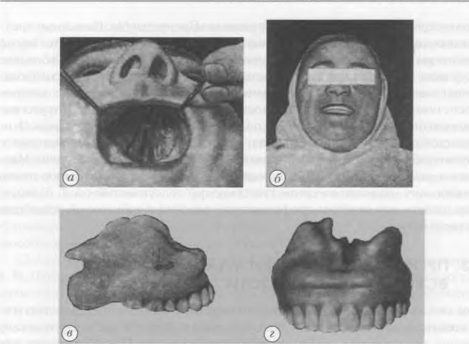

Fig. 40. Prosthetics after resection of the upper jaw according to Oxman.

a — The type of postoperative defect of the upper jaw; b — the patient's face after prosthetics: c, — the appearance of the resection prosthesis

and the separation of the oral cavity and nose. The massive obturating part of the prosthesis can be an additional traumatic factor.

The operating cavity narrows depending on the time elapsed after the operation, due to the ongoing scarring process, so the prosthesis periodically needs correction (Fig. 40).

The tasks and methods of prosthetics of patients after mandibular resection are determined by the type of resection. the size of the bone defect, the number of teeth on the preserved part of the jaw and the condition of their periodontal. In case of resection of the mandible with loss of its continuity , the tasks of prosthetics include:

1) keeping bone fragments in the correct position and preventing their mixing;

2) restoration of the patient's appearance, speech, chewing;

3) replacement of a postoperative bone defect; 4) formation of a prosthetic bed; 5) preservation of the remaining teeth.

When resecting the lower jaw while maintaining the continuity of its body or when resecting with simultaneous bone grafting, other tasks come to the fore, namely:

1) replacement of the bone defect

of the chin of the lower jaw

2) restoration of the patient's appearance, speech, chewing; H) preservation of the remaining teeth;

4) preservation of the viability of the bone graft.

In the first case, the tasks are solved by direct prosthetics or the use of splints, in the second — by remote prosthetics.