THE USE OF IMPLANTS IN ADENTIA

The successful development of implantology and orthodontics, the interaction of these disciplines, as well as the emergence of new technologies in dentistry allow for the combined treatment of patients with the absence of dental rudiments. The possibility of using implants after orthodontic treatment was reported by 1.. Linkow back in 1970, A. NOI in 1981 drew attention to the fact. that the absence of rudiments of teeth is an absolute indication for implantation in adolescents. The use of implants in congenital adentia avoids the preparation of healthy teeth during prosthetics with bridges and negative effects on the mucous membrane when using removable dentures (cosmetic plates). When orthodontic teeth are moved, the use of implants to eliminate defects also gives a functional result of treatment, since, according to kobes (1984), the loss of each tooth leads to a weakening of the chewing function.

The use of implants in the treatment of congenital adentia has been proven by long-term clinical and experimental studies.

According to A. A. Kulakov (2002), there may be a congenital absence of any dental element, but more often there are no second lower premolars, upper lateral incisors, second upper premolars and third molars. Adentia of one or both of the second incisors of the upper jaw is most common in girls.

When choosing a treatment method, age and the results of an orthodontic examination are taken into account. the number of missing teeth, X-ray examination data (bone density, location of the bottom of the maxillary sinuses. the topography of the mandibular canal), the width of the alveolar process and the extent of the defect, the presence of antagonist teeth, the presence of dentoalveolar bruising, the thickness of the mucous membrane, periodontal status.

The age limit when using implants is determined by different authors in different ways. Thilander (1994) installed 27 VgapetagK implants. 15 of them are teenagers aged 13-19 years. The patients were followed up for 3 years. There were no complications, except for a small bone loss both at the implant level and at the surface level of adjacent teeth. Lederman, Schroeder and Sutter 0982) found that before the completion of jaw growth, the bone segment with the inserted implant also grows. Will (199 [ ) recommends implantation in adolescents after the age of 16.

According to R. However, after the end of teething, the process of jaw growth continues in girls up to 16-18 years, in boys — up to 18-20 years. V. kokich examined patients 14-15 years after orthodontic treatment. The best moment for implantation, in his opinion, is the completion of the growth of the bones of the linear part of the skull (the stability of the distance N/Me), i.e. the absence of the dynamics of the facial line. And the best method of determining the end of this process is to conduct two consecutive gelerentgenographs: 1st — after the patient passes the peak of growth, 2nd - after 6-12 months. To assess the development of bones, an X-ray of the hand is also examined.

In 1989, at the conference on implantology of the DGZMk Society of Implantologists, it was stipulated that "in adolescents, implantation can be carried out only after the end of jaw growth, and in children under 15 years old only if orthodontic closure of the dentition defect or replantation is impossible."

Treatment should be carried out under X-ray and CT control, bone density should be determined according to radiography and echosteometry. In addition, it is useful to evaluate the periodontal blood supply, microcirculation and oxygen exchange, to study diagnostic plaster models of dentition and telerentgenograms.

In the Department of Clinical and Experimental Implantology of the Central Research Institute for the Purpose of optimal placement of implants in the bone, plaster models were sawed, then the thickness of the mucous membrane at the intended place of implant placement was measured with a special instrument and the data obtained were transferred to the model.

All patients underwent clinical and laboratory tests to identify contraindications, and based on functional and clinical results, a strategy was developed to prepare them for surgery.

The stage of manufacturing orthopedic construction began in patients with implants installed on the upper jaw after 5-6 months, on the lower jaw after 3-4 months.

The analysis of the literature data, as well as our own clinical observations indicate the high efficiency of the use of implants in congenital adentia with mandatory previous orthodontic training.

USE OF SUBPERIOSTEAL IMPLANTS FOR REHABILITATION

PATIENTS WITH SIGNIFICANT BONE ATROPHY OF THE JAWS

There are a lot of implant designs that make it possible to compensate for the loss of teeth. But with significant atrophy of the alveolar process, the installation of intraosseous implants becomes problematic. In these cases, it is advisable to use various designs of subperiosteal implants.

V. Weinberg describes in detail a one-stage procedure for operations using cobalt-chromium alloy (CCC) implants.

The pressure method is used to make a cast of the area to be implanted with missing teeth. Then the contours of the implant base are transferred to the model. Under local anesthesia, by inserting a pointed probe into the tissue until it comes into contact with the bone, the thickness of the mucous membrane and periosteum is determined directly above the place where the implant head will be located and the prosthesis is fixed. The medial and distal depth of this zone is marked by a movable gasket on the probe rod. The received data is recorded and, based on them. such a layer is removed from the model so that the implant is located below the level of the mucous membrane and periosteum. In the future, the results of measuring the depth of the zone are used to determine the distance between the lower surface of the jaw and the surface of the mucous membrane. The thickness of the mucous membrane is measured in the same way on each of the 4 angular projections of the implant to determine the thickness of the layer that should be removed from the model so that the implant matches the contour of the underlying bone as best as possible. After that, a future implant is modeled from wax and cast from vitellium on the model. The implant is cleaned and sandblasted, but not polished. The author believes that the fibers of the periosteum are easier to strengthen on the surface of the vitallium treated with a sandblaster than on a polished implant.

Further, V. Weinberg describes in detail the procedure of operations, paying special attention to the type of incision in the shape of the letter "B", the thoroughness of its execution without repeated incisions. This is required to prevent injury to the edges of the wound, which should subsequently connect. The author also emphasizes that the incision from the buccal side should not take place in the area of the future implant. After the implant is inserted, the wound is sutured with silk. The stitches are removed after 5 days. Naturally, due to the incomplete adaptation to the bone, the implant is mobile, but after 10 days it becomes stable, and the surrounding tissue takes on a normal appearance. After 4-5 weeks, the implant is firmly fixed to the bone, which makes it possible to make a denture.

Based on his personal experience, V. Weinberg notes that subperiosteal implants made using this technique have performed well both from the functional side and from the point of view of convenience. Sure. using this technique, he could not achieve a good adaptation of the implant to the bone, but sought to bring its shape closer to the relief of the jaw with minimal injury to soft tissues.

One of the most important conditions for the success of subperiosteal implantation is the removal of an accurate impression. Specialists also emphasize the need for atraumatic conduct of all stages of the operation, preferring a two-stage method,

In the beginning, an individual spoon is made directly in the patient's mouth. The incision is made along the top of the alveolar ridge, the surface of the jaw is skeletonized, and the drawn edges of the muco-periosteal flap are fixed with silk threads to the neck or the existing teeth of the opposite side. This fixation of the flap achieves a convenient approach to the exposed bone. Elastic materials are used for the impression. Be sure to take a general impression to establish a central occlusion. After removing the impression, the edges of the wound are sewn with rare stitches.

The second stage of subperiosteal implantation — the introduction of the implant — is carried out after 6-8 weeks. after complete healing of the wound.

In order to increase the metal's bio-tolerance and strengthen the connection between the implant and the periosteum, the outer surface of the implant is coated with bioactin material hydroxyapatite (HA). Due to this, any inflammatory process that occurs after subperiosteal implantation will be minimal and localized.

On the other hand, according to a number of researchers, the GA coating applied directly to the implant does not provide mechanical support, and therefore the implant is predisposed to defects due to chipping or resorption of the coating. After GA resorption, the new bone tissue remains unsupported, which can lead to implant failure.

M. McMi11an et al. in 1993 proposed to apply a composite coating consisting of a porous titanium layer to the subcostal implant by plasma spraying, and then — also by spraying — GA. In this composite coating, the outer HA layer, which by its nature is weak and brittle, is tightly adjacent to the lower porous titanium layer, which creates a zone of tight adhesion between the two layers of the coating.

The subject of the search is the creation of an endosubperiosteal implant that combines the positive properties of endossal and subperiosteal implants.

Endosubperiosteal implants have a very complex geometry and are very difficult to manufacture. The bendable subperiosteal elements do not provide adaptation to the bone and cannot serve as a full-fledged support. The minimal endossal part does not contribute to the firm fixation of the implant and adequate transfer of the chewing load. An analysis of the clinical results of the use of these implants showed that the endossal part should be maximal, and the subperiosteal as a unifying and stabilizing part should be minimal due to its probable exposure.

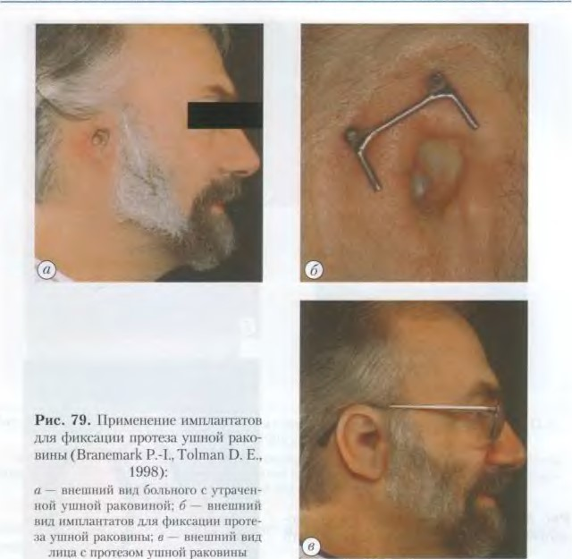

9.3.

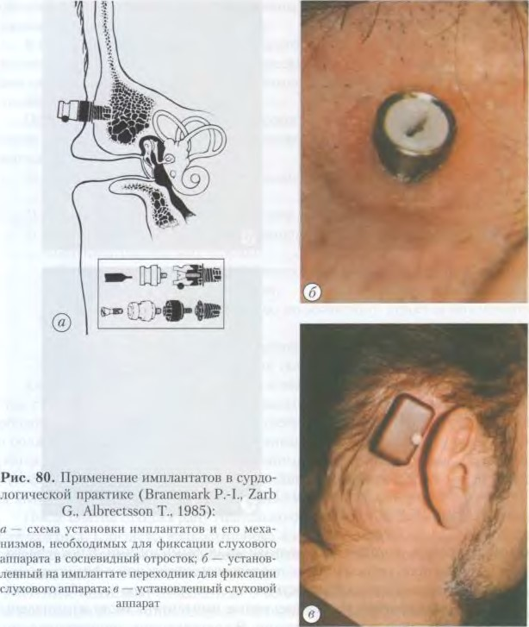

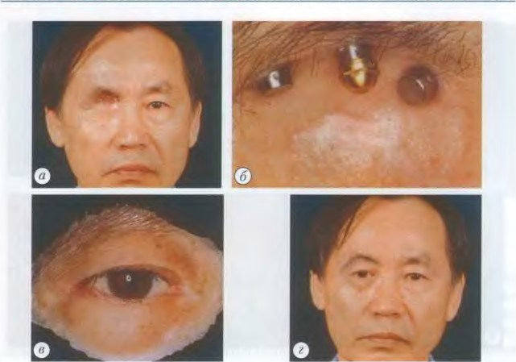

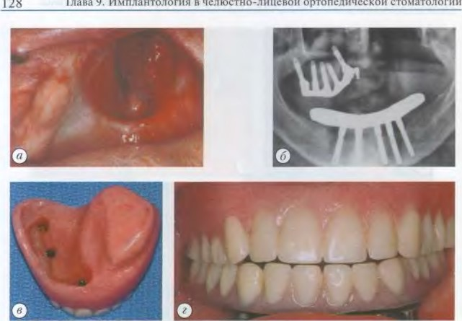

челюстно-лииевой