An 11-year-old patient came to the dental clinic with complaints of tooth pain.

4.6. The pain is spontaneous, periodically occurring, long-lasting, and can be relieved by taking painkillers. Over the past few days, the pain has intensified, and night pain has appeared.

Objectively: the face is symmetrical. The submandibular nodes are enlarged and painless on palpation. There is a filling in tooth 3.6, the color of the tooth is with a grayish tint. Percussion is painless, thermometry is painful

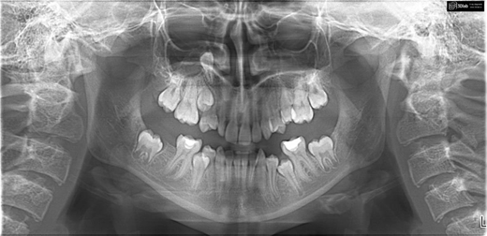

Questions

1. Make a diagnosis.

2. Carry out differential diagnosis.

3. Fill out your medical record.

4. What additional research methods can be carried out.

5. Create a treatment plan for the patient.