A 45-year-old patient came to the clinic with complaints of pain in the lower jaw on the right and swelling of the cheek on the right. According to the patient, teeth 4.6 and 4.5 were removed 3 months ago.

Objectively: facial asymmetry due to swelling of the soft tissues of the masticatory area on the right. The transitional fold is smoothed, the mucous membrane is swollen, hyperemic, and a symptom of fluctuation is noted. There are fillings in teeth 4.7, 4.8, 4.5, percussion is painless, the color of the teeth is not changed, thermometry is painless.

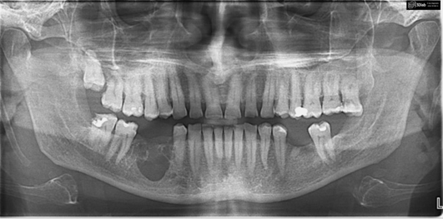

Questions

1. Make a diagnosis.

2. Carry out differential diagnosis.

3. Fill out your medical record.

4. What additional research methods need to be carried out.

5. Create a treatment plan for the patient.