Adhesive/Maryland bridge

In fact, the chewing function is impaired even in the absence of one tooth, the load on the remaining teeth increases and, over time, adjacent teeth move towards the missing one, the bite changes and aesthetic and psychological problems arise in patients. Timely restoration of the unity of the dentition leads to normalization of aesthetics, function and prevents secondary deformations.

Modern dentistry offers three options for solving the problem: implantation, bridge construction, removable microprosthesis or adhesive bridge construction. All these types of prosthetics have every right to exist and are widely used in dental practice. They all have their advantages and disadvantages.

The adhesive bridge design was first proposed at the University of Maryland and therefore this type of prosthesis is often called the “Maryland bridge.” These bridges are designed to replace one or two teeth. The technology of adhesive composite bridge structures performed directly in the mouth during one patient visit was developed by Sergei Radlinsky in the early 90s and published in 1998. The technique became possible after the advent of modern composite and fiberglass materials. This method of replacing an included defect has undergone modification, which has made it possible to significantly improve the technology.

Essentially, it is an artificial tooth that is bonded to two adjacent natural teeth. Compared to a conventional bridge, any adhesive bridge prosthesis can be called “gentle” - there is no need to grind the supporting teeth and install dental crowns.

The Maryland bridge, in the pontic part of the prosthesis, has a porcelain coating, and the fixing metal part is glued to the palatal surface of the etched enamel of the supporting teeth. The attached surface of the prosthesis is sandblasted and a dual-cure adhesive is used as a fixing material, which bonds to both the tooth enamel and the metal

. 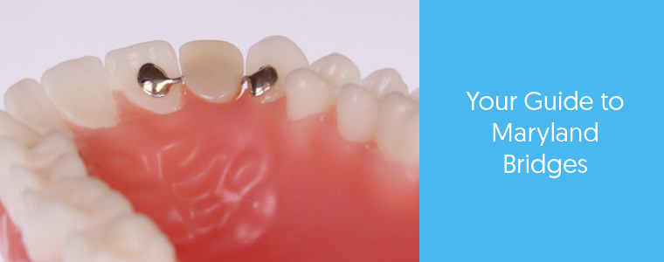

It is possible to avoid radical tooth preparation while simultaneously splinting mobile teeth and achieving reliable fixation of the prosthesis using a design that domestic authors mainly call an adhesive bridge prosthesis (AMP), better known in foreign literature under the term pontic. This type of prosthetics uses fiberglass systems.

Fiberglass systems contain quartz or zirconium fibers of inorganic nature. For example, Connect (Kerr, USA), Splint-ti (Pentron Clinical, USA), “EverStick” (Stick Tech, Finland), DENTAPREG (Advanced Dental Material, Czech Republic). Thanks to saturation with an adhesive composition under special conditions, complete homogenization of glass fibers after curing and a complete chemical connection with the composite material are achieved. The use of this technique in dentures has become a significant step forward in terms of aesthetics, strengthening of restorations and splinting of mobile teeth, elasticity during operation and the integration of bridge elements into a single whole.

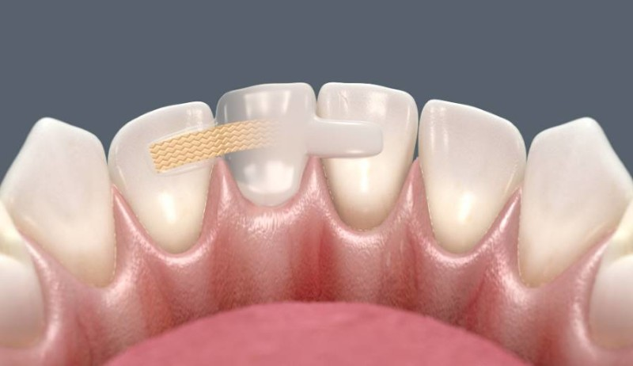

Indications for the manufacture of adhesive bridge structures.

▪ When defects of small dentition are included. Absence of teeth extending to a maximum of two teeth.

▪ If necessary, simultaneous replacement of a dental defect and splinting, due to periodontal diseases.

▪ If it is necessary to urgently replace a missing tooth for aesthetic purposes.

▪ When solving the problem of missing teeth associated with congenital adentia or injuries in young people aged 14 to 18 years, when implantation is undesirable due to incomplete formation of bone tissue.

▪ Refusal of the patient from classical orthopedic methods of restoration.

▪ Production of a temporary bridge, for example with two-stage implantation.

Contraindications for performing adhesive bridge structures

1. Significant destruction of the supporting teeth (over 60% of the crown area) and if the hard tissues of the teeth are not able to perceive full adhesion.

2. Pathological abrasion, low clinical crowns.

3. Increased chewing load in the area of the intermediate part of the adhesive bridge structure, in the absence of more than two teeth.

4. Parafunctions (Parafunctions of the masticatory muscles manifest themselves in the form of involuntary and poorly controlled by patients contractions of the facial muscles, biting the lips, cheeks, and tongue), bruxism.

5. Rotation and significant inclination of the supporting teeth.

The method of prosthetics with adhesive bridge structures is an addition to traditional methods of indirect dental restoration and has its advantages:

- it requires minor preparation of the supporting teeth, which always remain vital (alive);

- the prosthesis is manufactured in a short time;

- due to the fact that a chemical connection is provided between all structural elements and the composite has the ability to undergo elastic deformations (like natural dental tissues), the micromobility of the supporting teeth is maintained and the periodontium is not overloaded.