 Classifications of dentition defects

It should be noted that all classifications have disadvantages and positive aspects. Any classification makes it easier to study the clinical picture of partial tooth loss, reduces entries in the medical history and, finally, helps mutual understanding between doctors. But not a single classification gives precise instructions for the use of a particular prosthesis, since it is not able to fully reflect the complex clinical picture of partial tooth loss, the type of bite, the condition of hard tissues and periodontal disease.

Betelman A.I. divides dentition with defects into two classes. The first category includes dental arches that have one or more defects, but one or two of them are terminal. The second class consists of dentitions with included defects. In addition, within each class it distinguishes subclasses.

Classification of dentition defects according to Betelman a. AND.

Defects of dental arches

I class

One or more defects

among which at least one is limited only on the mesial side, class II

One or several defects,

but all defects are limited on both sides

I subclass

The defect is located on one side, class II

Defects are located on both sides I subclass

In each of the defects there are no more than three missing teeth II subclass

There is at least one defect in which the number of missing teeth is more than three

Gavrilov E.I. proposed his own classification of dentition defects (see figure). Its peculiarity is the separation of jaws into a separate group with single preserved teeth. According to this classification, four groups of defects are distinguished: 1) end (unilateral and bilateral); 2) included (lateral – one-sided, two-sided and anterior); 3) combined; 4) jaws with single preserved teeth. Preparation and methods of prosthetics for such defects have their own characteristics.

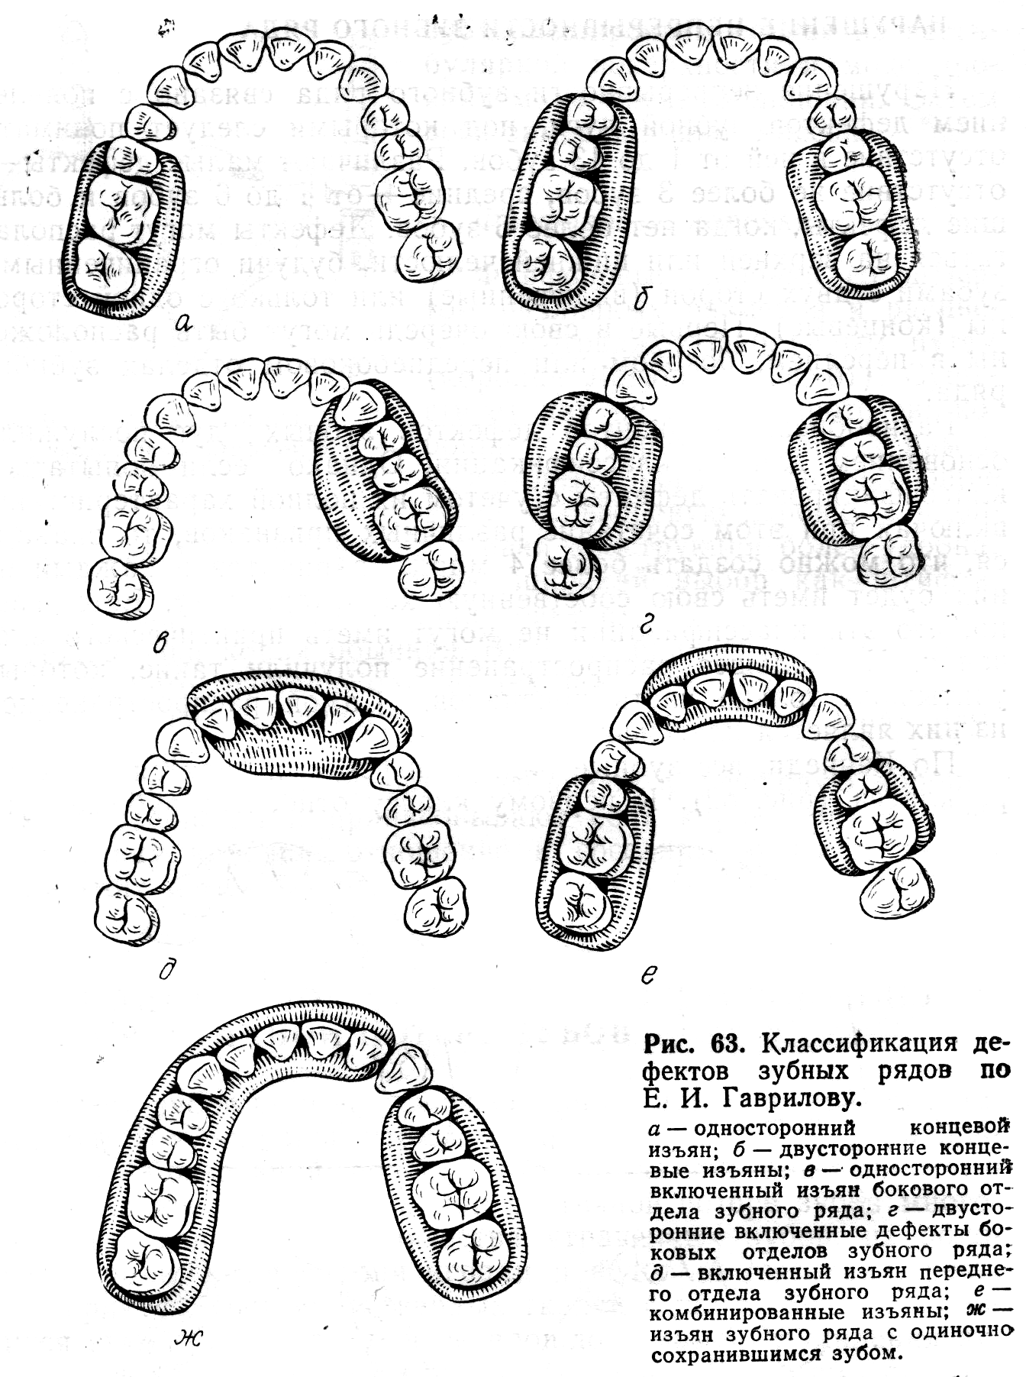

According to Kennedy, all dentitions with defects are divided into four classes (see figure). The first class includes dental arches with bilateral end defects, the second class includes dental arches with unilateral end defects, the third class includes dental arches with defects included in the lateral section, and the fourth class includes defects in the anterior section of the dental arch. Each class, except the last one, has subclasses.

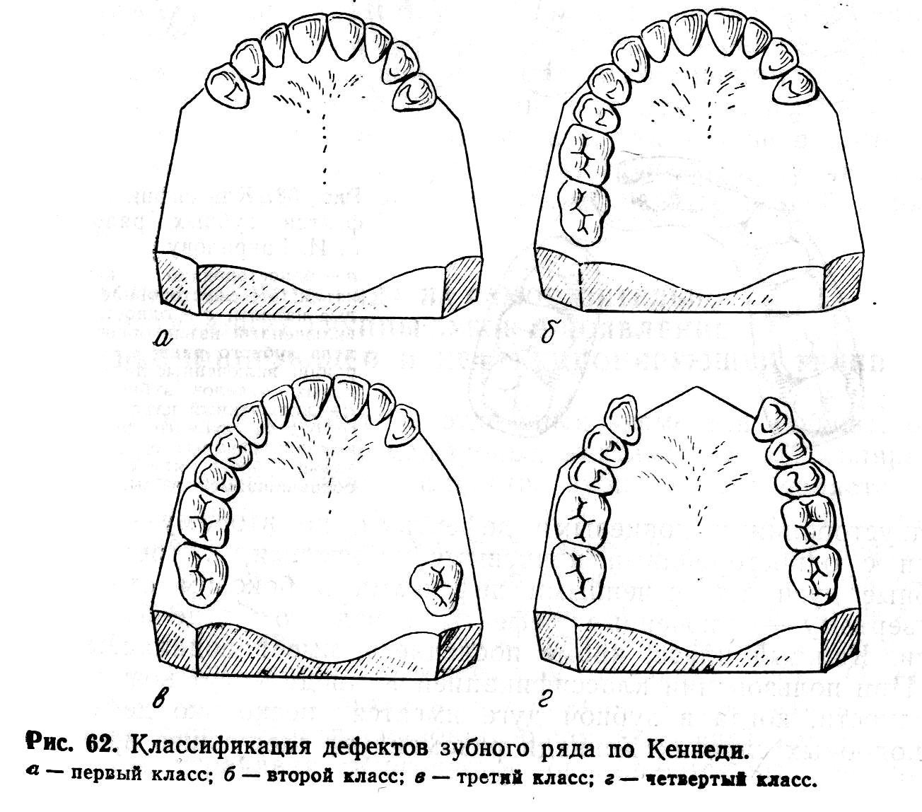

При пользовании классификацией Кеннеди могут возникнуть трудности, когда в зубной дуге имеется несколько дефектов. В подобных случаях рекомендуется следовать правилам (дополнениям) Апплегате:

1. Определение класса дефекта не должно предшествовать удалению зубов.

2. Если отсутствует третий моляр, и он не должен быть замещен, то он не учитывается в классификации.

3. Если имеется третий моляр, и он должен быть использован как опорный зуб, то он учитывается в классификации.

4. Если отсутствует второй моляр, и он не должен быть замещен, то он не учитывается в классификации.

5. Класс дефекта определяется в зависимости от наиболее дистально расположенных беззубых участков.

6. Дополнительный дефект рассматривается, как подкласс, и определяется их числом.

7. Величина дополнительных дефектов не рассматривается, учитывается только их число, определяемое нормой подкласса.

8. Четвертый класс не имеет подклассов