METHODS FOR DETERMINING CENTRAL OCCLUSION IN THE PARTIAL ABSENCE OF TEETH

METHODS FOR DETERMINING CENTRAL OCCLUSION IN THE PARTIAL ABSENCE OF TEETH

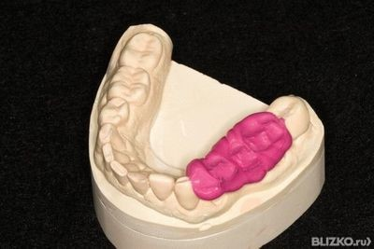

Occlusion is the simultaneous and simultaneous closure of a group of teeth or dentition with the contraction of the masticatory muscles and the corresponding position of the elements of the temporomandibular joint.

The determination of central occlusion is one of the important stages of prosthetics in case of partial loss of teeth. It consists in determining the relationship of the dentition. The height of the lower part of the face is directly related to the central occlusion.

With the existing antagonists, the height of the lower part of the face is fixed by natural teeth and it only needs to be registered.

When they are lost, it becomes unfixed and needs to be determined.

With partial loss of teeth , the following clinical options for determining central occlusion are possible:

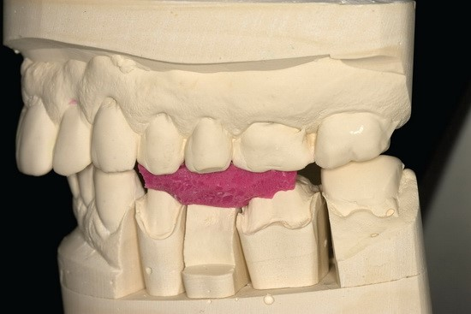

) Antagonist teeth were preserved in three functionally oriented groups of teeth: in the area of the anterior and chewing teeth on the right and left sides. The height of the lower part of the face is fixed by natural teeth. The central occlusion is established on the basis of the maximum number of occlusal contacts, recorded with silicone masses, without resorting to the manufacture of wax occlusal rollers.

2) There are antagonist teeth, but they are located only in two functionally oriented groups (anterior and lateral sections or only in the lateral sections on the right or left). In this case, it is possible to compare the models in the position of the central occlusion only with the help of occlusive wax rollers. The definition of central occlusion consists in fitting the occlusal roller of the lower jaw to the upper jaw.

3) There are teeth in the oral cavity, but there are no pairs of antagonist teeth (there is no occlusion of teeth). In this case, we are talking about the central ratio of the jaws.

It consists of several stages:

- formation of the prosthetic plane;

- determination of the height of the lower part of the face;

- fixation of the mesiodistal ratio of the jaws.

To fix the central ratio of the jaws in the 2nd and 3rd cases, it is necessary to manufacture wax (preferably plastic) bases with occlusive wax rollers.

There are the following methods of setting the lower jaw to the position of central occlusion:

• Functional method - to place the lower jaw in the position of central occlusion, the patient's head is tilted back a few times. The neck muscles are slightly strained at the same time, preventing the lower jaw from moving forward. Then the index fingers are placed on the occlusal surface of the lower teeth or a wax roller in the molar area so that they simultaneously touch the corners of the mouth, slightly pushing them aside. After that, the patient is asked to raise the tip of the tongue, touch the posterior parts of the hard palate with it and at the same time make a swallowing movement. This technique almost always eliminates the reflex extension of the lower jaw forward. When the patient closes his mouth and the occlusal rollers or occlusal surfaces of the teeth begin to converge, the index fingers lying on them are removed in such a way that they do not interrupt communication with the corners of the mouth all the time, pushing them apart. Closing the mouth using the described techniques should be repeated several times until it becomes clear that the correct closure of the dentition takes place.

• The instrumental method involves the use of a device that records the movements of the lower jaw in a horizontal plane. The position of the central occlusion corresponds to the top of the "Gothic angle" formed when recording laterotrusion and protrusion movements of the lower jaw. With partial absence of teeth, this method is rarely used, only in difficult cases of clinical practice. At the same time, the forcible displacement of the lower jaw is carried out by the pressure of the doctor's hand on the patient's chin to match. In severe clinical cases, it is also possible to use the K7 diagnostic system, this diagnostic equipment is used to analyze the state of the masticatory muscles and the trajectory of movement of the lower jaw, to assess the noises that occur in the temporomandibular joint during movement of the lower jaw.

With a significant absence of teeth, and most importantly - in the absence of pairs of antagonists, the formation of the occlusal surface is carried out using the Larin apparatus or two special rulers. The occlusal surface should run parallel to the pupillary line in the frontal plane, parallel to the nasolabial line in the lateral sections. In height, the plane of the occlusal wax roller should correspond to the line of closure of the lips. After determining the height of the lower part of the face, the lower wax roller is stored to the upper one. The rollers should be tightly closed in the anteroposterior and transversal directions, and their buccal surfaces should be in the same plane. When closing the mouth, the wax rollers simultaneously touch in the anterior and lateral sections, and the wax bases fit tightly to the surface of the mucous membrane. All corrections are carried out only on the roller of the jaw where the smallest number of teeth has been preserved (wax is added or its excess is removed with a heated spatula).

There are several methods for determining the height of the lower part of the face.

• Anatomical - based on the study of the configuration of the face.