**Organization of retail space and principles of its use.**

Lecture outline:

1. Determining priority places on the sales floor. Separation of product groups (the “Golden Triangle” rule).
2. Determining the directions of customer flow and changing it using special retail equipment. Information navigation rule.
3. Approaches to color solutions in merchandising.

Proper placement of commercial equipment affects the efficiency of a pharmacy organization. There are two ways of trading: open display of goods and the traditional way of trading from behind the counter. The option with an open display gives more possibilities: not only wall-mounted shelving and display cases work, but also the area in the center of the sales floor. In accordance with the rules of merchandising, the directions of movement of buyers are calculated, product groups of medicines and cosmetics, goods of impulse demand are laid out accordingly, which the buyer simply cannot help but notice on his longest journey from the first display cases to the checkout. Wall displays and shelving alternate with island equipment, which even supports side panels.

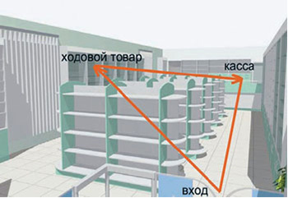

***Photo - Golden Triangle Rule***

**Golden triangle rule**lies in the fact that the most purchased product groups are located as far as possible from the entrance, and the cash register unit is located at the other end of the sales floor, so that they can be connected into a triangle. This is done so that the buyer walks through the entire hall in search of the right product and buys a few more along the way.

In addition, merchandisers propose dividing the retail space of a pharmacy supermarket into separate zones and using each of them with maximum efficiency. In particular, in the visitor service area, which includes aisles for viewing display cases, their width should be correctly calculated. In this case, in each specific case, the density of the consumer flow, i.e., the number of buyers per unit area, should be taken into account.

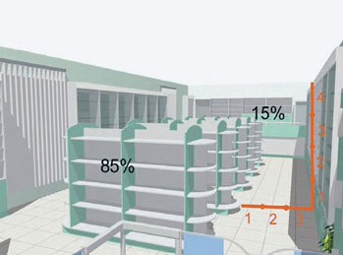

***Photo - Optimal ratio of furniture height and aisle width***

It is also necessary to take into account the height of commercial equipment. With tall equipment and a narrow aisle, the buyer will feel cramped, unsafe and even threatened. Experts recommend a ratio of aisle width to equipment height of 3:4 as optimal.

Installing high display cases and shelving can significantly save retail space, but the display of medicines in this case should be organized taking into account the characteristics of the human eye.

When the head is stationary, a person's field of vision covers an angle of 54 degrees horizontally, 27 degrees up and 10 degrees down from eye level - vertically. The optimal location of the product will be in this area. With an average human height of 165 cm, the optimal visibility zone will be located at a height of 155 cm, and the range will depend on the viewing distance from the rack. The greater the distance, the wider the optimal viewing area.

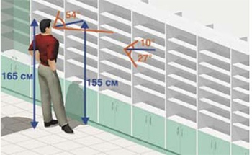

***Photo -Range of perception of the displayed product***

It is known that inside a pharmacy, a buyer moves along the sales floor at an average speed of 1 m/sec, and the human eye is able to mark the image of an object if it is in the field of view for at least 1/3 of a second. In addition, the buyer best sees the product located at eye level (120-160 cm from the floor). Taking into account these data, in order for the drug to be noticed by the buyer, the space on the shelf allocated for it must be at least 33 cm. Hence the principle of display windows: drugs by therapeutic groups, in the form of displays, must be located at a distance of at least 33 cm. Such a display, located in showcases, takes up little space and is provided with brief information about each drug.

Merchandisers also calculated a special coefficient of installation area, which is defined as the ratio of the area occupied by equipment (installation area) to the total area of ​​the sales floor. If the value of this installation area coefficient exceeds 0.35, then, most likely, the pharmacy is overloaded with equipment, and customers will feel cramped and uncomfortable in it. If the indicator is less than 0.25, then the premises are used ineffectively and the possibility of increasing the number of commercial equipment should be considered.

In pharmacies with a large sales area, the installation area ratio, on the contrary, is often underestimated. In this situation, the pharmacy can introduce additional display cases, equip a seating area for customers, as well as an area for holding various promotions.

*Creating the atmosphere of the trading floor is also*

*merchandising tool.*

**Atmosphere of the trading floor**- this is a set of external factors present in the trading floor and having a certain impact on sensory receptors and the psychological state of a person, focused on the formation of emotional and sensory components of the behavior of a visitor to the trading floor and their management.

The main task in creating the atmosphere of the sales floor is to ensure that it meets merchandising goals and contributes to increasing sales. To do this, they use lighting, colors, music, smells, temperature and other elements that can form a predictable emotional state, reveal stimulating adaptive abilities, and ensure a positive perception of goods by customers.

The pharmacy is not the place to use aggressive and dark shades (red, yellow, purple, crimson). Warm colors excite people, and their breathing may become faster or their blood pressure may increase. Cool tones (shades of blue, cyan or green), on the contrary, calm people down. This is due to the fact that people associate white with purity, blue with the sea, green with the forest. You can reduce activity with the help of cold tones in places with large crowds of people, for example in the cash register area. It is unacceptable to use black and brown colors, which evoke sad thoughts.

Lighting is a very important component of a pharmacy's atmosphere. In bright lighting, the product appears more attractive. With the help of the right light, you can turn a “cold” display case into a “hot” one.

The temperature in the pharmacy is an equally important component. It's nice to be in a cool pharmacy when it's 30 degrees outside! And how you don’t want to leave the warm and cozy pharmacy hall into the severe winter weather raging with a blizzard! The most pleasant temperature for buyers - 16-18 degrees Celsius - can be achieved using an air conditioner.

**PRACTICAL LESSON**

**EXERCISE 1.**Solve the problem. The pharmacy manager went out to the over-the-counter department, where at that time the visitors standing in line were irritably listing the shortcomings in the design of the department's windows: medications were arranged in such a way that the price tags obscured their names; Most of the display cases are occupied by drugs from the group of antifungals, contraceptives, as well as drugs for weight loss, for the treatment of gastrointestinal diseases, and expensive medicinal cosmetics, while drugs for the treatment of seasonal respiratory diseases and influenza are located in the farthest corner, and their difficult to detect. Analyze the situation presented and give a critical assessment. Is there a violation of merchandising principles in the pharmacy? If yes, which ones?

**Test tasks**

Pharmacy merchandising is

1. a set of measures for placing goods and advertising materials on the shelves and display cases of the pharmacy in order to sell the goods as quickly as possible
2. activities for placing goods and advertising materials on pharmacy shelves and display cases
3. a set of measures for planning the sales floor, placing goods and advertising materials on the shelves and display cases of the pharmacy in order to sell the goods as quickly as possible
4. measures to plan the sales floor in order to sell the goods as quickly as possible

The golden triangle rule is that

1. the most purchased product groups are located as far as possible from the entrance, and the cash register is at the other end of the sales floor
2. the most purchased product groups are located as close as possible to the entrance, and the cash register is at the other end of the sales floor
3. the most purchased product groups are located as far as possible from the entrance, next to the cash register
4. The cash register is located as far as possible from the entrance, and the least purchased product groups are at the other end of the sales floor

The optimal ratio of aisle width and equipment height in a pharmacy sales area:

1. 3:4
2. 1:2
3. 1:3
4. 2:3

A buyer moves around the pharmacy sales floor at an average speed:

1. 1 m/sec
2. 0.5 m/sec
3. 1.5 m/sec
4. 2 m/sec

The buyer best sees the product on a shelf located at a distance from:

1. 120-160cm
2. 160-180cm
3. 100-120cm
4. 80-160cm

Drugs by therapeutic group, in the form of displays, should be located at a distance:

1. not less than 33 cm
2. no more than 33 cm
3. not less than 55 cm
4. no more than 55 cm

If the installation area coefficient value exceeds 0.35, then most likely the pharmacy:

1. overloaded with equipment
2. uses the sales floor ineffectively
3. makes optimal use of commercial equipment
4. does not have the opportunity to use commercial equipment

The atmosphere of the trading floor is formed by the following factors EXCEPT:

1. lighting
2. color in the interior
3. temperature
4. staff

Optimal temperature for customers in the sales area:

1. +18-20 0С
2. +16-18 0С
3. +12-18 0С
4. +18-25 0С

In the design of a sales area it is unacceptable to use:

1. Blue
2. Blue color
3. White color
4. Brown color