during complex dental operations, including those related to prosthetics and implantation, doctors need to take into account the individual features of the structure of the maxillofacial apparatus of the patient, namely, the trajectory of movement of the lower jaw. The existing trajectory may deviate from the normal one in case of tooth loss, malocclusion and in a number of other cases. If you do not take this point into account, prosthetics can result in discomfort during chewing movements, headaches and other problems. Special articulator devices are used in dentistry to determine the individual trajectory of movement of the mandible.

The use of dental articulators

Articulators are used in the following cases:

• for the diagnosis of occlusion and the choice of occlusive correction techniques;

• during diagnostic grinding of teeth;

• in the manufacture of prostheses of any design: removable, non-removable and partially removable (laboratory, technical stage);

• in the manufacture of crowns;

• in orthodontic practice – in the manufacture of bite patterns and other designs;

• when determining the presence of supracontacts;

• when planning complex dental treatment.

Articulators are a guarantee for the manufacture of high-quality dental structures and an easy process of adaptation to them without discomfort and other troubles associated with getting used to the prosthesis.

See also: metal-free ceramics, metal ceramics

Types and types of articulators

There are four main types of articulators:

1. Simple hinged. Lateral movements are excluded. They are used as visual aids.

2. Medium anatomical. Incisor and articular angles are completely fixed. Such devices are used when prosthetics are performed with complete adentia, as well as in the manufacture of single crowns.

3. Semi-adjustable. The mechanisms of the devices are adjusted according to the average statistical data or according to the angles obtained with the help of other devices. The angle of the Bennett and sagittal articular pathway are adjustable.

4. Fully adjustable/universal dental articulators with facial arch. These devices are configured based on individual axiographic or pantographic recordings of the trajectory of the lower jaw, transferred to the articulator using the facial arch. Such complex articulators are used when a complete reconstruction of occlusion is necessary.

When choosing a device, it is necessary to take into account the level and volume of the robot that needs to be carried out in the articulator. In serious and complex cases (in the analysis of complex and pathological occlusions, the manufacture of volumetric orthopedic structures, total restorations), a universal articulator is necessary. You can buy articulators, including those with a facial arch, at any professio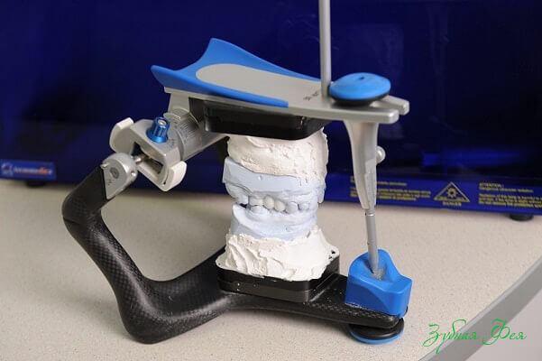nal medical equipment store.