A patient V. 48 years old turned to the clinic of orthopedic dentistry. Complaints: lack of teeth in the lateral areas of the lower jaw and difficulty chewing

Anamnesis of the disease: I have not consulted an orthopedic dentist for eight years.

The last extraction of teeth 18 and 28 was 4 years ago.

Objectively during the inspection:

The remaining teeth on the upper and lower jaws have 1 degree of tooth mobility. The mucous membrane is pale pink in color. There is attrition of the frontal group of teeth of the lower jaw by 1/3. The height of the lower part of the face in the state of central occlusion is reduced by 3-4 mm. There are symptoms of periodontitis on the upper and lower jaw in the area of all teeth.

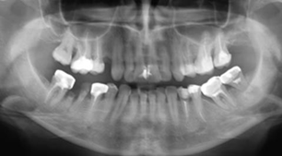

1. Make a diagnosis.

2. Formulate the objectives of the treatment.

3. Make an orthopedic treatment plan.

4. Make a therapeutic treatment plan to prepare the oral cavity for orthopedic treatment.

5. Make a plan for surgical preparation of the oral cavity for prosthetics.