The patient V. 65 years old applied to the clinic of orthopedic dentistry. Complaints: lack of teeth in the lateral areas of the lower jaw and difficulty chewing.

Anamnesis of the disease: I have not consulted an orthopedic dentist for eight years.

The last tooth extraction was 3 years ago.

Objectively during the inspection:

The remaining teeth in the upper jaw have 1-2 degrees of tooth mobility. The mucous membrane is pale pink in color. There is attrition of the frontal group of teeth of the upper and lower jaw by 1/3. Mobility of 41.42.31.32 3 degrees is noted. The height of the lower part of the face in the state of central occlusion is reduced by 6-8 mm. There are symptoms of periodontitis on the upper and lower jaw in the area of all teeth.

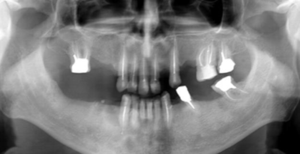

Questions

1. Make a diagnosis.

2. Formulate the objectives of the treatment.

3. Make an orthopedic treatment plan.

4. Make a plan for surgical preparation of the oral cavity for prosthetics.

5. Biological and clinical foundations of bridge prosthesis treatment. Justification of the choice of the number of supporting teeth