The patient V. 46 years old applied to the clinic of orthopedic dentistry. Complaints: difficulty chewing food due to lack of teeth 3.5, 3.6.

Anamnesis of the disease: missing teeth 3.5, 3.6 were removed due to caries and its complications during the last 10 years. The existing crown on the 1.6 tooth was made 3 years ago.

Objectively during the inspection:

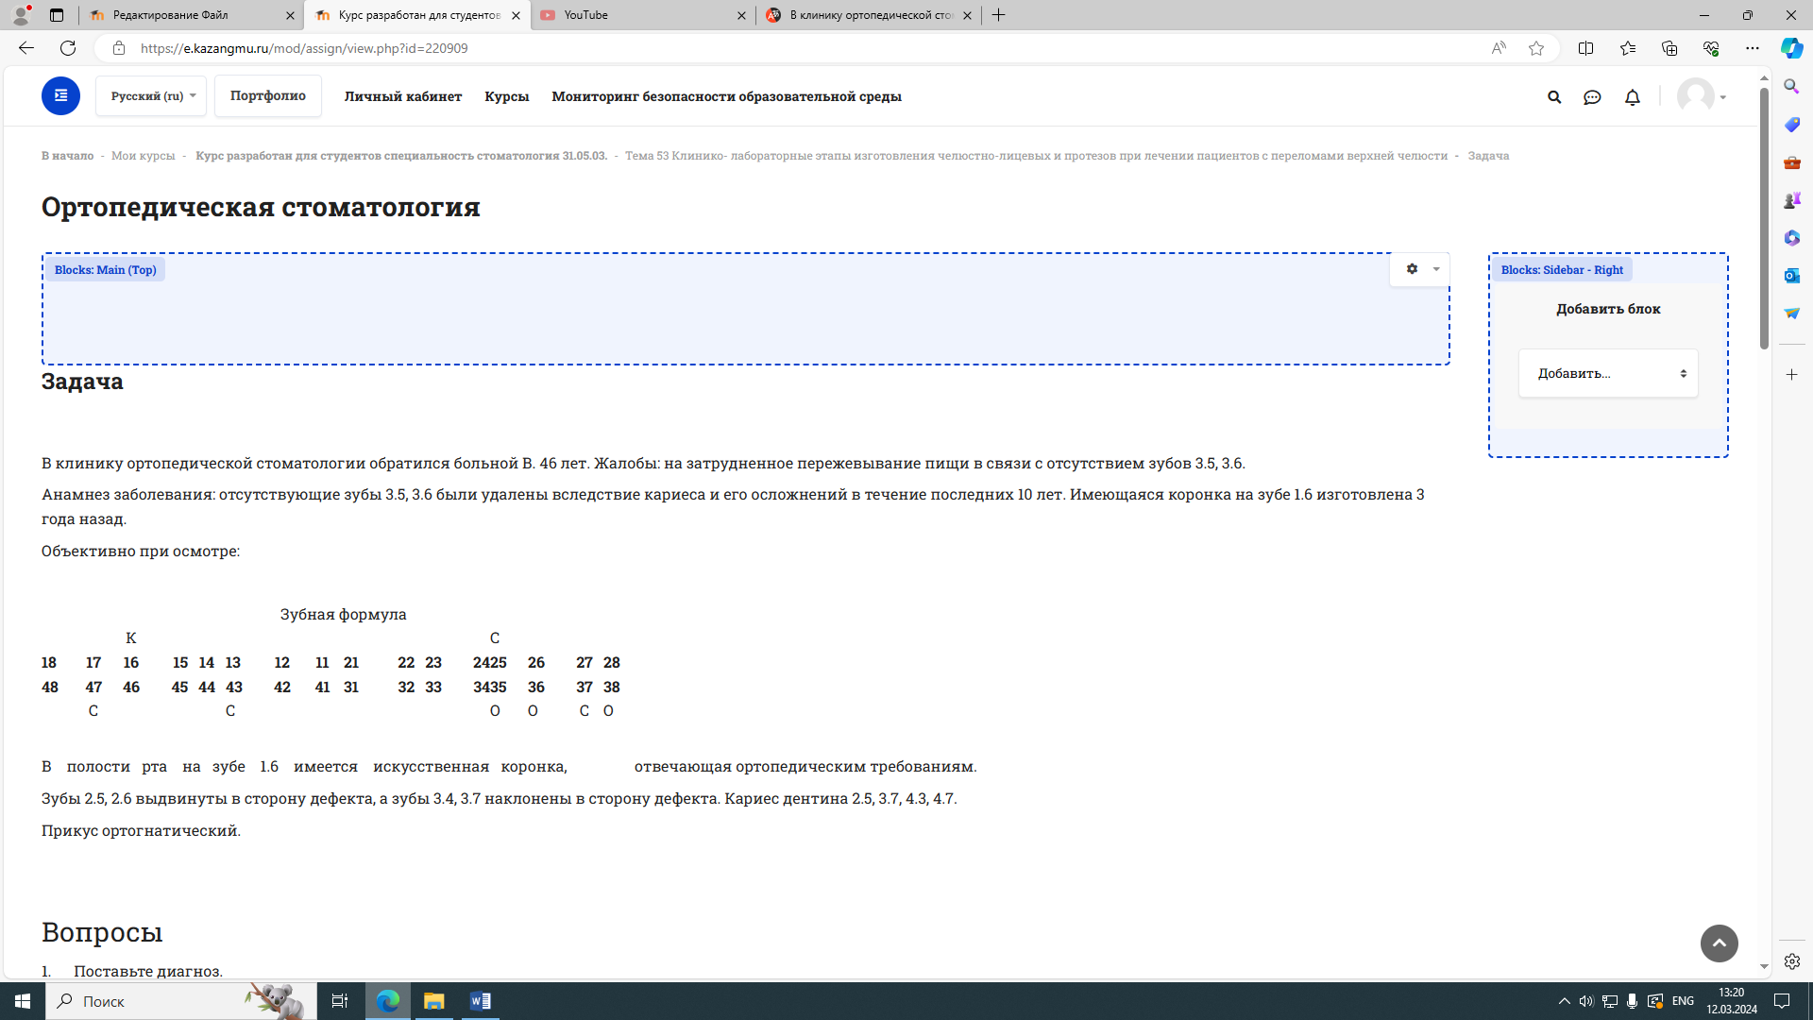

There is an artificial crown in the oral cavity on tooth 1.6 that meets orthopedic requirements.

Teeth 2.5, 2.6 are pushed towards the defect, and teeth 3.4, 3.7 are tilted towards the defect. Dental caries 2.5, 3.7, 4.3, 4.7.

The bite is orthognathic.

Questions

1. Make a diagnosis.

2. Formulate the tasks of orthopedic treatment.

3. Make an orthopedic treatment plan.

4. Name the causes of the deformation of the dentition.

5. Which groups do these deformations belong to?