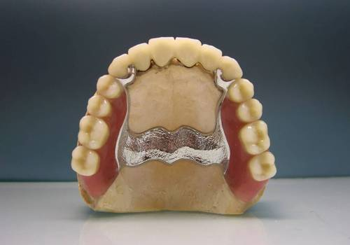

absence of teeth requires the use of different treatment approaches. The most effective method is implantation. But not all patients can use it, due to subjective and objective reasons.

However, in this case, there is a good alternative - clasp dentures. These are orthopedic structures of a removable or conditionally removable type. They are used to restore lost teeth with partial edentia.

The name of these systems comes from the German word bügel, which means “arc”. This is exactly the shape of the metal frame of this structure.

What is a clasp prosthesis?

Module components:

• acrylic base imitating natural gum;

• artificial crowns that replace missing teeth;

• cast metal frame in the form of an arc or curved plate;

• fastenings, which can be used as clasps (hooks), attachments (locks) and telescopic crowns.

Any clasp dental prosthesis, regardless of its features, is fixed on supporting units that are located next to the defective part of the row. Therefore, with complete edentia, this means of removable prosthetics is not used. The only exceptions may be cases of preliminary installation of several implants, on which an arched prosthetic structure with a metal frame can be fixed.

Stages of making a clasp prosthesis

The manufacturing process begins with examining the patient's oral cavity and drawing up a treatment plan.

The following are the steps:

• Preparation of abutment teeth. If necessary, they are treated and strengthened with crowns.

• Creation of a plaster model. It is carried out on the basis of previously taken impressions of the patient’s jaws.

• Creation of a prosthesis prototype. Based on the plaster “jaw”, a model of the arch with a wax base and artificial teeth is made.

• Trying on. The frame with a wax base is tried on the patient's jaw. If inconsistencies are detected, adjustments are made.

• Manufacturing of prosthesis. The wax is replaced with plastic, the structure undergoes final processing, sanded and polished.

• Installation. The finished prosthesis is fixed in the patient’s mouth.

Properly made clasp dentures fit snugly to the gums and are firmly held on the supporting teeth. The aesthetics of such structures is also high, especially if locking or crown retainers are used.

Indications and contraindications for clasp prosthetics

Structures on an arc metal frame are characterized by increased strength, so they can be used in the most difficult cases. In particular, this type of prosthetics is considered the best choice in the following clinical situations:

• absence of two to four or more units in the dentition;

• the presence of terminal defects of the jaw, when there are no extreme molars in its posterior sections;

• loss of units of the anterior dentition (incisors, canines);

• tooth mobility that has developed as a result of periodontitis or periodontal disease;

• pathological wear of teeth, in which other types of prosthetic structures are not used;

• deep bite, in which the upper incisors overlap the lower ones by more than a third.

Removable clasp prosthetics also has contraindications, but almost all of them are relative. For example, the installation of orthopedic structures should be postponed until infectious diseases of the oral cavity and the whole body are cured. Manipulations related to prosthetics cannot be carried out during pregnancy, in case of severe diabetes mellitus, heart disease, vascular disease, or respiratory disease. Absolute contraindications include too low a height of the supporting teeth and severe atrophy of the alveolar processes.

Types of clasp dentures

Structures are classified according to the method of their fixation:

• On clasps. The prosthesis is held on the teeth using metal fasteners that resemble hooks in shape. When using this type of structure, the supporting units are not ground. The disadvantages include the visibility of metal fasteners, which reduces the aesthetics of prosthetics.

• On attachments. These are micro-locks that secure the structure more reliably than clasps, but increase its cost. Attachments consist of two elements - a patrix and a matrix. One of them is fixed on the supporting tooth, the second - in the body of the prosthesis. This fixation system is invisible to others, so the new teeth look natural.

• On telescopic crowns. This is an effective but expensive way to attach a clasp prosthesis. The structure is fixed by inserting one crown into another. The connection is as reliable as possible and completely invisible.

Advantages and disadvantages

The main advantages of clasp dentures are that they do not limit the physiological mobility of teeth and take up minimal space in the oral cavity. At the same time, chewing pressure is evenly distributed between the remaining units in the row and the alveolar processes. Another advantage over removable plate dentures is a longer period of use.

Disadvantages of clasp structures - impossibility of installation in complete hell

