A surgical template is an element for dental prosthetics, which is necessary to determine the position of implants in the oral cavity. These are pads that have guide cylinders, which ensures accurate placement. During the work, computer programs are used, as well as tomography to collect data and implement the restoration operation. Even CAD modeling can be inaccurate if installation requirements are not followed.

Contents hide

1. Types of templates for implantation

2. General features

2.1. Manufacturing

3. Cost of templates

These components allow you to achieve the following aspects when performing a dentist’s work:

– safety increases, archaic methods that are labor-intensive and time-consuming are excluded from the process;

– literally ideal conditions are created for prosthetics, under which any risks are reduced to minimal values;

– the result is easier to predict and implement all aspects previously agreed upon with the patient;

– accuracy is at its maximum, the risk of complications is practically eliminated.

Let's take a closer look at the product variations and parameters.

Types of templates for implantation

Externally, the components for prosthetics resemble a regular boxing mouthguard, but the difference is that there are holes of equal diameter on the surface. They make it possible to accurately determine the area to be treated for implanted systems.

This class is quite extensive even in comparison with other options for dental systems. There are three main types:

– systems supported by bone tissue. In this case, extensive surgery is required, which involves dissection of the tissue, which is pulled back to expose the surface for fixation of the component. The best results are achieved when using the MSCT technique, otherwise it is more difficult to convey the relief of the reference area with high accuracy.

It is important to note that this is an archaic technique that is rarely used today; in the early stages of the development of navigational implantation it was used everywhere. Nowadays, solutions such as body scans are more common, allowing you to collect data for models;

- sometimes on the teeth. This is a modern solution that has practically replaced the previous method from the practice of dentists. This technology requires the creation of an impression and model of the jaw, using CBCT. After creating the form, it is scanned and loaded into a computer program. It is combined with the results of computed tomography, which ultimately forms the exact parameters of the relief from which the templates are created;

– based on the mucous membrane of the oral cavity. This method is no less popular than the previous one, however, it is most often used if there are few teeth left, or the patient suffers from complete edentia. In this case, the steps of forming a radiopaque template are added to the steps described above; it is necessary to see the relief of the mucous membrane on a computed tomography scan if the client does not have any intact teeth left. As a result, it becomes possible to find a place for future artificial teeth and predict the outcome of the operation much more accurately.

Type: Support option: Indications: Advantages:

1 Bone tissue is involved Replaced by more promising methods, as it is outdated No. The main disadvantage is the need for serious surgical intervention

2 Reliance on the preserved units Used for any operations when the number and condition of the preserved teeth allows for reliable fixation of the prosthesis. Simpler than the previous method, characterized by increased accuracy.

3 Applies to the oral mucosa Allows to solve difficulties with complete edentulism Highest accuracy for removable structures of all alternative techniques

In addition to these types, there are subspecies that differ in functionality and specific application. The option for a pilot drill is a solution that allows you to save on the purchase of tools and accessories for it.

The bottom line is that the templates are created exclusively for use in conjunction with conventional surgical kits for any implantable systems with a cross-section of no more than 2 mm. This design, for example, combines well with standard abutments, increasing the accuracy of their positioning, simplifying the selection of optimal inclination angles, and therefore increases the reliability and convenience of future installation operations. If you use cad cam 3d in parallel with the template, you can achieve unprecedented precision in the restoration.

The system can be assembled for each tool equipment option, be it keys or drills. In this situation, for each set of equipment, its own set of templates is purchased. You will have to spend additional money to obtain the necessary sets of tools, but it becomes possible to carry out a wide range of operations with high accuracy.

The third subtype is the purchase under a full protocol, which is a guarantee of the reliability of navigation implantation. The entire range of actions within the framework of a restoration operation is carried out using one template. Currently the best meth

no wild cards have been created.

The downside is the considerable expense that will be required to purchase a new set of templates, either designed for a specific implant system or universal. The latter solution is becoming increasingly widespread, thanks to the growing production of kits by leading market manufacturers. The problem is that adapters will also be needed for the system of structures being implemented.

When talking about surgical templates, we cannot fail to mention bushings or sleeves. All components are conventionally divided into plastic and equipped with a titanium insert. The positive aspect of options with metal is that the part will not allow the bur to deviate from the specified direction, which significantly increases the accuracy of the operation. The negative side is the possibility of overheating of the instrument due to increased friction against titanium, which also leads to overheating of the implant bed.

General Features

Templates at the moment are a fresh solution for carrying out operations, however, most experts are already inclined to believe that the future of dentistry lies in these small structures.

The component in the form of a tray with holes allows you to obtain the exact position of the areas for preparation for the introduction of prostheses and the direction of processing, taking into account all angles of inclination. The essence of the element is to eliminate the slightest inconsistencies and deviations of the drill during the implementation of the work.

One of the important components of success: the identity of the surface of the finished structure adjacent to the tissues of the oral cavity, and the natural curves and shape of these tissues. Obviously, the product is a one-piece product and is developed taking into account the slightest anatomical features of the patient.

Products are created based on lightweight and easy-to-process materials such as acrylic, various polymers, and medical plastic. The main requirement is safety, the absence of harmful emissions during use.

Special strength is not required from the product, since the loads on it are minimal during the implementation of the work. If the specialist is highly qualified, problems should not arise at all stages. Basic and auxiliary materials in orthopedic dentistry allow you to work equally effectively with the structures in question.

It is noteworthy that there are two types described above: completely made of one material and with titanium inserts. The latter are more convenient in the sense that they create a guide for the drill, which does not grind down or deform in case of accidental contact with the cutting edges during drilling.

However, working with such products requires a lot of experience to avoid deviations from the center, which can lead to tool failure. In addition, the above problem occurs, that is, overheating from friction during prolonged contact with titanium.

Impressions in dentistry

In the series of stages of creating a prosthesis in dental practice, taking an impression stands out. It allows you to create a three-dimensional model of the patient’s jaw with the location of the remaining units.

There are a number of indications and contraindications for using the template. First of all, this is convenience for the treating specialist and a guarantee of high accuracy of results for the patient. The system helps in the following cases:

– a large number of row units are lost and the holes from them prevent the dentist from navigating the position of the necessary channels for drilling;

– if there are no frontal units, the template is convenient because it allows the operation to be performed with the best aesthetic result;

– the product is recommended for use if anatomical anomalies or the results of injuries are identified at the work site. In this case, positioning holes without a template can be extremely difficult;

– the element is necessary as a stage for creating temporary prosthetic systems;

– when the method of flapless surgery was chosen for restoration.

[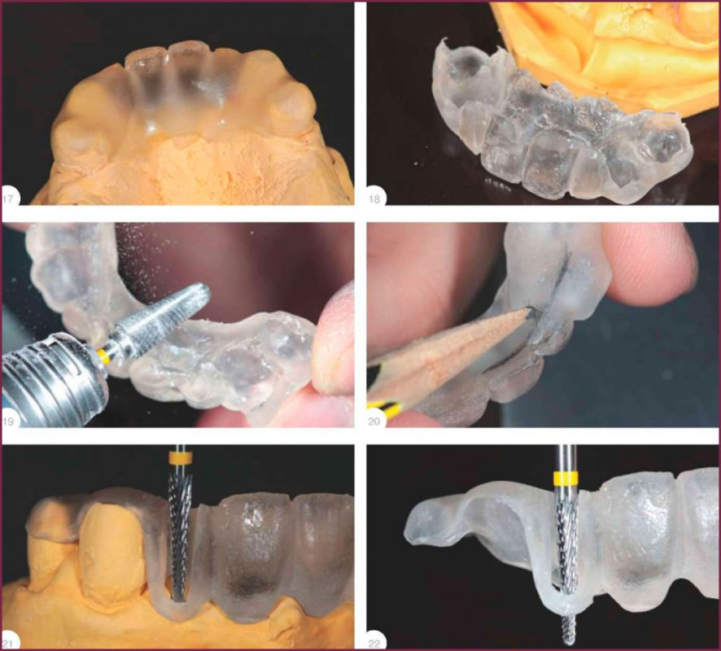](https://ortos.biz/wp-content/uploads/2020/08/khirurgicheskiy-shablon-dlya-implantatsii-9.jpg)

Severe illnesses and their consequences limit their use, such as:

– oncology at any stage;

- heart failure.

There are factors that can simply make working with a template difficult or even impossible. An experienced surgeon can eliminate a number of reasons. The list includes:

– macroglossia, especially if accompanied by a small jaw opening height and nausea;

– if in the supporting zone the mucosal tissue is compacted or there are significant formations;

– when implants are implanted at an angle;

– the head of the angled end is accessible;

– difficulties arise with fixing the finished product;

– In addition, the presence of very large flap fragments when using a bone-supported design can be a limitation.

There are several options for raw materials for production, but each type has its own characteristics. If we talk about acrylic parts, they are very similar to standard removable components with a base.

Products are created after receiving an impression, from which a dental technician casts a model in the laboratory. This is a budget solution, but popular, for obvious reasons. The part is distinguished by its high strength and softness, which makes it easy to use for both the doctor and the client.

Plastic products are formed on the basis of special plastic, which is stronger than the previous one and softer. The CAD/CAM technique is implemented, that is, at all stages of data processing, automatic equipment and computer programs are used to create the form and the actual production. The template can be used with any implantation systems in dentistry.

Ready-made templates have excellent resistance to high temperatures and have a “tunnel”; in combination, this also increases sterility parameters. The disadvantage of products is their increased cost.

In total, all the requirements of technicians and surgeons for templates can be summarized in the following list:

– high strength, ability to withstand temperature, enzymes or humidity without loss of structure and integrity;

– rigidity is important so that at all stages of fabric processing the structure retains its shape and does not deform under the slightest mechanical stress;

– the design must provide a passage to position the product during operation, including at a certain angle;

– the tissue relief must be conveyed as accurately as possible; most of the success of the operation depends on this;

– another task is to obtain a product with the possibility of precise and reliable fixation on the gums and supporting elements of the jaws.

Manufacturing

The stage of producing a template for each patient is a complex task that is solved by a dentist, an orthopedist and a practicing surgeon, as well as a dental technician.

The following stages are distinguished:

– preparatory. This is a general diagnosis of the oral cavity, during which it is necessary to identify all anomalies, inconsistencies, diseases and prospects for using a particular restoration method. As part of this step, an assessment picture of pathologies and a computed tomogram are created, which is necessary for selecting a prosthesis and positioning supporting implants;

– creating a copy. An impression of the jaw must be taken even when solving edentulous problems;

– volumetric modeling. The impression model is scanned, a three-dimensional model of both jaws and rows is created, if they are preserved. Next, the collected data array is loaded into a special program, which on a computer generates optimal ways to solve problems, determines the position of the prostheses and the angles of inclination.

At this stage, a projection is created that will allow the patient to understand what the finished structure will look like;

– Next comes the creation of a template. This process involves the CAD/CAM technique or a dental laboratory with a set of tools and equipment. The second option is a manual method, the first is an automated process for processing the workpiece. Computerized technology requires a 3D printer

Advantages and disadvantages

Qualified specialists prefer to work with the type of product in question. This allows you to obtain greater accuracy and eliminate the risk of errors, which often occurred even when manipulations were carried out by an experienced expert.

Less risk of complications, including due to the absence of surgical intervention. There is no need to incise soft tissue, therefore rehabilitation is faster and the system implemented according to the method takes root better. Rejection is less likely; patients do not experience swelling, redness, pain and discomfort, inflammatory and similar processes.

The system does not have any disadvantages in the usual sense, of course, if you do not perceive the high cost in this light. This stage requires additional costs and time for preparation, which is why the total period of planned operations within the framework of restoration increases.