Classification of diseases of the temporomandibular joint

1. Diseases associated with dysfunction of the masticatory muscles -

muscular-articular dysfunctions:

- myositis;

- muscle contracture;

- hypertrophy of individual masticatory muscles.

2. Diseases associated with morphological and functional disorders inside the joint:

- incorrect position of the head and disc of the joint;

- hypermobility of the articular head;

- subluxation of the articular head;

- dislocation of the articular head;

- subluxation of the articular disc;

- dislocation of the articular disc with reduction;

- prolapse (loss) of the articular disc (disc dislocation without reduction);

- thinning and perforation of the disc;

- inflammatory diseases of the tissues of the joint capsule, synovial membrane, retrodiscal zone (arthritis);

- degenerative diseases of joint tissues: arthrosis, chronic arthritis;

- ankylosis (fibrous, bone).

3. Anomalies and acquired diseases of the TMJ:

- hyperplasia or hypoplasia of one or both articular heads;

- aplasia of one or both articular heads;

- asymmetry of the position of the TMJ in relation to the base of the skull;

- neoplasms of the joint or neighboring formations spreading to the joint;

- joint diseases with rheumatoid arthritis, blood diseases, systemic scleroderma.

Conclusions:

1. The proposed classification of TMJ pathology includes: diseases associated with dysfunction of the masticatory muscles, diseases associated with morphological and functional disorders within the joint: anomalies and acquired diseases of the TMJ;

2. The method of computed tomography examination of the TMJ in the sagittal projection allows one to visualize the articular disc, determine the displacement of the articular heads, measure the joint space along its entire length, and identify violations of the bone structures of the articular surfaces.

In the axial projection, this technique allows you to visualize the medial and lateral poles of the articular heads, identify the asymmetry of the position of the articular heads, and measure the thickness of the chewing muscles in diameter;

3. Computed tomography of the TMJ and masticatory muscles confirms and expands the results of clinical studies and analysis of occlusion, proves the etiological and pathogenetic significance of occlusion disorders in muscular-articular dysfunction, internal disorders of the TMJ;

4. Computed tomography of the TMJ is a non-invasive, highly informative method that allows you to identify morphological and functional disorders, which is especially important for persistent joint pain, the cause of which cannot be identified by other methods.

Functional anatomy and biomechanics

temporomandibular joint

For the diagnosis and treatment of diseases of the temporomandibular joint (TMJ), it is important to know the functional anatomy and biomechanics: the main components of the masticatory system in their functional connection, movements of the mandible and occlusal contacts of the teeth during movements of the mandible, as well as factors influencing the nature of these contacts.

1. Functional anatomy of the temporomandibular joint

The temporomandibular joint is a paired articulation of the articular heads of the lower jaw with the articular surfaces of the mandibular fossae of the temporal bones.

The right and left joints form one system; movements in them occur simultaneously. In terms of its structure, the TMJ has a number of common features with other joints, but differs from them in many ways. These include, for example, the influence of dentition occlusion on the spatial position of the joint elements and on the nature of the movements of the lower jaw.

Each articulation consists of the head of the articular process of the lower jaw, the articular fossa of the tympanic part of the temporal bone, the articular tubercle, the disc, the capsule and ligaments.

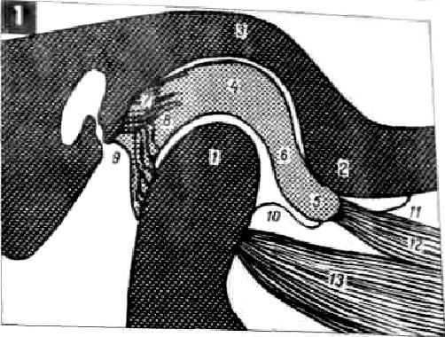

Temporomandibular joint (diagram):

1 - head; 2 - tubercle; 3 - hole; 4 - posterior pole of the disc; 5 — anterior pole of the disc; 6 — central section of the disk; 7 and 8 - “retrodiscal” zone (7 - posterior disco-temporal ligament, 8 - posterior disco-maxillary ligament); 9 - joint capsule (posterior); 10 - anterior discomaxillary ligament; 11 - anterior discotemporal ligament; 12 and 13 - external pterygoid muscle (12 - upper part, 13 - lower part).

The articular head has a shape close to a cylinder, the size in the mediolateral direction is about 20 mm, in the anteroposterior direction - about 10 mm. The internal pole of the head is located more distal than the external one, the longitudinal axis of the head is located at approximately an angle of 10° - 30° to the frontal plane. The convex anterior surface of the articular head is located opposite the convex surface of the articular tubercle. This facilitates all kinds of movements of the head and at the same time, due to the discrepancy between the shape of the articular surfaces, creates an unstable position of the head and fossa of the TMJ, a complete dependence of intra-articular relationships on the occlusion of the dentition and the state of the masticatory muscles.

Joint incongruity is corrected by two factors. The articular capsule is not attached outside the glenoid fossa (as in other joints), but inside it - at the anterior petrotympanic (glaser fissure), which “reduces” the glenoid fossa.

The anterior convex intracapsular part of the articular fossa is represented by a dense bone formation - the articular tubercle, adapted to perceive chewing pressure. The posterior extracapsular part of the articular fossa is a thin bone plate (its thickness is 0.5-2 mm) that separates the articular fossa from the middle cranial fossa. It is both the wall of the tympanic cavity and the auditory tube.

The articular disc, located between the articular surfaces in the form of a biconcave plate, creates with its lower surface a different movable fossa, more corresponding to the articular head. However, the disc is not a stable formation, since the upper part of the external pterygoid muscle is attached to its anterior surface. The tone of this muscle is of great importance for the normal location of the movable complex: head - disc - fossa. In turn, the tone of the external pterygoid muscle largely depends on the occlusion of the dentition.

The thickness of the disc in the center is 1 mm, in the anterior section - about 2 mm, in the posterior section - 3 mm. The disc divides the joint cavity into upper and lower sections, isolated from each other, filled with synovial fluid. In the lower section, rotation of the head occurs in relation to the disc; in the upper section, translational movements of the head-disc complex occur in relation to the articular tubercle. These movements are performed simultaneously, but at certain moments of the joint function one of them predominates: at the beginning and at the end of opening the mouth, rotational movements of the articular head predominate, and in the middle, translational movements predominate. The central part of the disc has no blood vessels or nerve endings. The latter are located mainly in the posterior part of the disc, in the “behind-disc” zone, where synovial fluid is produced, which reduces friction of the articular surfaces and plays an important role in the life of joint tissues.

Normally, in central occlusion, the cap-shaped disc is located on the articular head. When opening and closing the mouth, the disc and head of the TMJ on the left and right move synchronously. With the maximum opening of the mouth, they are installed on the tops of the articular tubercles. During lateral movements of the lower jaw, predominantly rotational movement occurs on the side of displacement, and downward, forward and inward movement occurs on the opposite side.

The smoothness and ease of these complex movements depends on the correct positioning of the head-disc-fossa complex.

A common cause of anterior disc dislocation is loss of occlusal height and posterior displacement of the articular head. In this case, at the beginning of the opening of the mouth, the head moves forward with a click, overcoming the obstacle in the form of the posterior pole of the disc, and the disc is pressed posteriorly. At this moment, the dislocated disc is reduced and returned to its correct position. At the end of the closing of the mouth, a click occurs - the articular head moves posteriorly again, overcoming the obstacle in the form of the posterior pole of the disc (disc dislocation). Clinically, this is detected by a double (reciprocal) click: the first click when opening the mouth - reduction of the disc, the second click when closing the mouth - dislocation of the disc.

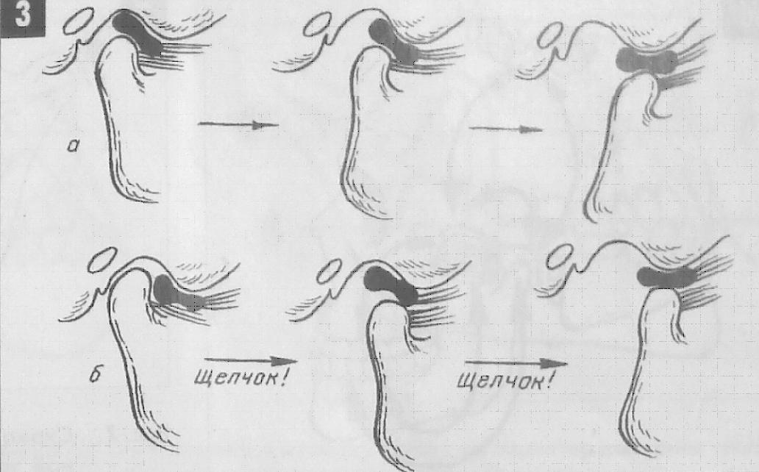

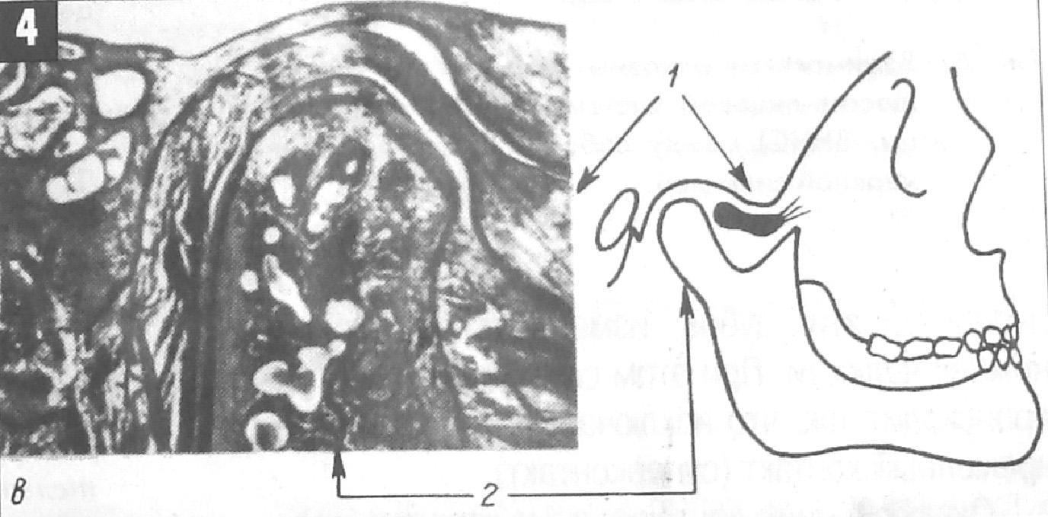

\

Fig. 4. Anterior dislocation of the disc (1), displacement of the articular head (2) backward and upward with loss of lateral teeth. Destruction of all elements of the joint with arthrosis (c) (Steinhardt, 1947).

The joint capsule is a connective tissue membrane, which on the temporal bone is attached to the anterior edge of the articular tubercle (anteriorly) and to the edge of the petrotympanic fissure (posteriorly), and on the lower jaw - to the neck of the articular process. The thickness of the joint capsule is 0.4 – 1.7 mm. The capsule, as well as the intra-articular ligaments of the TMJ, consist of fibrous, inelastic connective tissue, therefore, after they are overstretched, the original length is not restored.

Biomechanics of the temporomandibular joint

Biomechanics of the TMJ studies the functional connection of the joint with the masticatory muscles and dentition, which is carried out by the trigeminal nerve system. The TMJ creates guiding planes for the movement of the lower jaw. A stable vertical and transversal position of the lower jaw is ensured by occlusal contacts of the chewing teeth, which prevent displacement of the lower jaw, providing “occlusal protection” of the TMJ.

The TMJ is a “muscular type” joint. The position of the lower jaw, as if suspended in a cradle of muscles and ligaments, depends on the coordinated function of the masticatory muscles.

The correlation of the activity of a large number of different muscles that have various functions and ensuring complete synchronization of the movements of both joints is carried out by complex constant reflex activity.

The source of reflex impulses are sensory nerve endings located in the periodontium, muscles, tendons, capsule and ligaments of the joint.

Sensory information from the dentition, joint, periodontium, and oral mucosa enters the cortical centers, as well as through the sensitive nucleus of the trigeminal nerve into the motor nucleus, regulating the tone and degree of contraction of the masticatory muscles. If, for example, there is premature contact when the teeth are closed, then the periodontal receptors of these teeth are irritated, and the movements of the lower jaw change. In this case, the closing of the jaws occurs in such a way that this premature contact (supercontact) is eliminated.

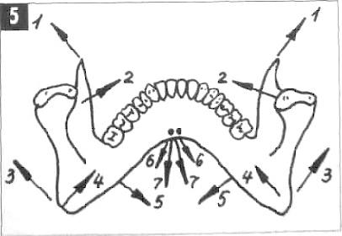

Direction of traction of the muscles attached to the lower jaw:

1. temporal muscle;

2. external pterygoid muscle;

3. the chewing muscle itself;

4. internal pterygoid muscle;

5. mylohyoid muscle;

6. digastric muscle;

Relationships between the main elements of the dentofacial

systems (periodontium, muscles, TMJ) among themselves

and with the central nervous system.

Occlusal contacts of the dentition, tension in the periodontium that occurs during chewing, through the central nervous system program the work of the masticatory muscles and the TMJ. The main chewing load is concentrated in the area of occlusal working contacts, where the proprioceptive sensitivity of the periodontium regulates the degree of chewing pressure on the teeth. The muscle force is directed distally, therefore, the more distal the food is, the more favorable the muscle work and the greater the chewing pressure. Normally, the TMJ on both sides performs a uniform supporting function with a slight load in the forward and upward direction from the articular heads through the disc to the posterior slope of the articular tubercle.

The most important feature of the TMJ function is that the articular heads, when chewing, make movements in the vertical, sagittal and transversal planes.

The path of movement of the mandible in the sagittal plane can be studied by the displacement of the lower point between the central lower incisors when opening and closing the mouth, as well as by the displacement of the mandible from central occlusion to centric relation (sliding along the center).

Scheme of movements of the lower jaw (midpoint between the central incisors)

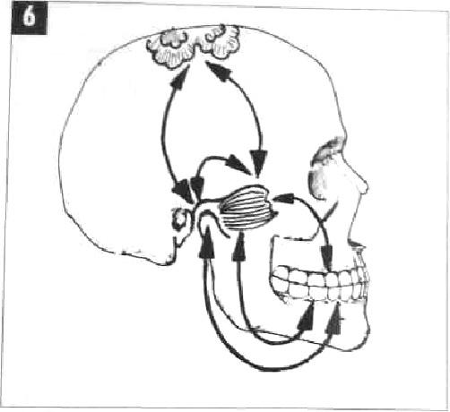

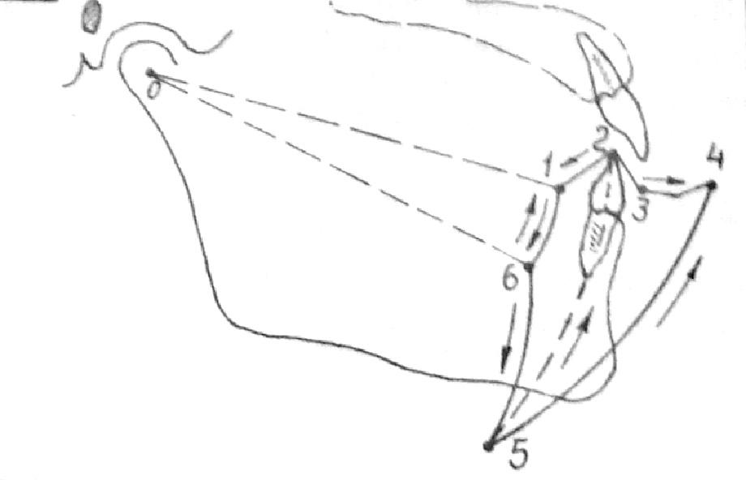

1 - central relation (posterior contact position - occlusal analogue of the central relation); 2 - central, occlusion; 3 - anterior occlusion when installing the incisors “end-to-end”; 3 - 4 - extreme anterior movement from anterior occlusion; 5 - maximum mouth opening - 5 cm; 1 – 6 - arc of purely hinged movement of the lower jaw from the central ratio when opening the mouth - by 2 cm; 6 - 5 - movement of maximum mouth opening with a combined rotational-translational displacement of the articular head; 0 - hinge axis of the TMJ.

At the beginning of the opening of the mouth, a rotational movement of the heads occurs from the central ratio, while the midpoint of the central lower incisors describes an arc about 20 mm long. Then translational movements of the heads (together with the discs) begin forward and down along the posterior slope of the articular tubercles until the articular heads are positioned opposite the apexes of the articular tubercles. In this case, the midpoint of the lower incisors describes an arc up to 50 mm long. Further excessive opening of the mouth can also occur with a slight hinge movement of the articular heads, but this is extremely undesirable, since there is a danger of stretching the ligamentous apparatus of the TMJ, dislocation of the head and disc. These pathological phenomena occur when the sequence of hinge and translational movements of the articular heads at the beginning of opening the mouth is disrupted, for example, when opening the mouth begins not with rotational, but with translational movements of the articular heads, which is often associated with hyperactivity of the external pterygoid muscles (for example, with loss of lateral teeth).

When closing the mouth, normal movements occur in the reverse order: the articular heads move back and upward to the base of the slopes of the articular tubercles. The closing of the mouth is completed due to the hinge movements of the articular heads until occlusal contacts appear. After reaching the initial contact of the chewing teeth (centric relation), the articular heads move forward and upward - into central occlusion. At the same time, they move 1-2 mm along the mid-sagittal plane, without lateral displacements with bilateral simultaneous contact of the slopes of the cusps of the lateral teeth. One-sided contact during "center sliding" is considered premature (occlusal interference), capable of deflecting the mandible to the side when closing the mouth.

The advancement of the lower jaw forward with the teeth closed from the central occlusion to the anterior one is carried out due to the contraction of the lateral pterygoid muscles on both sides. This movement is guided by the incisors. If the lower incisors in centric occlusion contact the palatal surfaces of the upper incisors, moving the lower jaw forward from this position causes disocclusion of the lateral teeth. The path that the lower incisors take along the palatal surfaces of the upper incisors is the sagittal incisal path, and the angle between this path and the occlusal plane is the angle of the sagittal articular path (~ 60°). During this movement, the articular heads move forward and down along the slopes of the articular tubercles, making a sagittal articular path, and the angle between this path and the occlusal plane is called the angle of the sagittal articular path (~ 30°). These angles and their individual determination for each patient are used to adjust the articulator.

The occlusal plane runs from the median incisal point to the distal buccal cusps of the second lower molars with intact dentition. In the absence, they are guided by the Camper horizontal, which is parallel to the occlusal plane and runs from the middle of the tragus of the ear to the outer edge of the wing of the nose.

How can we explain why the sagittal incisal angle is 2 times greater than the articular sagittal angle?

If the angles are equal, then during the transition of the lower jaw from central occlusion to anterior occlusion, the articular head makes only sliding translational movements forward and down along the slope of the articular tubercle while maintaining contact of the lateral teeth. This rarely happens normally.

The influence of equality 1 and difference 2 sagittal and incisal angles on the character

movements of the articular heads and occlusal contacts of the lateral teeth

in anterior occlusion:

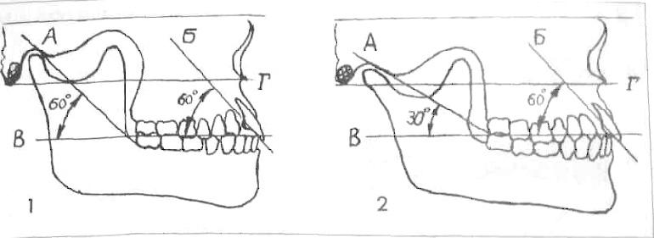

1. when the angles are equal, translational movements in the joint and contacts of the lateral teeth in anterior occlusion are observed (rarely occurs normally);

2. with different angles - combined movements - rotational and translational, there is no contact of the lateral teeth in anterior occlusion (often occurs normally). This shows the importance for the TMJ of preserving and restoring the sagittal incisal path during the manufacture of dentures in the anterior region;

A. sagittal articular path;

B. sagittal incisal path;

B. occlusal plane (between the midpoint of the central lower incisors and the distal buccal cusps of the lower second molars);

G. Camper horizontal.

In most cases, the above angles are not equal. Therefore, during the anterior occlusal movement of the lower jaw, combined translational and rotational movements of the articular heads occur in the joint. Along with translational movements in the upper part of the joint, rotational (hinge) movements occur in the lower part of the joint. At the same time, the lateral teeth become separated - a normal phenomenon with intact dentition.

When placing teeth in complete removable dentures, in order to create stabilization of the dentures during the chewing function during the transition from central to anterior occlusion, it is necessary to create contact between the lateral teeth. This is achieved by appropriate alignment of the teeth along the sphere in the articulator.

The path of movement of the lower jaw in the horizontal plane (movement forward, backward to the sides) can be represented as a “Gothic angle”.

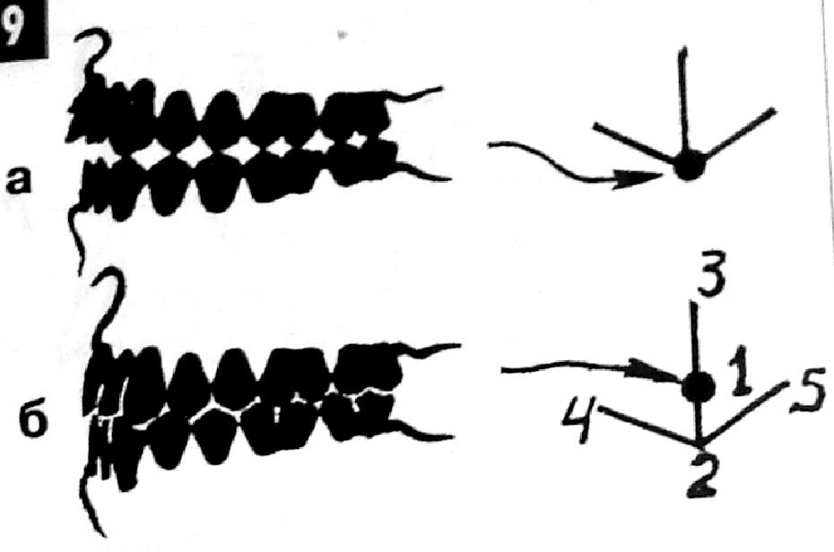

Scheme of movements of the lower jaw in the horizontal plane (recording the Gothic angle):

A. the apex of the Gothic angle corresponds to the central relationship of the jaws (with cusp contacts of the lateral teeth);

b. the point of central occlusion is located anterior to the top of the Gothic angle by 0.5-1.5 mm (with fissure-tubercular contacts of the lateral teeth);

1. central occlusion;

2. central relationship of the jaws;

3. movement of the lower jaw forward;

4.,5. lateral movements of the lower jaw.

It can be recorded using the intraoral method with a rigid funciograph pin (Khvatova V.A., 1993,1996). The essence of this method is that a pin is installed on the removable maxillary plate along the mid-sagittal plane, and a horizontal plate is installed on the mandibular plate. The sliding of the pin along the plate when moving the lower jaw back, forward, right and left is recorded, the Gothic angle is obtained. The apex of the Gothic angle, corresponding to the position of the central occlusion, is located 0.5-1.5 mm anterior to that corresponding to the central relationship of the jaws.

During the lateral movement of the lower jaw from the position of central occlusion, the articular head on the side of displacement (side of laterotrusion) rotates around its vertical axis in the corresponding articular fossa and also makes a lateral movement, which is called Bennett's movement. This lateral movement of the working articular head averages 1 mm and may have a small anterior or posterior component. The articular head on the opposite side (the mediotrusion side) moves downwards, forwards and inwards. The angle between this path of movement of the head and the sagittal plane is Bennett's angle (15-20°). The greater the Bennett angle, the greater the amplitude of the lateral displacement of the articular head of the balancing side.

Since the glenoid fossa does not have a regular spherical shape, and there is free space between the inner pole of the head and the inner wall of the fossa, at the beginning of the movement of the articular head of the balancing side, transversal movement is possible, which is designated as “initial (immediate) lateral movement.” These features of the lateral displacement of the articular head affect the nature of the occlusal contacts of the teeth of the working and balancing sides.