**Inventory logistics. Methodoloical material for preparing for lesson topic 2.2.**

**1. DEFINE THE CONCEPT OF “ RESERVES”**

**Stocks** are deliverable goods and materials stored within an organisation. They are formed whenever inputs or outputs are not used in the organisation, although they are available. Stocks act as a ‘buffer’ between the process of production of goods and their sale, necessary for the transition from the production unit of goods to the consumer unit.

**2. WHAT INVENTORY MANADGMENT SYSTMS DO YOU KNOW?**

**3. IN WHAT CASSES IS EACH OF THE LISTED TYPES USED?**

***There are 6 inventory management systems:***

S - normative stock, which characterises the estimated value of stocks to be reached at the next purchase (upper limit); s - minimum or control stock level (lower limit, order point); q - minimum or control level of stocks (lower

s - minimum or control stock level (lower limit, order point); q - volume of a single purchase;

t - duration of the interval between two possible purchases.

purchases.

***1) The s,q-system is used*** when it is profitable to buy a constant volume q.

current stock,

quantity

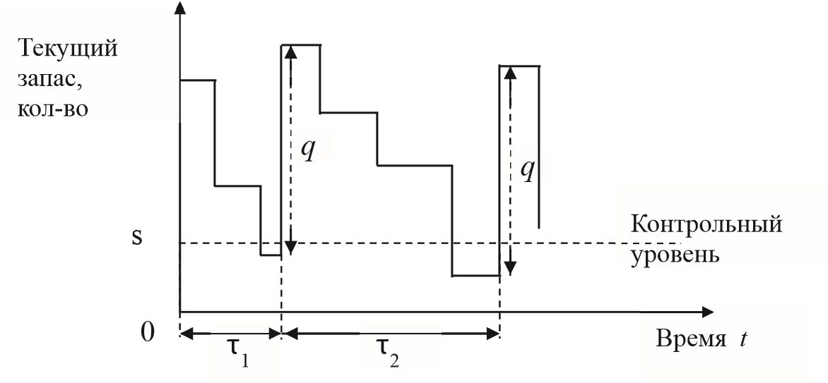

time

reference level time

**2)*s,S-system.*** The order volume is not constant, the stock is replenished to the normative level.

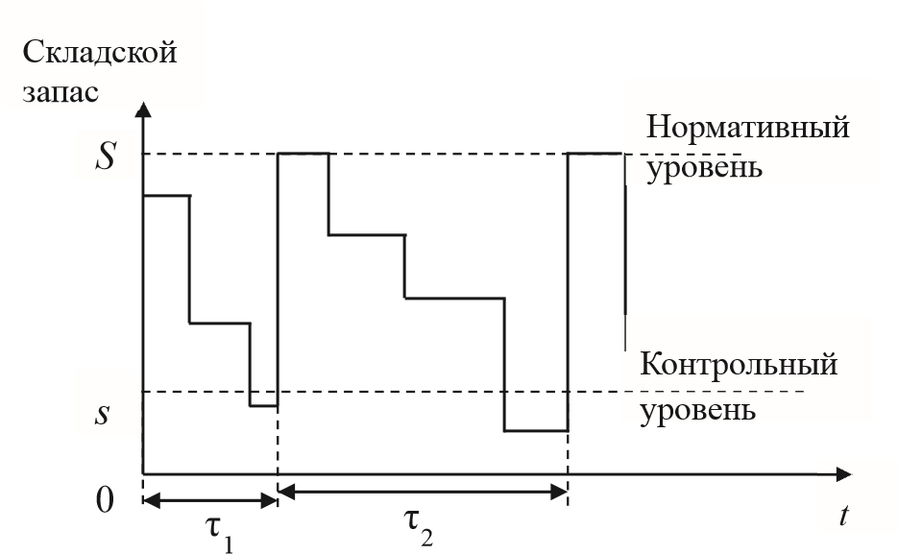

standard level

warehouse stock

control level

***3) t,q-system.*** Stock is replenished at regular intervals

warehouse stock

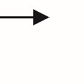

*t*



Складской

запас

0

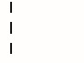

*q*

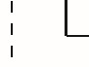

*q*

τ

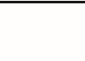

τ

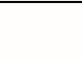

τ

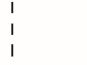

*q*

***4) t,S-system.*** The stock is replenished at regular intervals up to the normative level.

*normative level*

warehouse stock

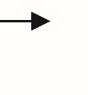

***t***



**Складской**

**запас**

**0**

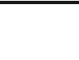

**τ**

**τ**

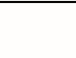

**τ**

***S***

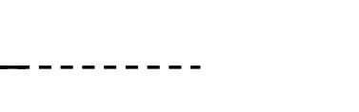

**Нормативный**

**уровень**

***5)t,s,q-система***. If the stock is below the benchmark level, a batch of goods of size *q is* purchased .

control level

warehouse stock



Складской

запас

0

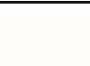

τ

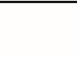

τ

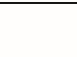

τ

*s*

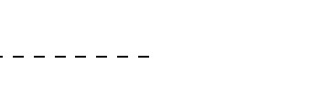

Контрольный

уровень

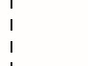

*q*

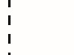

*q*

***6) t,s,S-system.*** If at the time of inspection the stock is below the control level, the stock level is replenished to the normative indicator.

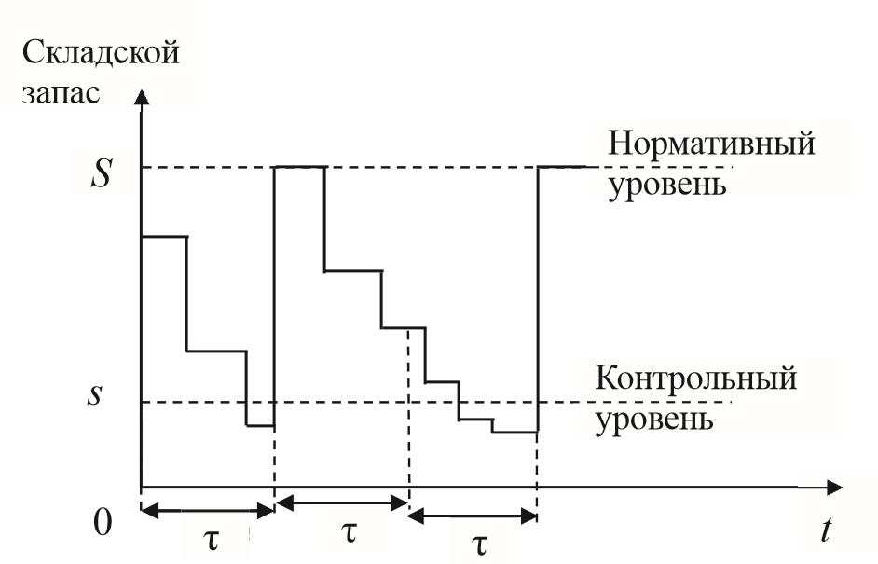

control level

*normative level*

warehouse stock

***Inventory management:***

*Sobst. = f (С сохран.; Сзап.; M; K; Q; P; T; T; S; Зтек.ср.; N;t).*

*Sobshch. - total costs, depends on several variables: uncontrollable:*

*K- unit stock of inventory creation;*

*M - unit stock on storage of stock;*

*Q - demand for goods;*

*P - purchase price per unit of goods;*

*T - duration of the analysed period; controllable:*

*C storage, C spare - costs;*

*Z tek.cf.* *- average current stock, pcs.*

*S - size of the ordered batch of goods, pcs.* *N - number of orders in a certain period; t - time interval between deliveries.*

*Calculation of costs for a certain period associated with the placement and receipt of goods:*

*C zap.= Q*K / S*

*Calculation of storage costs:*

*C storage.* *= M * T * Z tek.sr.* P Calculation of the optimal order size ( Wilson's formula):*

**4. Name the classification of inventories by purpose?**

**By purpose, inventories are divided into:**

1. current storage inventories. To ensure the usual daily sale of goods to the population and hospitals. They are regularly and evenly replenished. Current stocks are financed by own and borrowed funds.

2. Seasonal commodity stocks. It is created during a certain season and ensures the activity of the pharmacy organisation until the next season.

3. Targeted commodity stocks. To fulfil specific health care tasks (mass vaccination against a certain pathogen, fight against epidemics, etc.).

Target and seasonal stocks can be financed from budgetary funds and from the funds of compulsory health insurance.

**5. Name the classification of stocks by location?**

**By location, stocks are divided into:**

1. stocks in the retail pharmacy network (pharmacies, kiosks, etc.).

2. stocks in warehouses and bases.

3 Inventories in transit (those that have been shipped by suppliers, paid for with the relevant settlement documents, but have not arrived at the pharmacy or warehouse by the end of the reporting month, quarter, year).

**6.What does the concept of time of commodity circulation mean?**

The total duration of goods in circulation (from shipment by suppliers to sales to customers) forms the commodity circulation time.

**7. Name the classification of inventories in relation to the planned period**

**In relation to the planning period, inventories are divided into:**

1. Merchandise inventories at the beginning of the planning period (input, initial), coinciding with the final current period.

2. Merchandise inventories at the end of the planned period..

**8. How are inventories measured?**

**Merchandise inventories are measured by:**

1. In natural terms (poisonous drugs, narcotic drugs, potent drugs, ethyl alcohol). For example, the stock of narcotic drugs for city pharmacies should not exceed one month's demand.

2. In value terms - in purchase prices.

3. In relative terms - days of stock (time of circulation of goods).

**9. What factors influence the value of inventories**

The following factors have themost significant impact on the value of inventory :

- sales volume (the larger the pharmacy is in terms of turnover, the more inventory it should have, all other things being equal);

- the location of the pharmacy (urban pharmacy, rural pharmacy, distance to supply centres);

- sales structure (by customers; by assortment);

- organisation of the distribution network (speed, delivery conditions, ordering and receiving times).

**10. What does the concept o inventories standard mean ?**

**inventory standard**- is the optimum amount of stock that ensures uninterrupted sale of goods at minimum cost.

**11. What do we mean by the concept of norml inventories?**

***Normal stock*** levels in a pharmacy are defined as an irreducible stock of goods sufficient to fulfil the turnover plan and ensure uninterrupted supply of medical products to the population and medical organisations. These stocks are periodically circulated, and the speed of circulation, or ***turnover*** rate as it is also known, depends on many reasons.

**12. What factors accelerate turnover?**

**The following factors accelerate the turnover of goods:**

- shortening the period of goods in transit, accelerating the acceptance of goods and transferring them for sale to pharmacy departments and to the small retail network;

- delivery of goods in the required assortment in terms of quantity and quality;

- correct organisation of goods storage, prevention of goods spoilage;

- widespread use of more progressive methods of work of the pharmacy for the sale of goods;

- clear organisation of information of doctors about the availability of medical goods;

**13. what does the concept of inventories in days mean?**

Stocks of goods in days characterise the state of stocks of goods at a certain moment (end of the quarter, end of the year). The turnover of goods in days characterises the state of the stock of goods for the whole analysed period (for the year, quarter) and requires determination of the average stock of goods by means of appropriate calculations.

Depending on the conditions provided by suppliers, the size of the local market, the level of demand, as well as taking into account the financing possibilities, each pharmacy should find answers to the questions related to the size of the stock, the frequency of purchases, the volume of one-time purchases from the supplier. And also to identify the main priorities in working with manufacturers and distributors: price, quality of goods, stability of supply, etc.

**14. What is the formation of excess reserves dangerous?**

**‘Overstocks’ are also associated with certain risks, which include:**

- risks associated with changes in the consumer properties of medicines;

- risks associated with changes in product prices (depreciation of the inventory);

- risks associated with unrealisation of the stock.

In addition to the above risks, the extraction of significant cash from the pharmacy company's turnover may

have a significant impact on the speed of cash turnover. This reduces the total amount of cash, which will affect the profitability of the company

**15. Why each pharmacy individually forms the amount of inventory?**

**Thus, the size of the stock of goods should be individually determined for each pharmacy.**

**This will allow to find the necessary balance in the work, to maximise the turnover rate of the stock and, consequently, the cash flow, but at the same time to prevent an increase in the number of ‘failures’.**

1. Optimising the size of the inventory contributes to increasing profits by achieving the planned sales volume through full satisfaction of consumer needs.

2. Optimal inventory planning helps to smooth out unevenness of supply and provide customers with a choice. At the same time, there is an increase in the level of customer loyalty.

3. Stock evaluation and stock control allow for the fullest and most efficient use of available resources.

4. Effective assortment policy and analysis of each item allows to purchase only those medicines for which there is demand in the local market.

5. Optimisation of the assortment structure enables the pharmacy to adapt to the customer's requirements and work with only those products whose properties are able to meet the customers' needs.

**Inventory Management**

***Order quantity*** *is the number of items to be ordered.*

***Reorder level*** *is the number of items in stock at which an order for new items is submitted.*

***Delivery time*** *can be either instantaneous, fixed or random.*

***Shortage Penalty*** *is the loss due to lack of stock.*

*A certain charge is made for holding each unit of stockCh. The whole theory is built with the aim of minimising total costs.*

***The assumptions of the basic inventory management model are:***

*1) demand is uniform and constant;*

*2) delivery time is constant;*

*3) lack of stock is unacceptable;*

*4) a constant quantity is ordered each time - the optimal order size.*

***Determining the economical size of the next order for inventory supply is based on minimising the total cost of two types of costs:***

*inventory holding costs, which are directly proportional to the size of the order;*

*order placement costs, which include mainly paperwork costs and are independent of order size.*

*In the absence of storage costs, firms could hold unlimitedly large inventories and thus would not engage in reordering. Conversely, if a firm did not incur the cost of placing orders, it could continuously place orders and not maintain any stock at all, except for a reserve stock.*

*The total costs associated with ordering and storage of one batch of orders are equal to the sum of total costs of repeated placement of orders and total costs of stock maintenance = AB/Q + IQ/2.*

*Mathematically, the economic order size is determined by the formula:*

*A variation of the EOQ system is the Fixed-Order Quantity system used for multiple purchases of the same product.*

*In addition to the above EOQ system, a system with a fixed order frequency is widely spread.*

*In this system, orders are placed at certain fixed intervals, for example, twice a month three days before delivery. In a system with fixed order frequency - on the contrary, time is a fixed quantity and order size is a variable quantity.*

*A fixed order frequency system is used in the following situations:*

*When an organisation cannot automatically maintain set inventory levels. Typically, a manager systematically places orders for all items manually.*

*Suppliers offer significant discounts if she will place her orders at regular intervals. Since obtaining a discount is usually more favourable to the firm than using the EOQ system, the firm switches to using a fixed order frequency system.*

*When a firm purchases goods FOB and transports them using its own lorries. This situation arises if any of the firm's trucks systematically return underloaded from points close to the firm's source of supply.*

*Often the fixed order frequency system is supplemented by one element borrowed from the EOQ system. In the warehouse, a card indicating the minimum allowable current stock is placed near each dispensing hopper or dispenser. When storekeepers detect that the stock level has fallen below the minimum allowable level, they notify the supervisor, who decides either to place an emergency order immediately or to replenish the stock from other sources. In addition to the two ordering options proposed, there may be a combination of these options - fixed volume and time, introduction of a minimum and maximum order quantity, random orders within a given minimum and maximum order limit.*

**16. What you know about the just in time supply system?**

**JIT (just in time) supply system - ‘just in time’.**

This system was proposed by Japanese manufacturers and has proved its effectiveness in the USA as well. The JIT system was originally created to improve the quality of production. The logic of the JIT system implies reducing the stock of materials to the level necessary only for the production of a given batch of products. Each delivered part must meet quality standards.

**The basic model of inventory management**

**TC costs = order submission + storage = → min ,**

*where q is the optimal order size, q/2 is the average amount of stock stored.*

*The solution to this optimisation problem is the value of the optimal order size:*

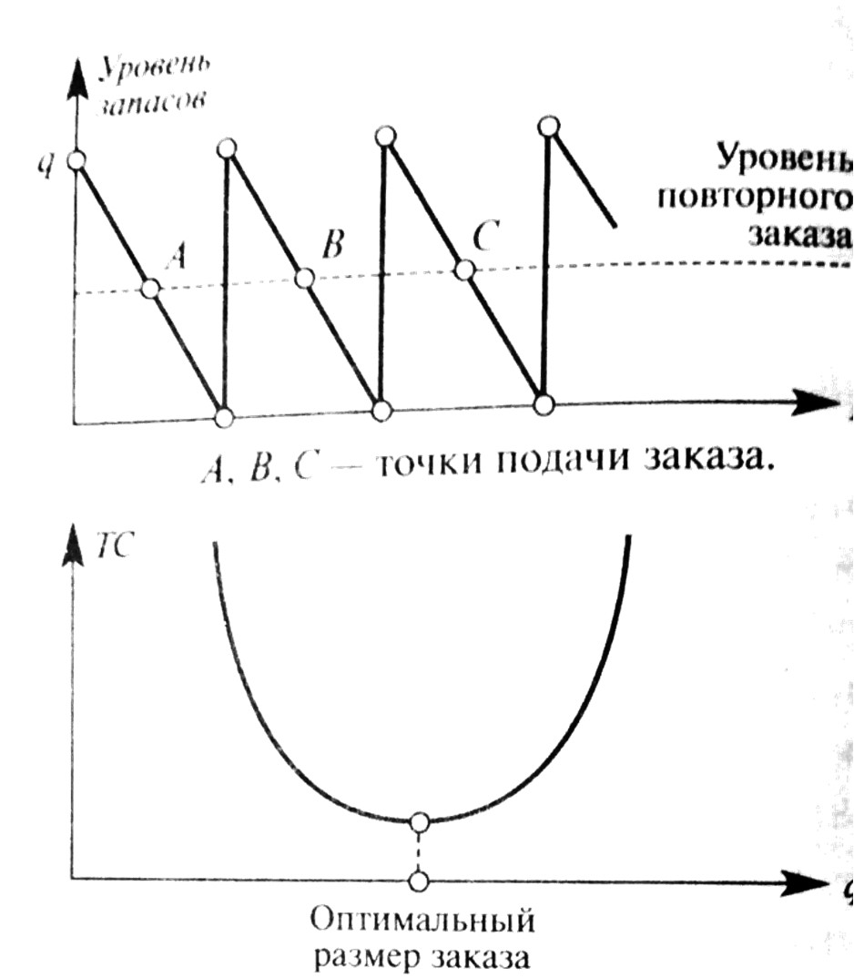

stock level

q =

**

reorder level

order entry points

***task:***

optimal order size

*.*

**Eхamples of problems to solve?**

**1. In the autumn-winter period weekly demand in pharmacy A for Ingavirin is 200 packs (D=200), the cost of order submission is 150 rubles/order, the cost of storage of one unit is 2 rubles/week, delivery time is 1 day. Find the optimal order size, costs, reorder level**.

**Quantity discount**

Very often, if the quantity ordered is greater than a certain number, a discount is given. In this case, procurement costs are reduced but storage costs are increased.

ТС(q) = CD +

+

Total cost = purchase + cost: TC(q) = CD + ,

+

where C is the purchase price.

It is necessary to find out whether it is worthwhile to take advantage of the discount.

**problem**

**2. Annual demand D = 1000 units, order submission cost C0 = 40 rubles/order, purchase price C = 50 rubles/unit, annual storage cost is 25% of its price. It is possible to get a 3% discount from suppliers if the order size is not less than 200 units (price-violating level). Is it worth taking advantage of such a discount?**

**Scarcity planning model**

In some cases, storage costs are very high. Therefore, it makes sense to allow regular intervals of time. When an item is out of stock.

TC costs = order submission + storage + shortage penalty.

Two approaches are possible:

1) the new production received does not go to fulfil orders for the product while it is out of stock;

2) part of the new production received goes to fulfil all orders left during stock-out.

**stock level**

time

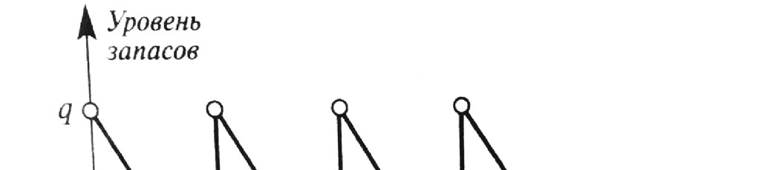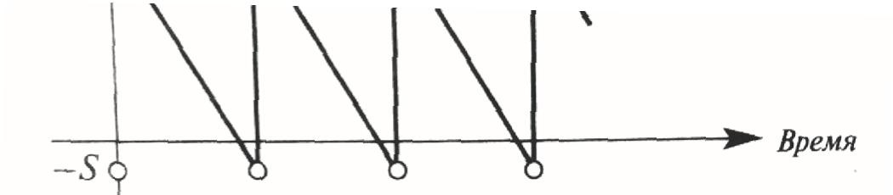

S - maximum deficit size (the maximum possible number of units of a commodity that could be realised during the period of its absence in each cycle). On the graph, the periods of shortage are conventionally depicted below the time axis. Cb - the annual cost of not having a shortage of products in stock (loss of customer confidence, unsold products, etc.). When using inventory management models, costs due to shortages are very difficult to calculate.

TC costs = order submission + storage + shortage penalty

= → min,

where q is the optimal order size, S is the maximum shortage rate.

measures of shortage.

The solutions to this problem are the values:

q =

.

S =

.

**Problem**

**3. Annual demand D = 500 units, cost of order submission C0 = 40 rubles/order, cost of storage of one unit Ch = 5 rubles/year, annual cost of lack of orders Cb = 100 rubles/unit.**

**Thus, in the deficit model, annual costs are less than**

**The main indicators of pharmacy stock assessment:**

**Inventory level** allows quantifying the size of the pharmacy's inventory (units - days).

It is calculated as of the date.

The term ‘inventory level’ is used when referring to a certain amount of inventory in monetary or physical terms.

**Inventory turnover**, calculated in days of sale, shows the average time during which the product was in turnover (from the moment when the product became the pharmacy's stock until the moment of its sale). The shorter the turnover cycle, the higher the turnover rate of the inventory, therefore, the faster the return of cash invested in this product. The higher the turnover rate, the less it is necessary to invest financial resources in the formation of inventory to achieve the planned level of profit of the pharmacy enterprise. Increase in the speed of inventory turnover contributes to the increase in the volume of product sales and reduction in the level of product inventory.

It is necessary to achieve a balance between the advantages and disadvantages, on the one hand, of ordering and, on the other hand, of storing goods. This balance is achieved by selecting the optimal volume of batches of ordered goods, or determining the economic (optimal) order quantity (EOQ), which is calculated by the formula**:**

#### EOQ = 2AD/vr,

where A is the cost of production; D is the average level of demand; v is the unit cost of production; r is the cost of storage.

**Problem.**

**4. Determine the optimal order size for the warehouse for ‘Novopassit’, if the annual demand is 1500 fl., the unit price is 50 rubles, the cost of storing the goods in the warehouse is equal to 20% of its price, the cost of ordering 5 rubles. Wilson's formula is used.**

Calculation algorithm:

,

where Q is the optimal order size, pcs;

A - costs associated with order placement (costs of documentation, information search, labour costs of a specialist, etc.). (in rubles);

S - demand for goods for a certain period of time (year, quarter, month);

J - costs associated with the storage of a unit of goods in the warehouse (in rubles).